**PROJECT SERVER 2010**

**Determine hardware and software requirements (Project Server 2010)**

**Hardware requirements:**

|  |  |
| --- | --- |
| **Component** | **Minimum requirement** |
| Processor | 64-bit, quad-core, 2.5 GHz per core |
| RAM | 4 GB for developer or evaluation installation  8 GB for single server and multiple server farm installation for pilot or production use |
| Hard disk | 80 GB for installation  For production use, you need additional free disk space for day-to-day operations. Add twice as much free space as you have RAM for production environments. |
| Hyper-V Virtualization | Supported |

# **Software requirements**

|  |  |
| --- | --- |
| **Environment** | **Minimum requirement** |
| Database server for a single-server farm | 64-bit version of Microsoft SQL Server 2005 with Service Pack 3 (SP3), or 64-bit version of Microsoft SQL Server 2008 with Service Pack 1 (SP1) and Cumulative Update 2 installed  Ee683978.note(en-us,office.14).gif**Note:**  If you install SQL Server 2005 SP3, you must use [Cumulative update package 3 for SQL Server 2005 Service Pack 3](http://go.microsoft.com/fwlink/?LinkId=165748) (http://go.microsoft.com/fwlink/?LinkId=165748).If you install Microsoft SQL Server 2008 SP1, you must install [Cumulative update package 2 for SQL Server 2008 Service Pack 1](http://go.microsoft.com/fwlink/?LinkId=165962) (http://go.microsoft.com/fwlink/?LinkId=165962).When you install Microsoft SQL Server 2008 SP1, you might receive a compatibility warning. You can disregard this warning and continue with your installation.The Microsoft SharePoint Products and Technologies 2010 Preparation Tool does not check your Microsoft SQL Server install version before Setup. The SharePoint Product and Technologies Configuration Wizard checks that you have the correct version of SQL Server after you have completed Setup. |
| Stand-alone server | * The 64-bit edition of Windows Server 2008 Standard with SP2   Ee683978.note(en-us,office.14).gif**Note:**  You must download an update for Windows Server 2008 before you run Setup, or Setup will not run.   * + For Windows Server 2008 with SP2, see [FIX: A hotfix that provides a method to support the token authentication without transport security or message encryption in WCF is available for the .NET Framework 3.5 SP1](http://go.microsoft.com/fwlink/?linkID=160770) (http://go.microsoft.com/fwlink/?LinkID=160770).   + For Windows Server 2008 R2, see [FIX: A hotfix that provides a method to support the token authentication without transport security or message encryption in WCF is available for the .NET Framework 3.5 SP1](http://go.microsoft.com/fwlink/?LinkID=166231) (http://go.microsoft.com/fwlink/?LinkID=166231). This link will become active when the hotfix is available.   The Beta version of the Microsoft SharePoint Products and Technologies 2010 Preparation Tool does not install these updates.  Ee683978.note(en-us,office.14).gif**Note:**  If you are running Windows Server 2008 with SP1, the Microsoft SharePoint Products and Technologies 2010 Preparation Tool installs Windows Server 2008 SP2 for you.   * Web Server (IIS) role * Application Server role * Stand-alone version of Microsoft SharePoint Server 2010 Enterprise Version   Ee683978.note(en-us,office.14).gif**Note:**  SharePoint Server 2010 will require the following software installation requirements. These software prerequisites can be installed through the Microsoft SharePoint Products and Technologies 2010 Preparation Tool prior to the installation of SharePoint Server 2010 Enterprise Version. The Microsoft SharePoint Products and Technologies 2010 Preparation Tool can be accessed from the SharePoint Server 2010 Start page.   * + Microsoft .NET Framework version 3.5 SP1   + SQL Server 2008 Express with SP1   + Microsoft "Geneva" Framework   + Microsoft Sync Framework Runtime v1.0 (x64)   + Microsoft Filter Pack 2.0   + Microsoft Chart Controls for the Microsoft .NET Framework 3.5   + Windows PowerShell 2.0 CTP3   Ee683978.note(en-us,office.14).gif**Note:**  If you plan to use Windows Server 2008 and Windows PowerShell 1.0 is already installed, you must uninstall Windows PowerShell 1.0 before you can successfully install Windows PowerShell 2.0 CTP3.   * + SQL Server 2008 Native Client   + Microsoft SQL Server 2008 Analysis Services ADOMD.NET   + ADO.NET Data Services v1.5 CTP2   Ee683978.note(en-us,office.14).gif**Note:**  To install the prerequisites through the Microsoft SharePoint Products and Technologies 2010 Preparation Tool, ensure that you have an Internet connection, because some of these prerequisites are installed from the Internet. If the server does not have access to the Internet, see the **Installing software prerequisites** section of this article for links to where you can download these updates to media. |

**Installing software prerequisites**

To install Windows Server 2008 or Microsoft SQL Server updates, you can go to the Web sites listed in this section. You can install all other software prerequisites through the Project Server Start page. Most of the software prerequisites are also available from Web sites listed in this section. The Web Server (IIS) role and the Application Server role can be activated manually in Server Manager.

* [Microsoft SQL Server 2008 SP1](http://www.microsoft.com/downloads/details.aspx?FamilyID=66AB3DBB-BF3E-4F46-9559-CCC6A4F9DC19&displaylang=en) (http://go.microsoft.com/fwlink/?LinkId=166490)
* [Microsoft SQL Server 2005 SP3](http://www.microsoft.com/downloads/details.aspx?FamilyID=ae7387c3-348c-4faa-8ae5-949fdfbe59c4&displaylang=en) (http://go.microsoft.com/fwlink/?LinkId=166496)
* [Microsoft Windows Server 2008 Standard SP2](http://technet.microsoft.com/en-us/dd727510.aspx) (http://go.microsoft.com/fwlink/?LinkId=166500)
* [Microsoft .NET Framework 3.5 Service Pack 1](http://go.microsoft.com/fwlink/?LinkId=131037) (http://go.microsoft.com/fwlink/?LinkId=131037)
* [Microsoft SQL Server 2008 Express Edition Service Pack 1](http://www.microsoft.com/downloads/details.aspx?displaylang=en&FamilyID=01af61e6-2f63-4291-bcad-fd500f6027ff) (http://go.microsoft.com/fwlink/?LinkId=166503)
* [Microsoft "Geneva" Framework](http://go.microsoft.com/fwlink/?LinkID=165752) (http://go.microsoft.com/fwlink/?LinkID=165752)
* [Microsoft Sync Framework v1.0](http://go.microsoft.com/fwlink/?LinkID=141237&clcid=0x409) (http://go.microsoft.com/fwlink/?LinkID=141237&clcid=0x409)
* [Microsoft Filter Pack 2.0](http://www.microsoft.com/downloads/details.aspx?displaylang=en&FamilyID=60c92a37-719c-4077-b5c6-cac34f4227cc) (http://go.microsoft.com/fwlink/?LinkId=166504)
* [Microsoft Chart Controls for Microsoft .NET Framework 3.5](http://go.microsoft.com/fwlink/?LinkID=141512) (http://go.microsoft.com/fwlink/?LinkID=141512)
* [Windows PowerShell 2.0 CTP3](http://go.microsoft.com/fwlink/?LinkId=165758) (http://go.microsoft.com/fwlink/?LinkId=165758)
* [Microsoft SQL Server 2008 Native Client](http://www.microsoft.com/downloads/details.aspx?displaylang=en&FamilyID=c6c3e9ef-ba29-4a43-8d69-a2bed18fe73c) (http://go.microsoft.com/fwlink/?LinkId=166505)
* [Microsoft SQL Server 2008 Analysis Services ADOMD.NET](http://go.microsoft.com/fwlink/?LinkId=130651&clcid=0x409) (http://go.microsoft.com/fwlink/?LinkId=130651)
* [Microsoft Silverlight 3.0](http://www.microsoft.com/silverlight/get-started/install/default.aspx) (http://go.microsoft.com/fwlink/?LinkId=166506)
* [ADO.NET Data Services v1.5 CTP2](http://go.microsoft.com/fwlink/?LinkId=158354) (http://go.microsoft.com/fwlink/?LinkId=158354) for Windows Server 2008 SP2
* [ADO.NET Data Services v1.5 CTP2](http://go.microsoft.com/fwlink/?LinkId=159780) (http://go.microsoft.com/fwlink/?LinkId=159780) for Windows Server 2008 R2

**DEPLOYMENT OF PROJECT SERVER 2010:**

**STEP 1:** Get the system ready for the deployment of project server 2010. The 64-bit edition of Windows Server 2008 Standard with SP2. Turn off both Windows Firewall and IE Enhanced security configuration.

**STEP 2:** Add Server Roles.

Web Server (IIS) role

Application Server role

**Go to Server Manager🡪 Role summary🡪Add Roles:**

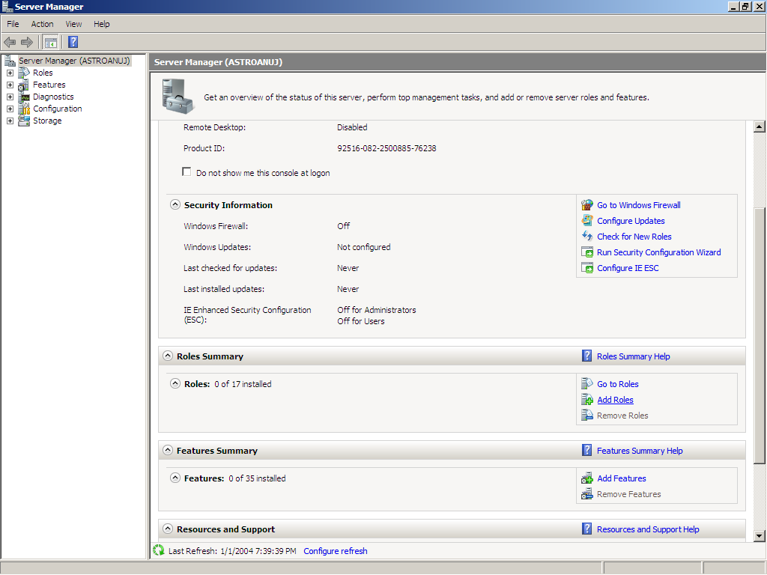

**Click on Add Roles.** 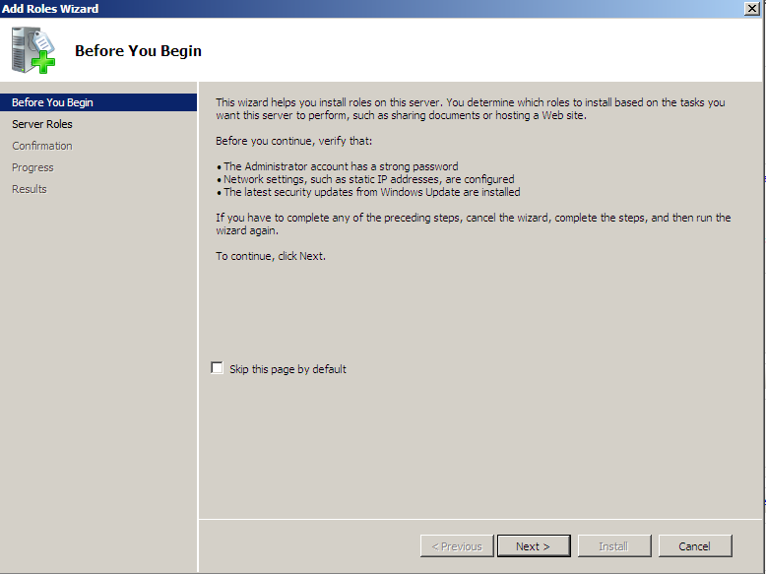

**Click on Next**

**Select Application Server and Click on Add Required Features**

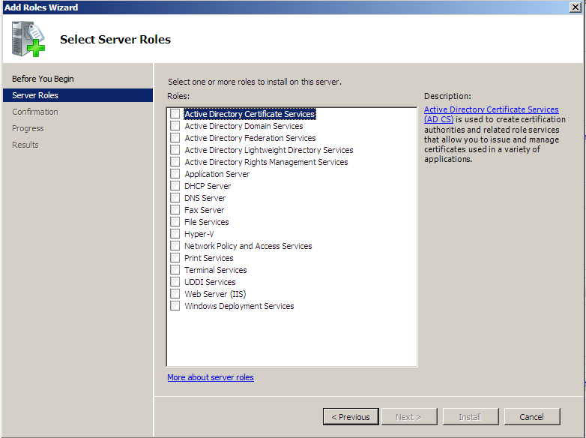

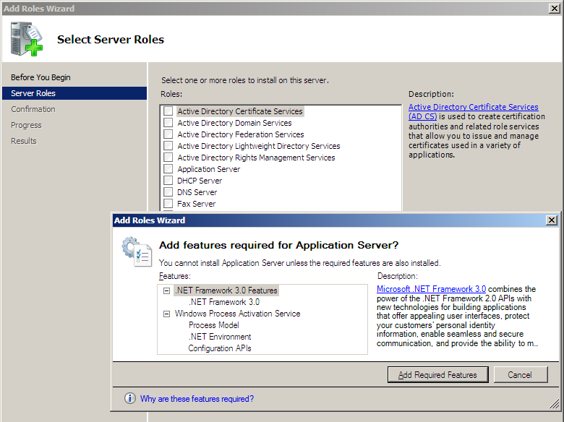

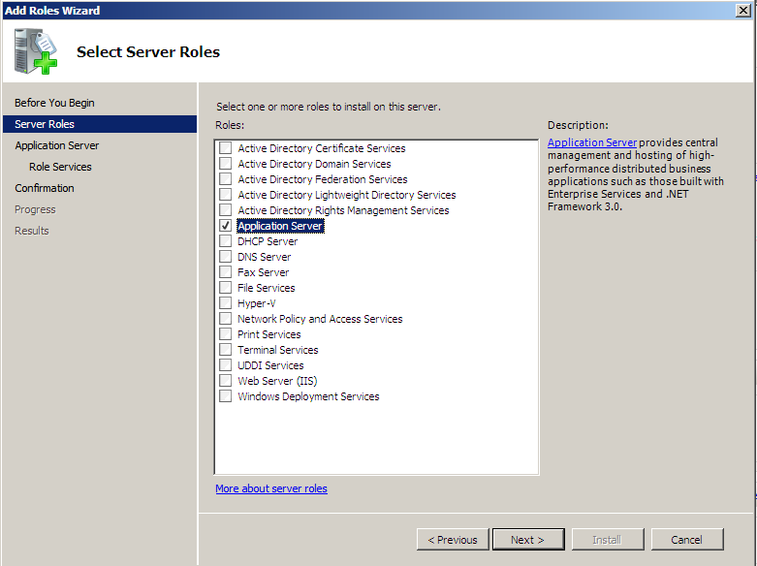

**Select Web Server (IIS)**

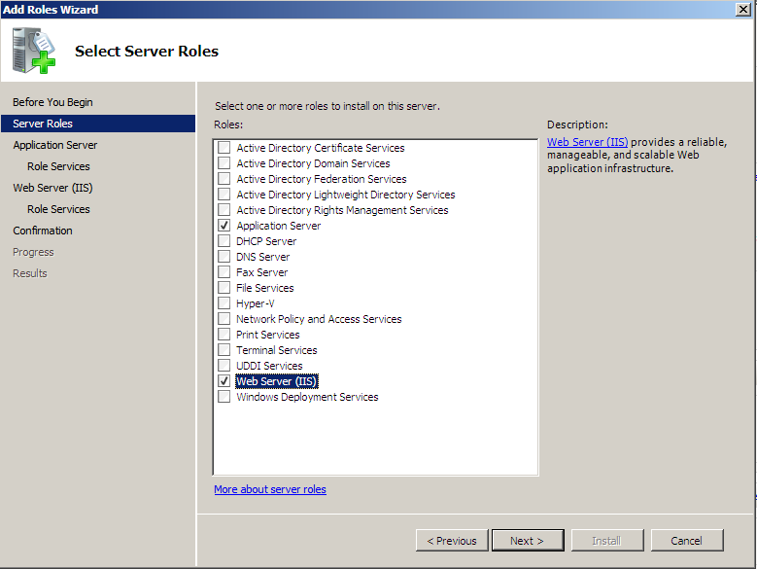

**Click Next**

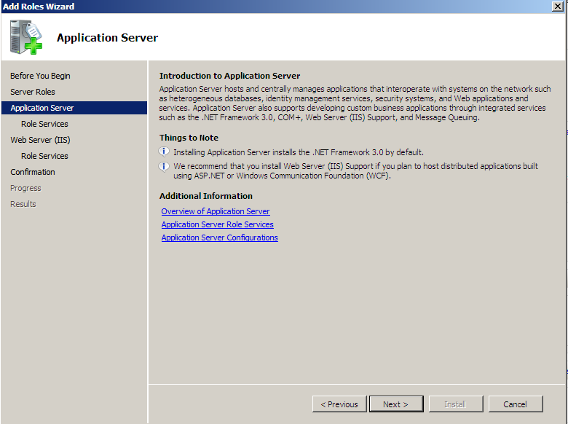

**Click Next**

**Add Web Server (IIS) Support**

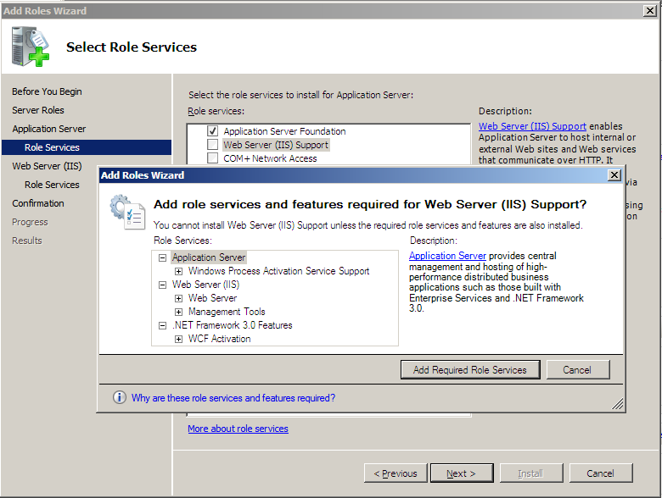

**Click Add Required Roles Services**

**Add COM+Network Access**

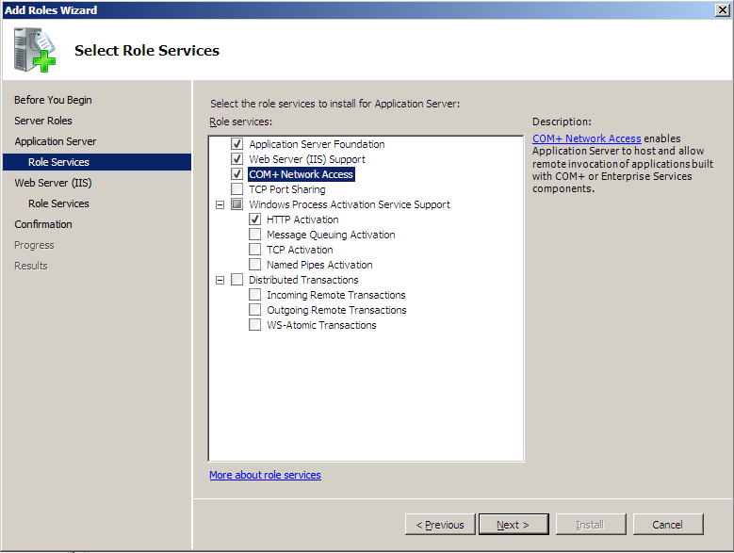

**Add TCP Activation and click on add required Role services**

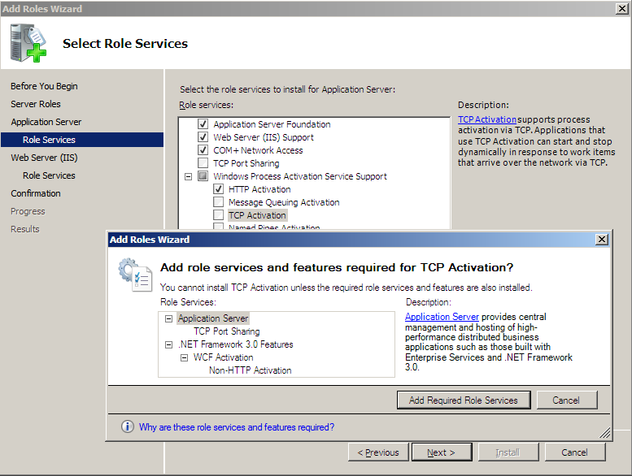

**Add Named Pipes Activation**

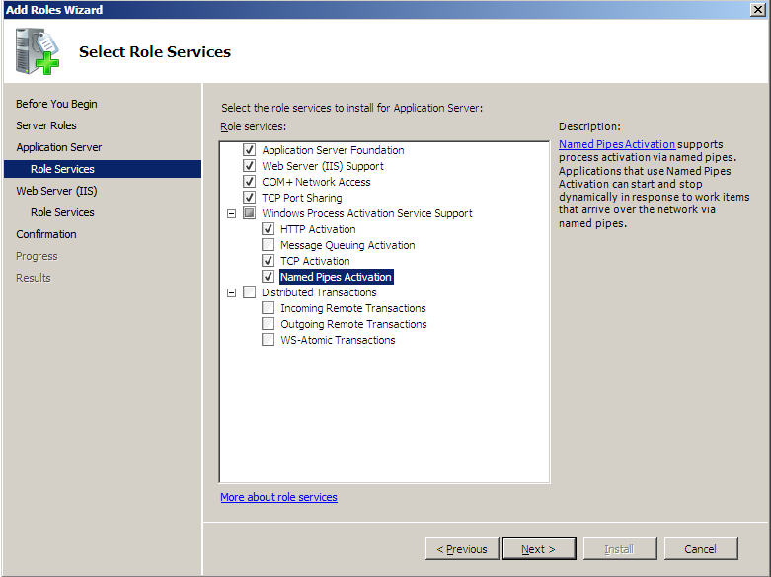

**Click on Next**

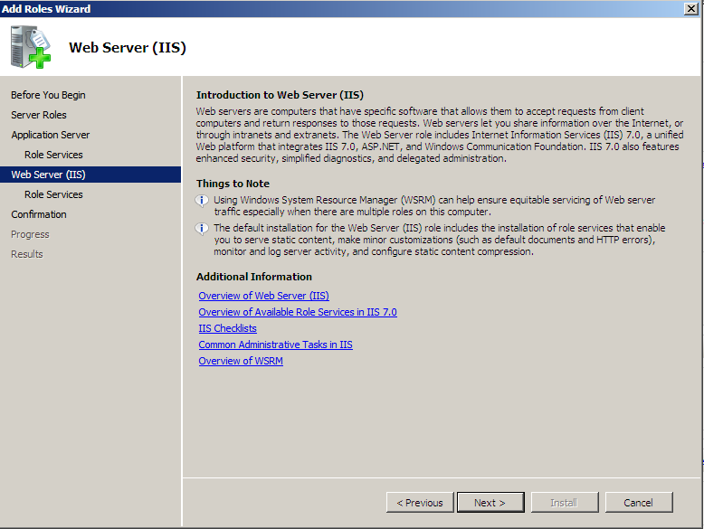

**Add Server side Includes and IIS 6management compatibility**

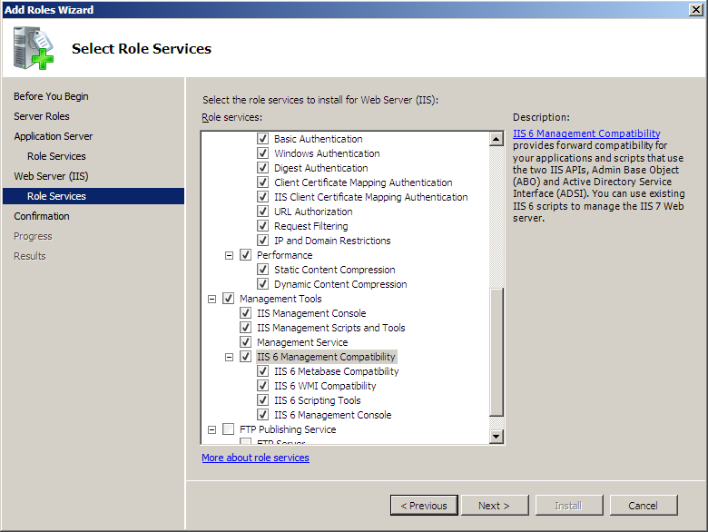

**Click Next**

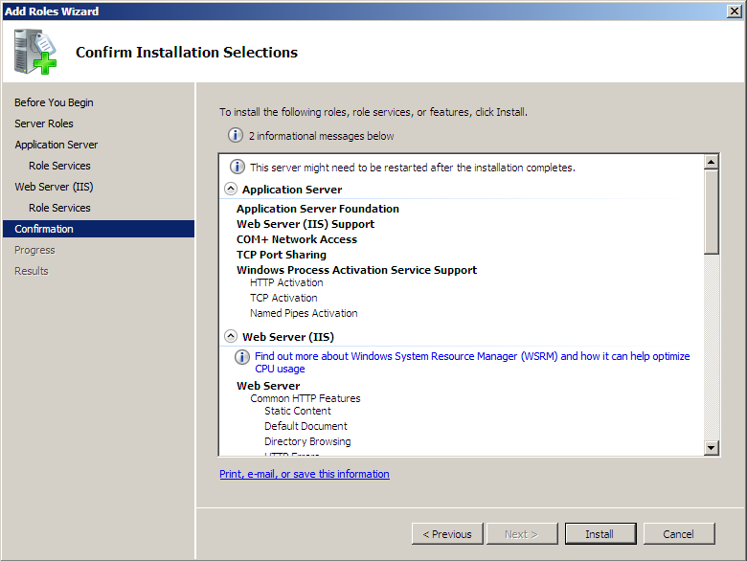

**Click on install**

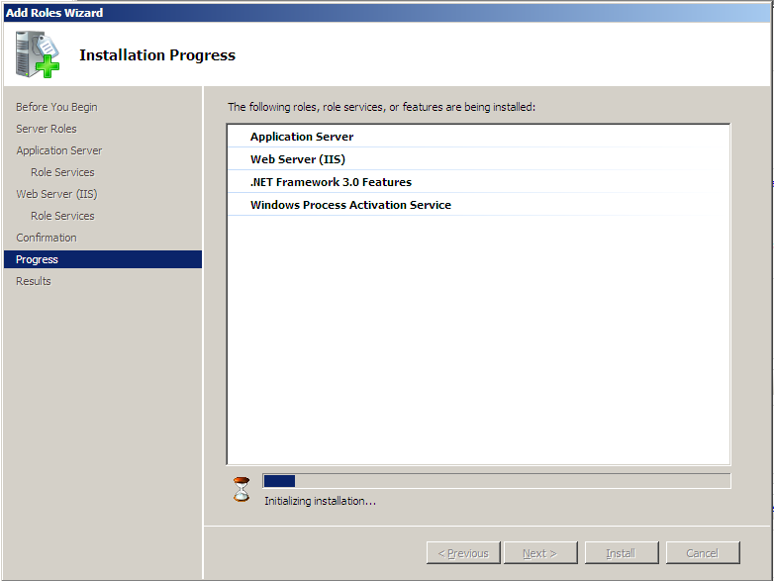

**Let the installation gets complete**

**After completion Installation results window will appear..**

**Check it to be successful.**

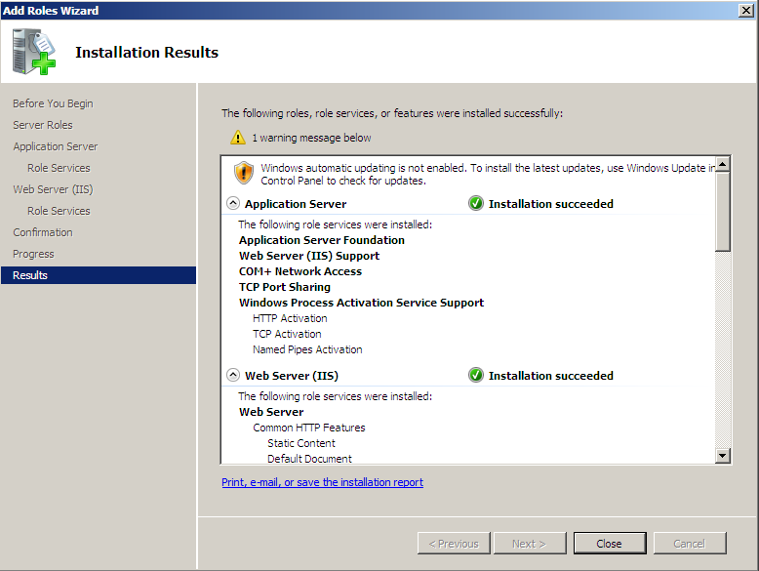

**Click Close**

**IIS and Application Roles has been configured successfully.**

**STEP 3:** Install SQL SERVER 2005

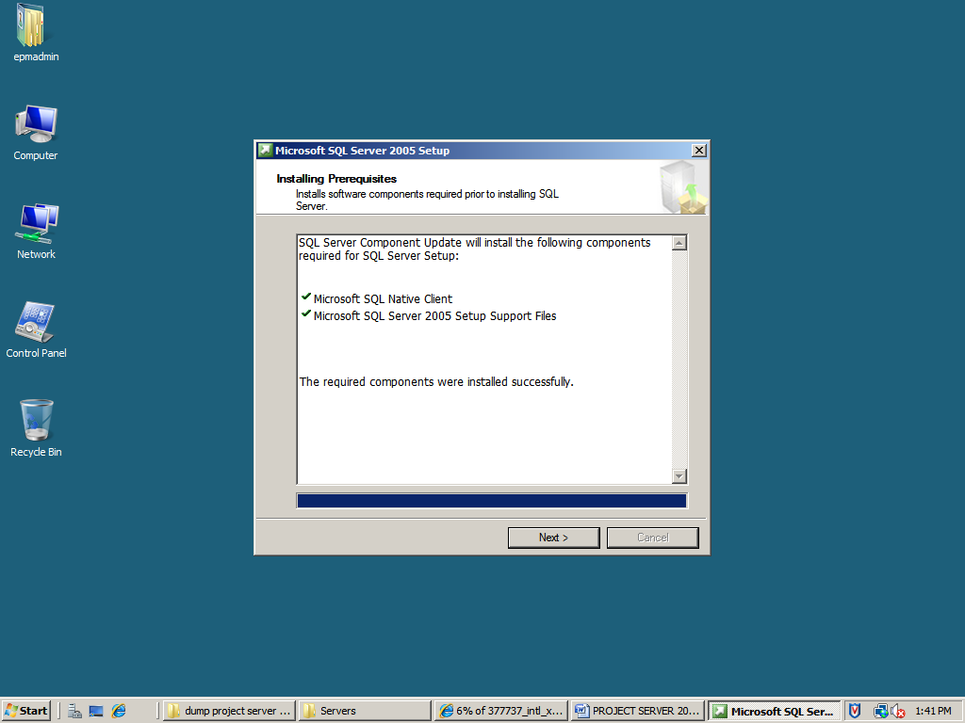

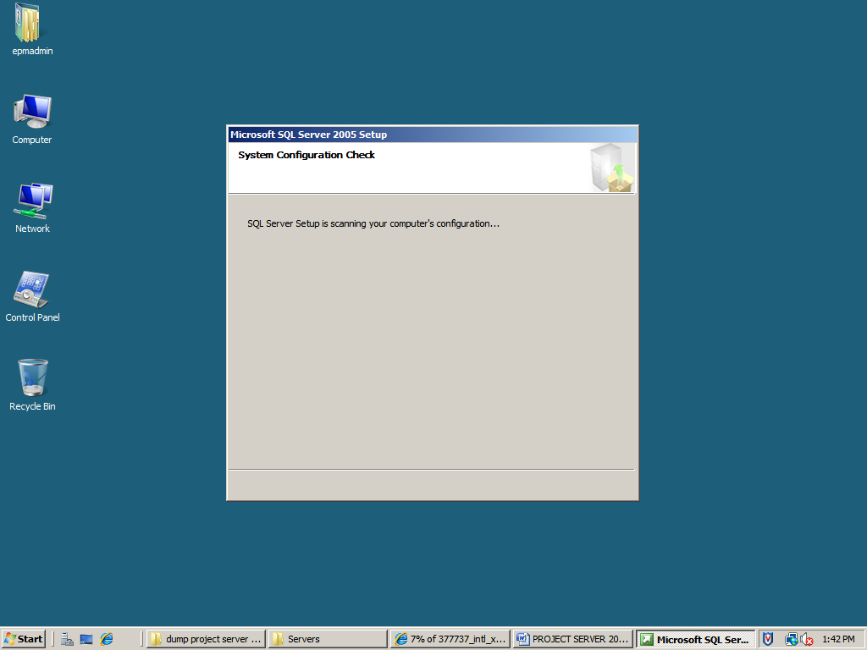

CLICK NEXT

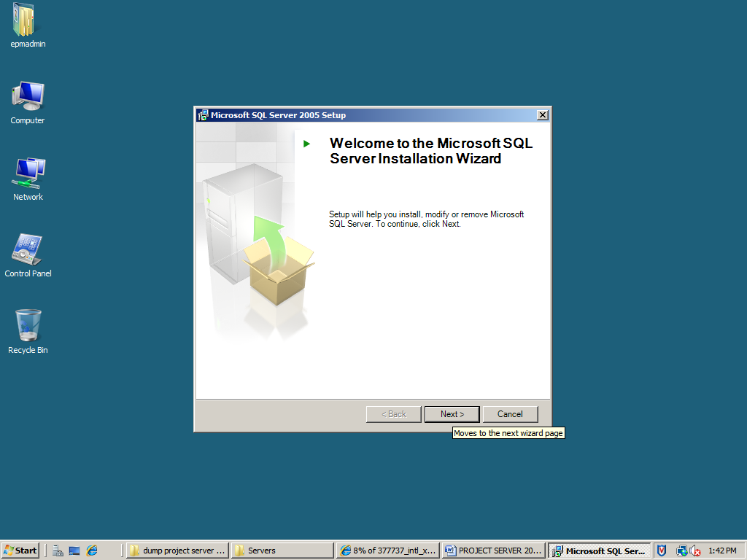

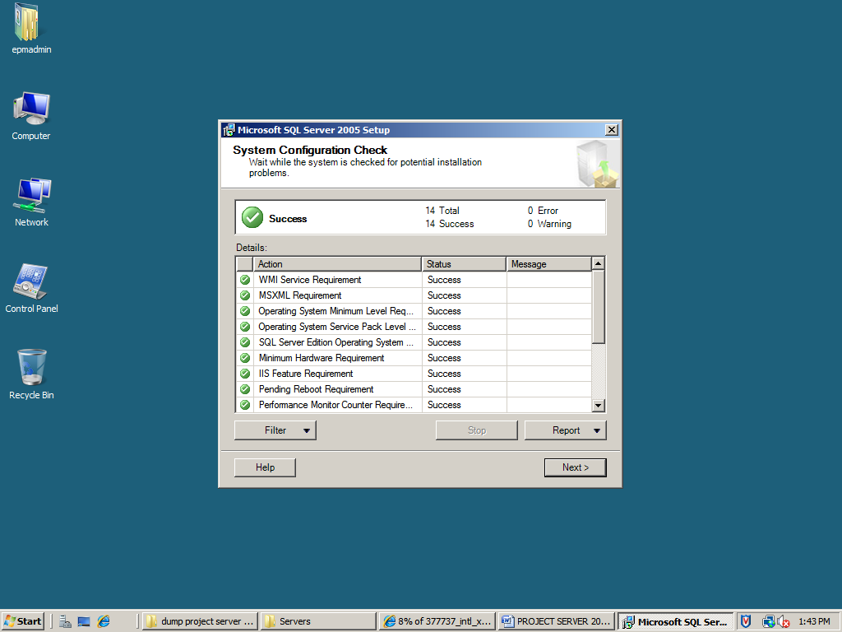

Click next

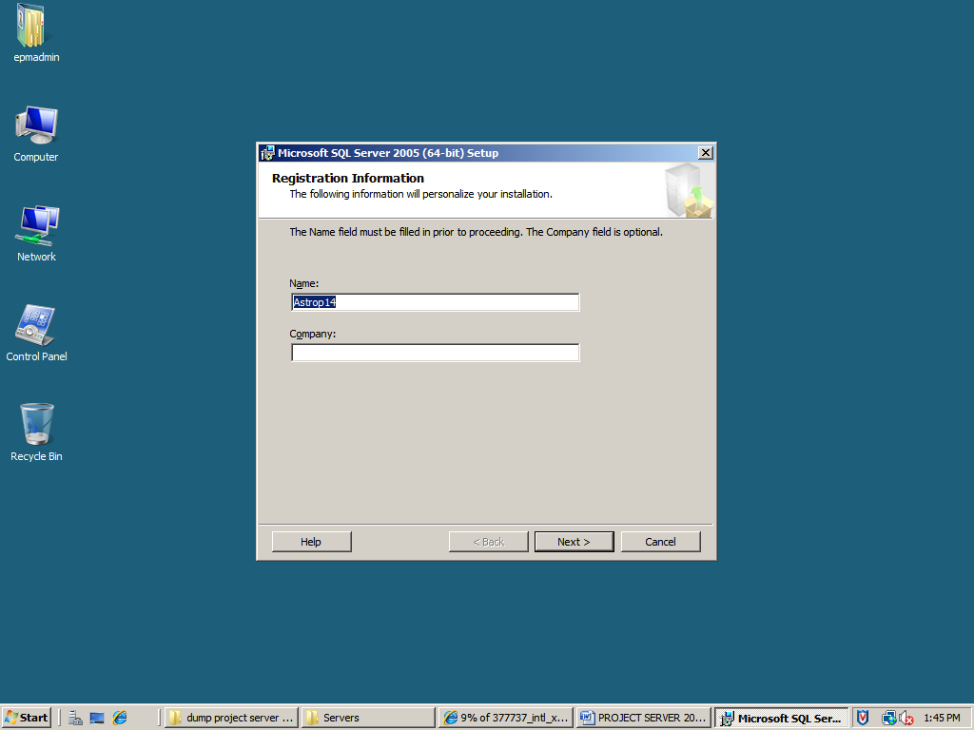

Add name (ASTROP14) and Company name (AWX) click next

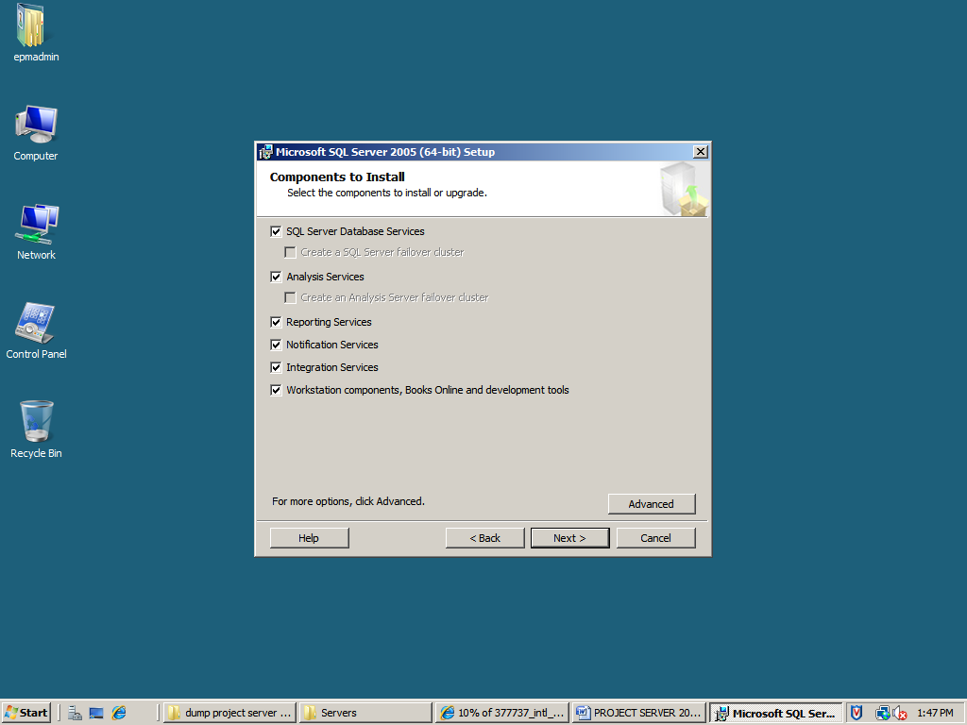

Add all the components: Database Services, Analysis Services, Reporting Services, Notification Services, Integration Services and Workstation Components. Click Next

Choose Default Instance and click next

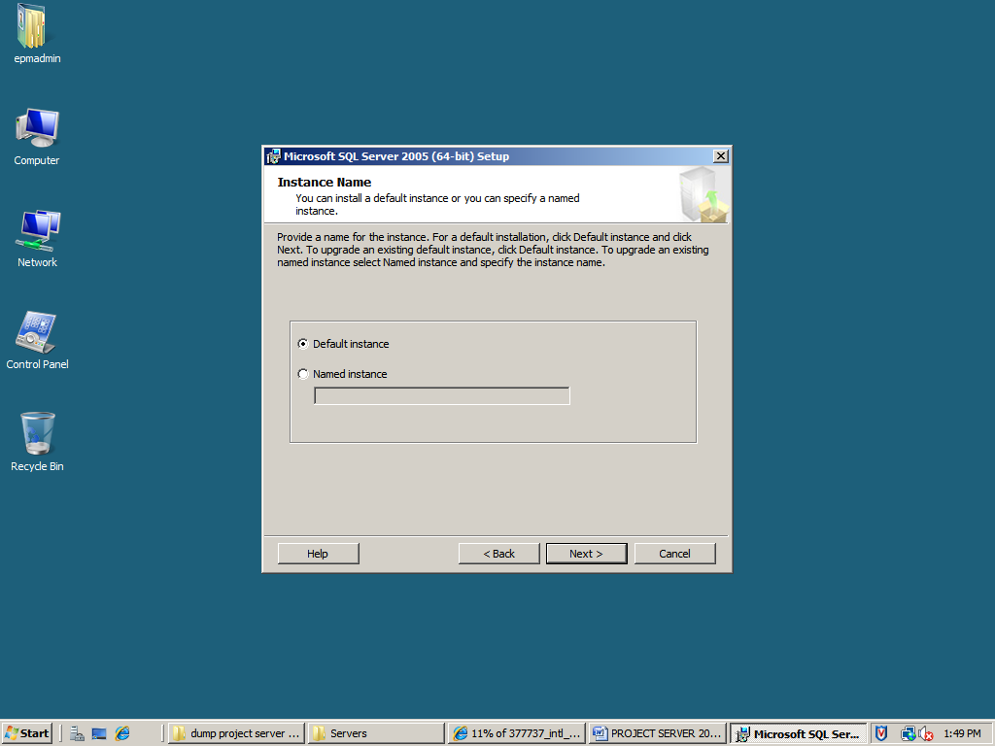

Pass the credentials (User Name, Password, and Domain) and check the services which need to be started at the end of the set up. Click next.

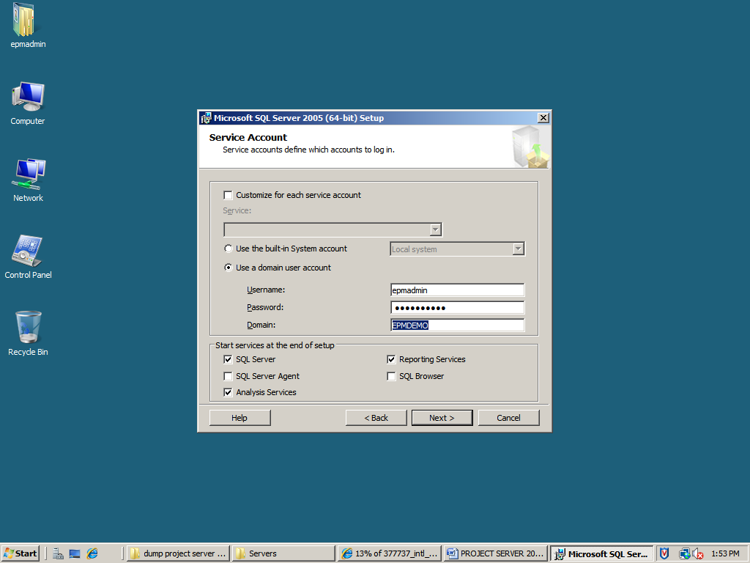

Choose Mixed Mode and pass the password.

Click Next

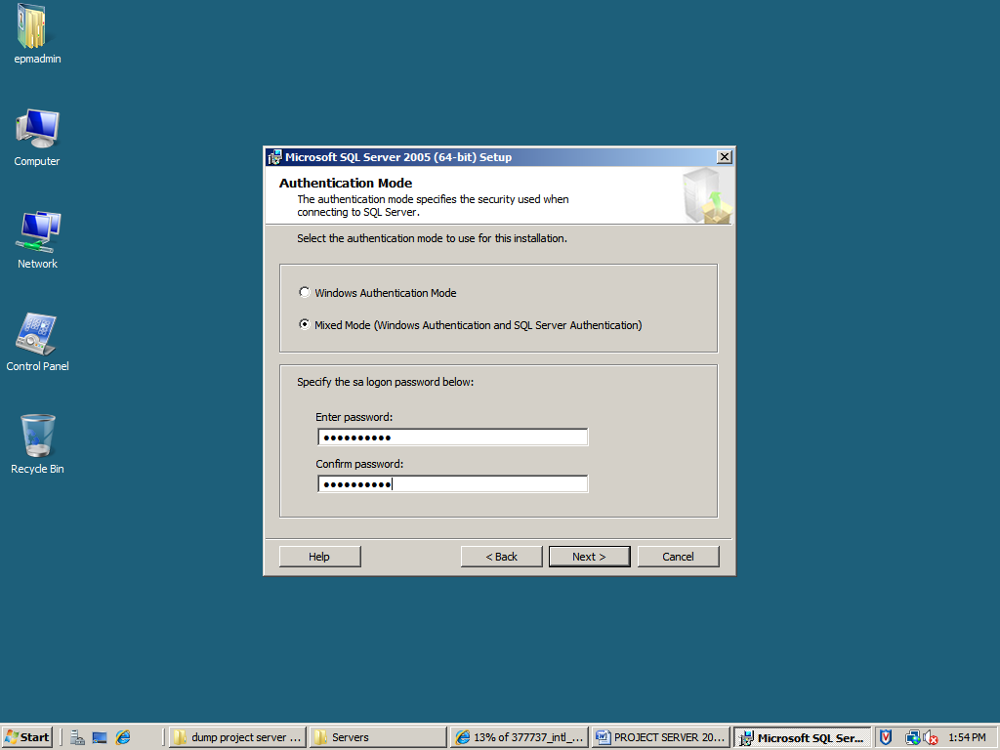

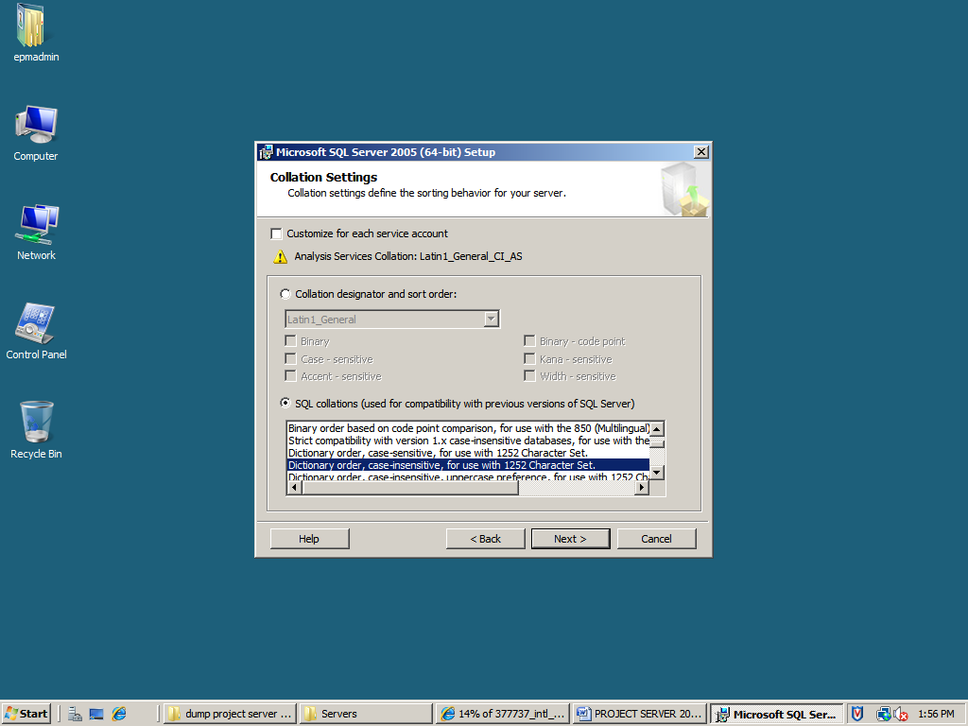

Click next

Opt for Install default configuration

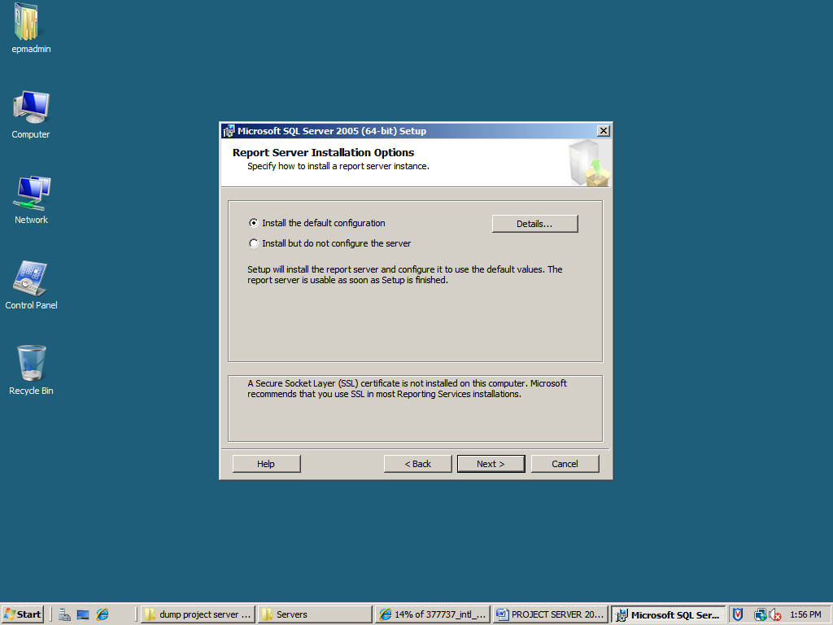

Click next

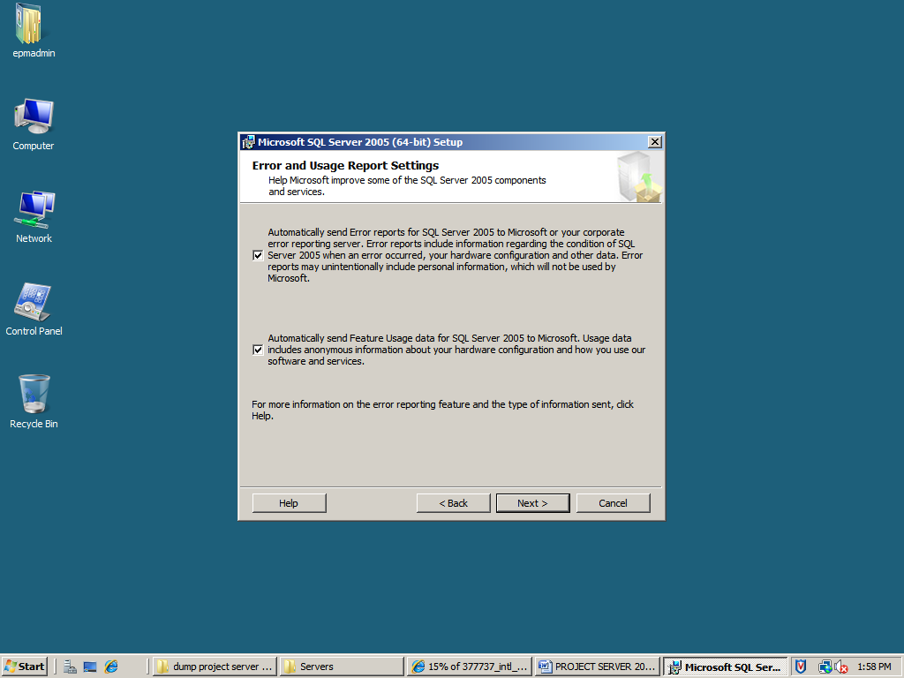

Click Next

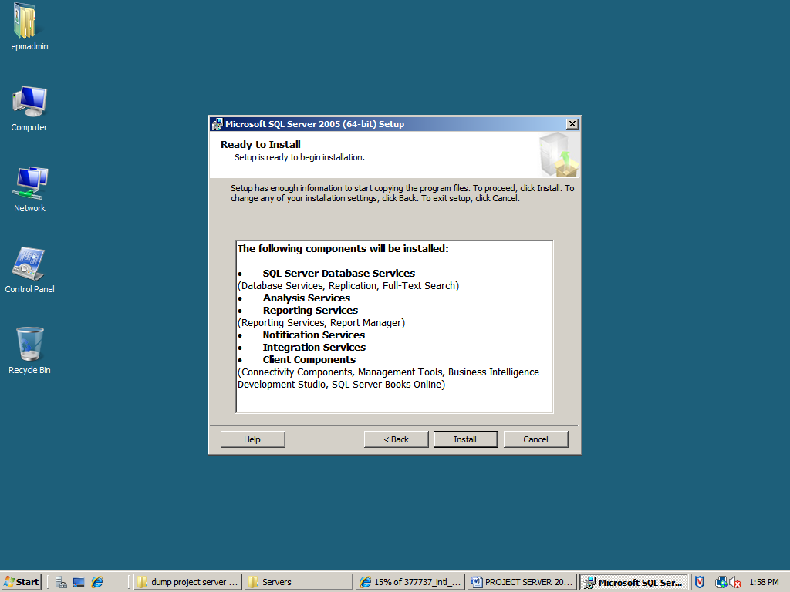

Click Install

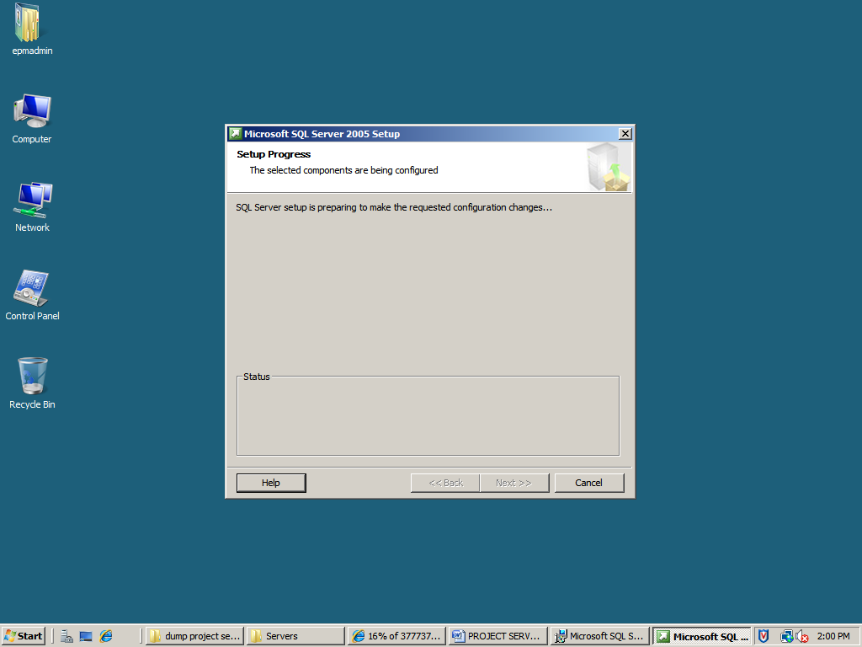

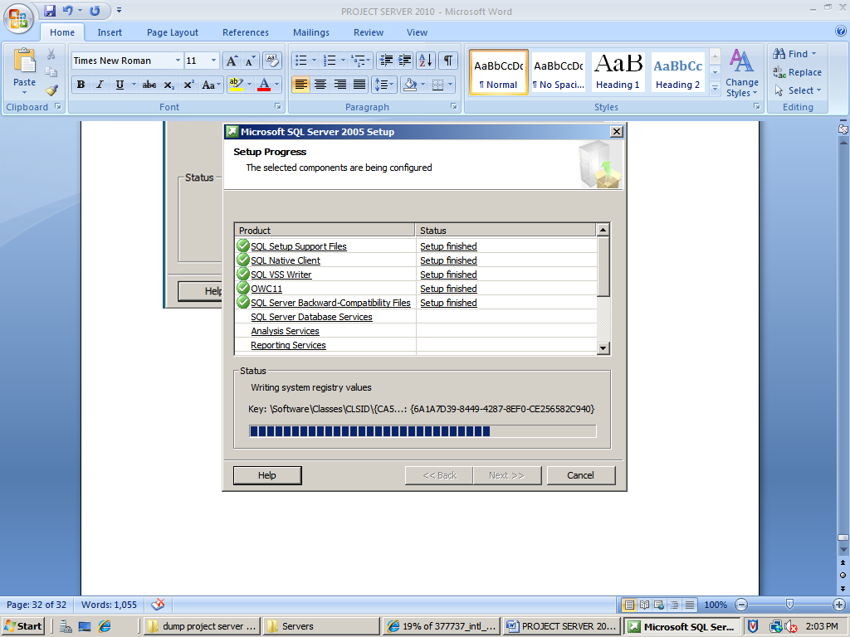

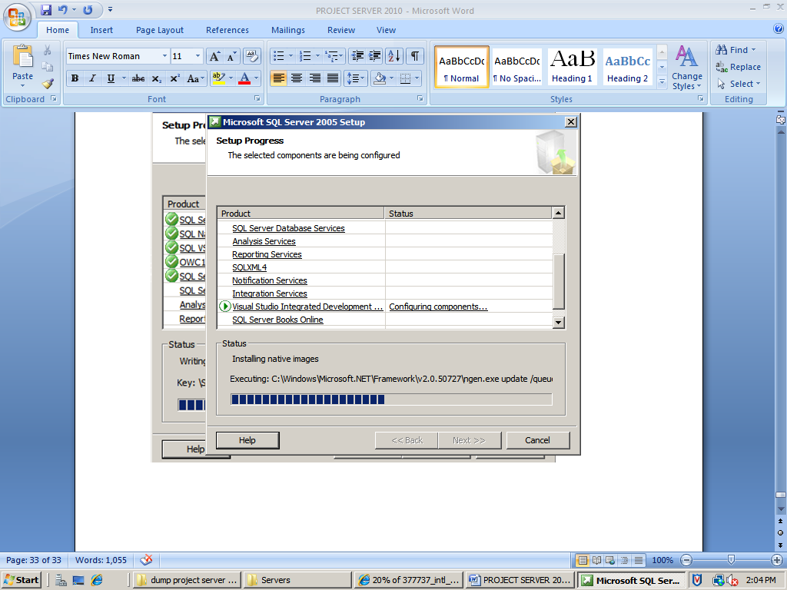

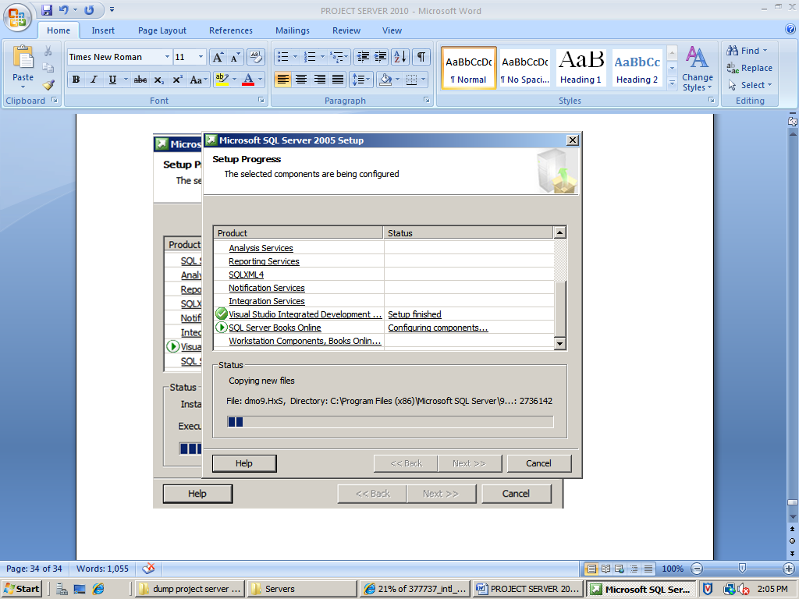

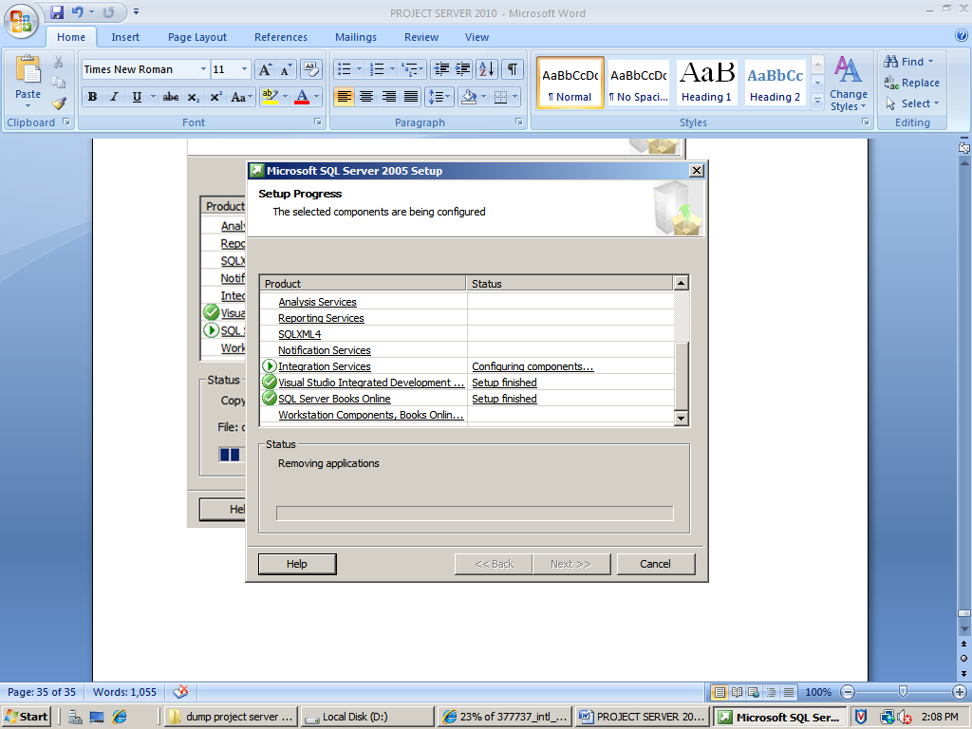

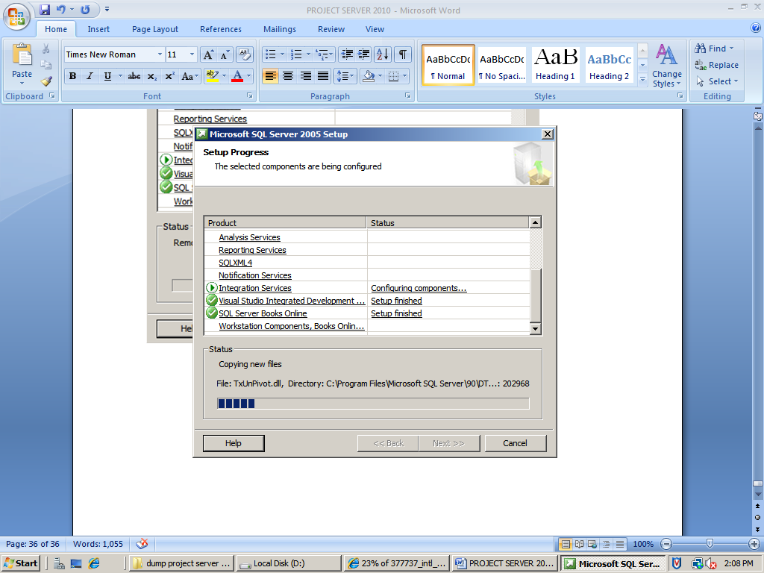

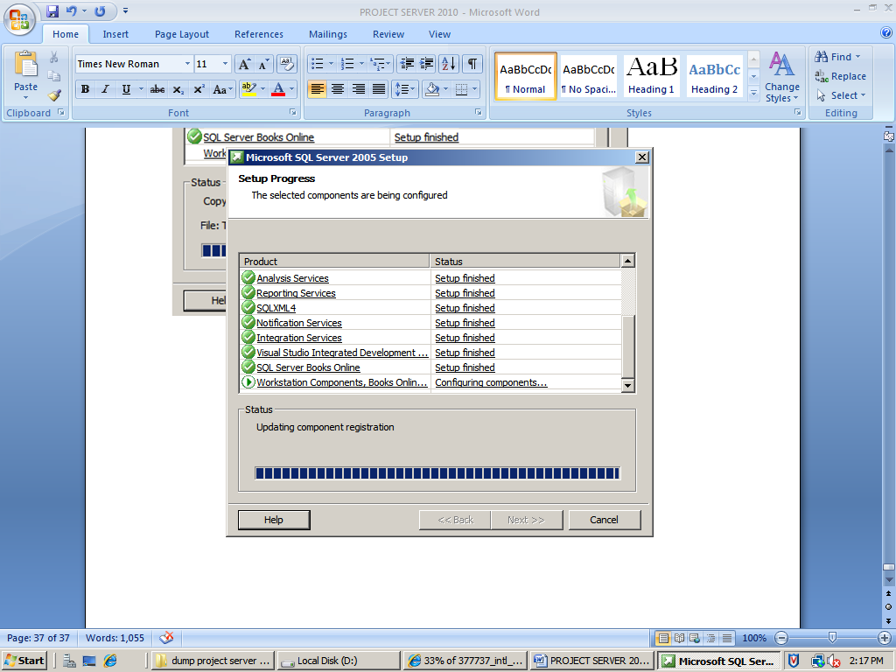

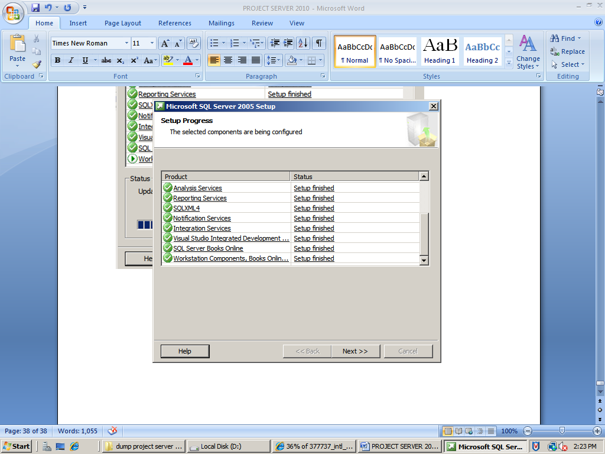

Click next

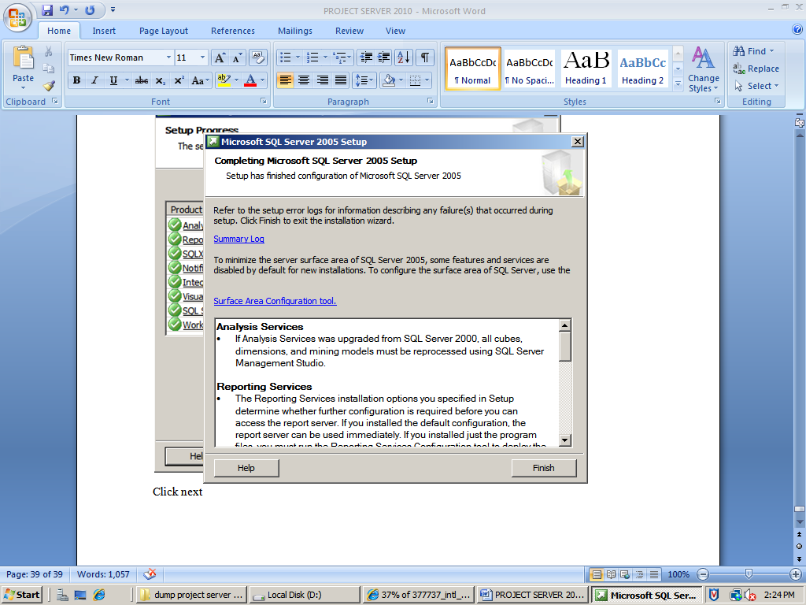

Click finish

Now Install SQL SERVER SERVICE PACK 3

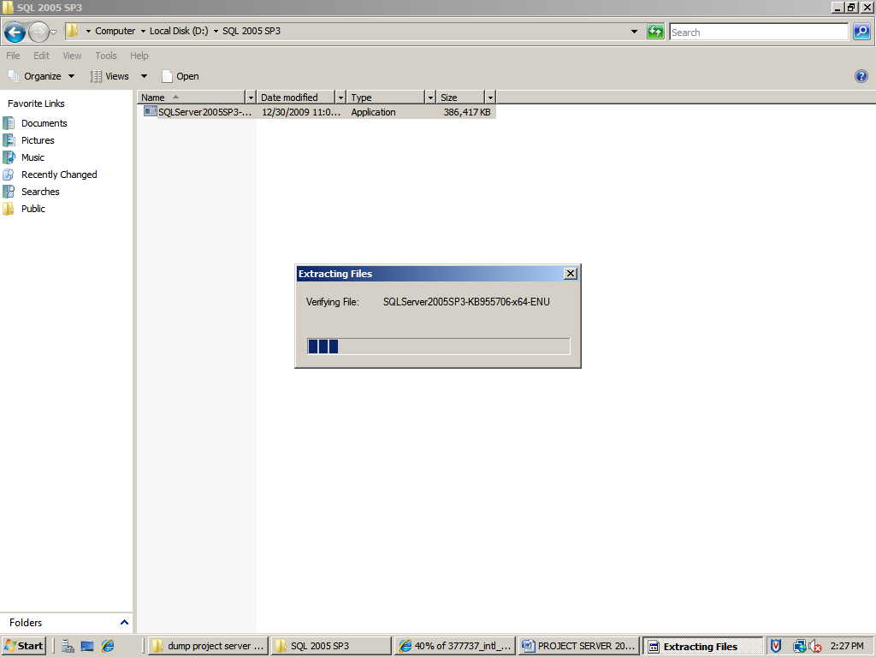

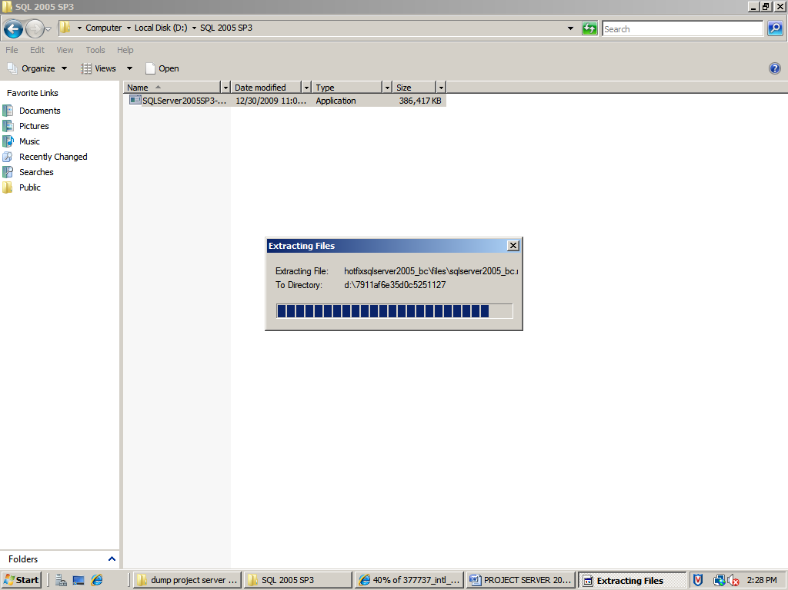

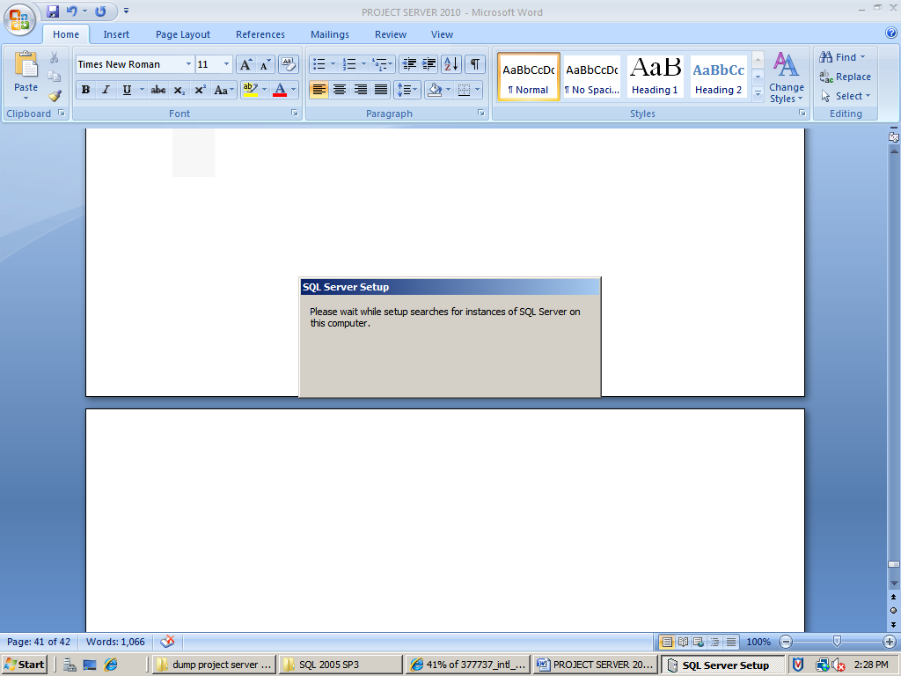

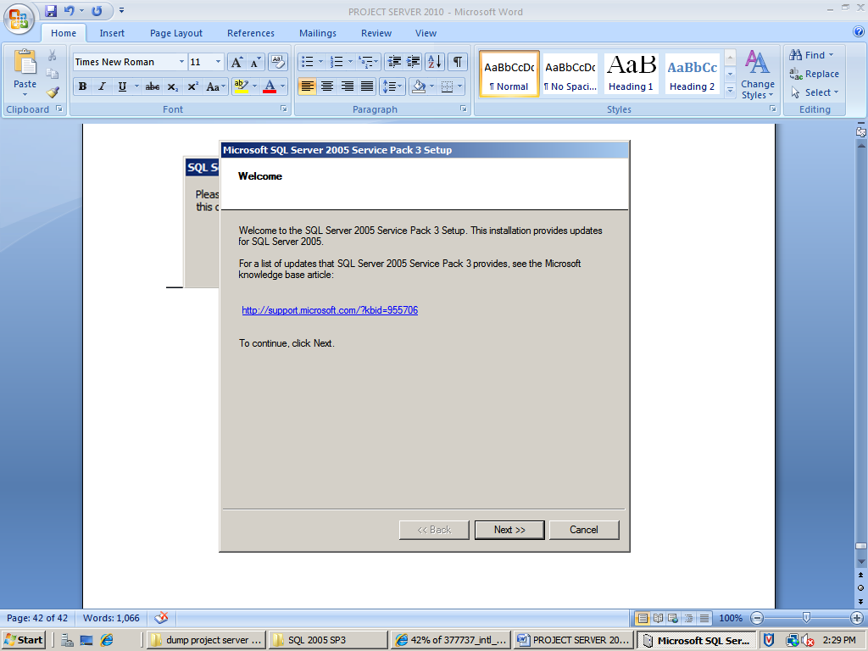

Click next

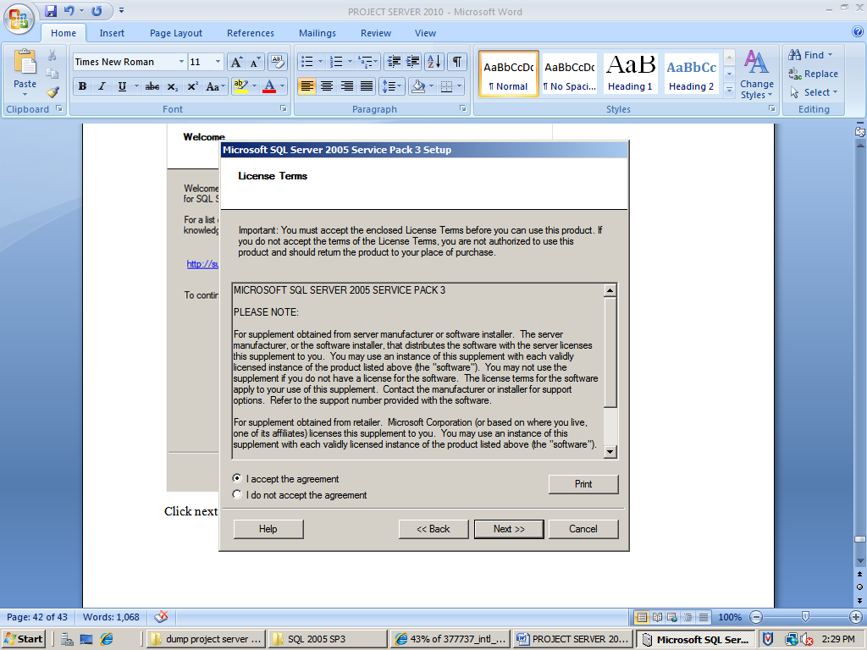

Click next

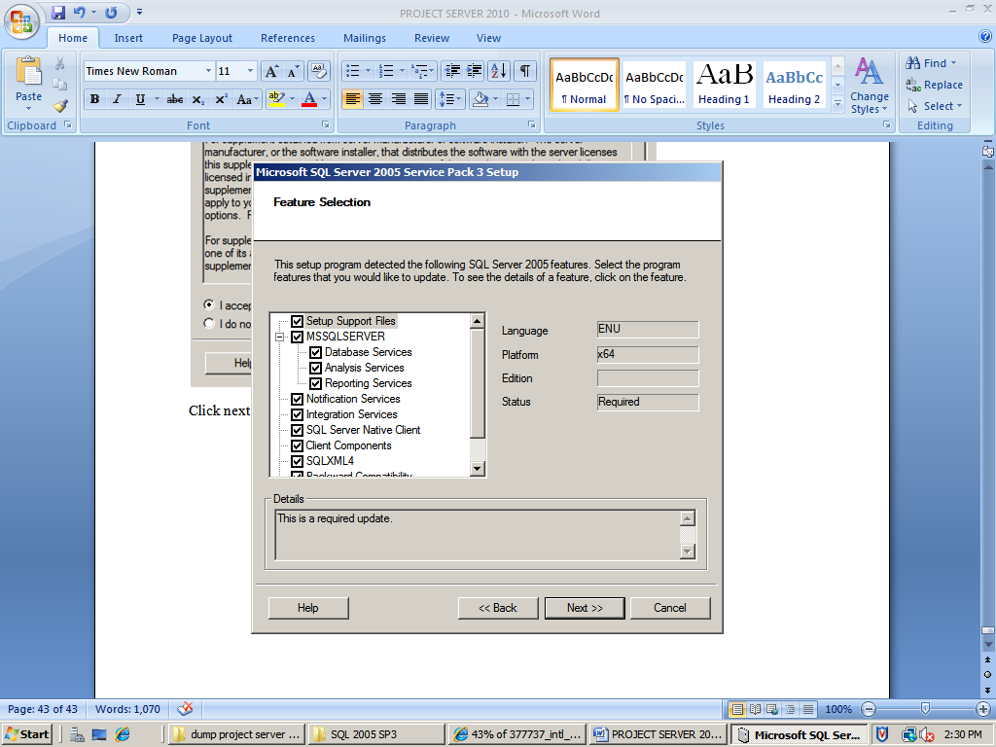

Click next and Use Windows Authentication

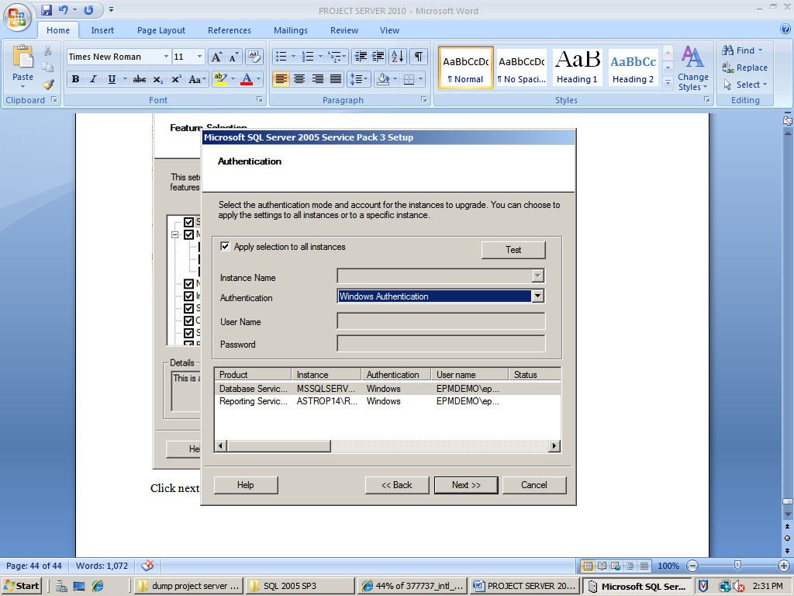

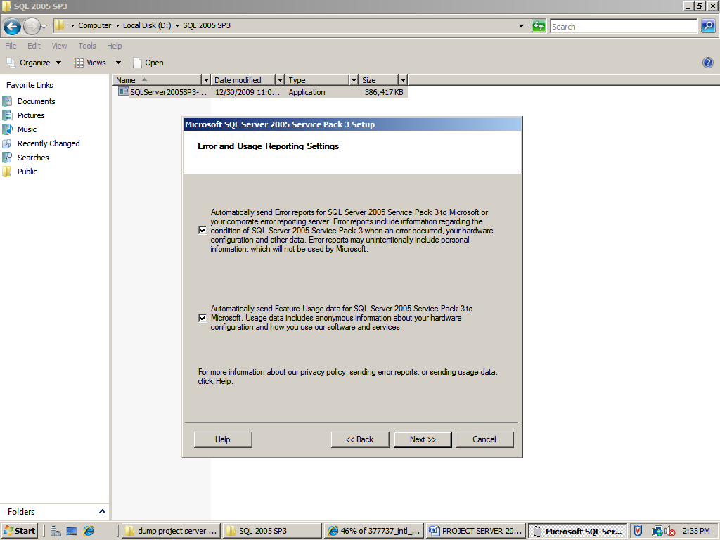

Click next

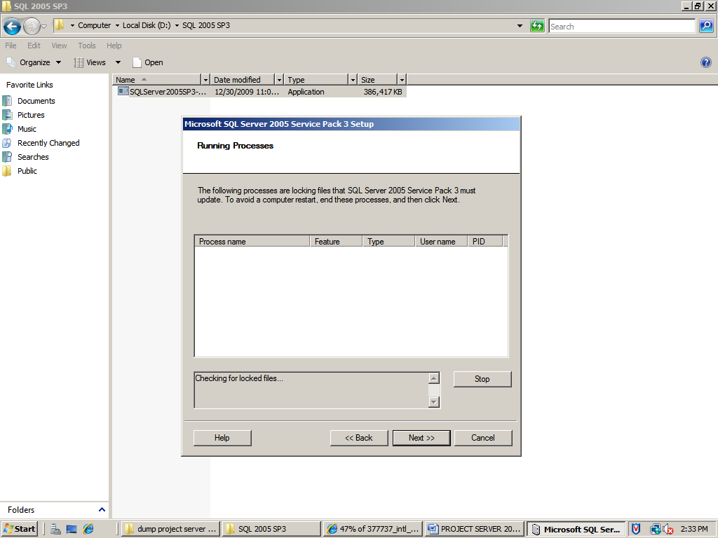

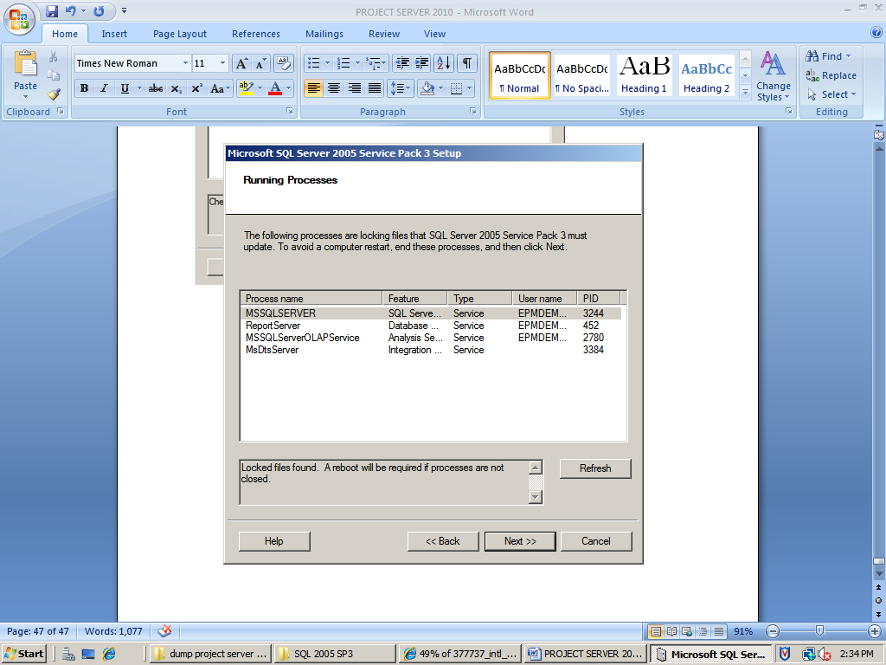

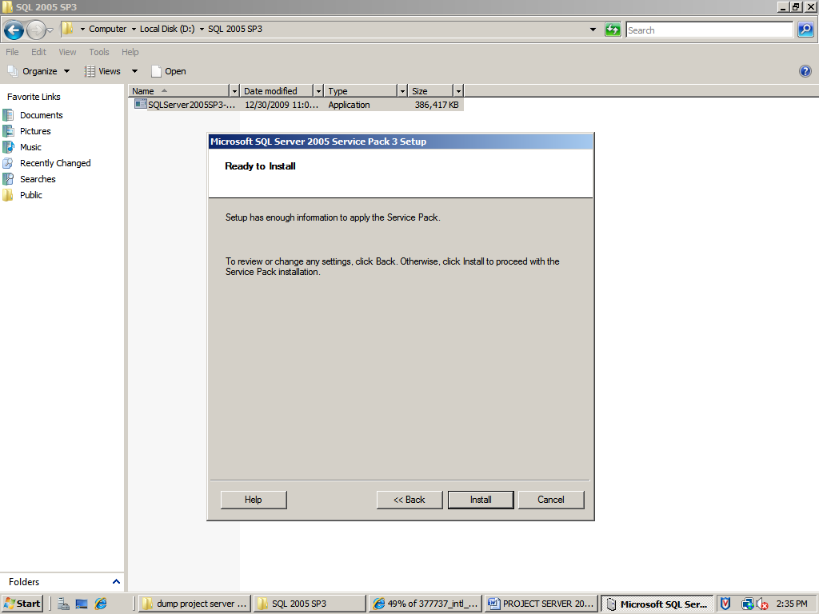

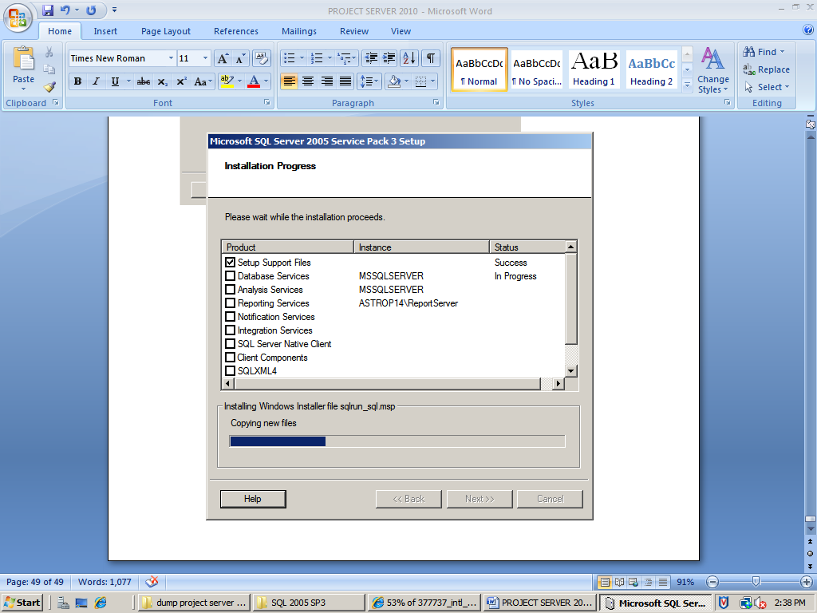

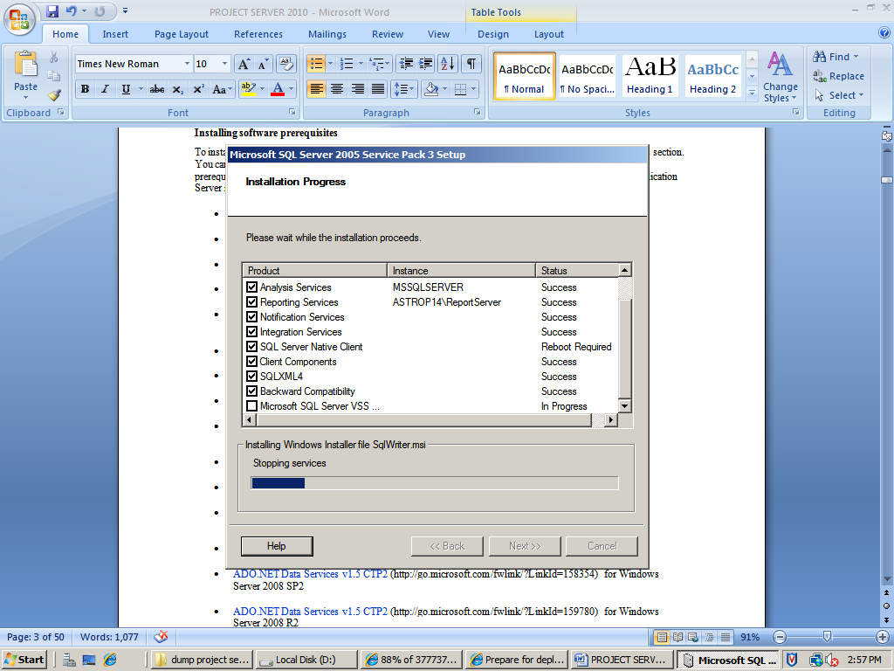

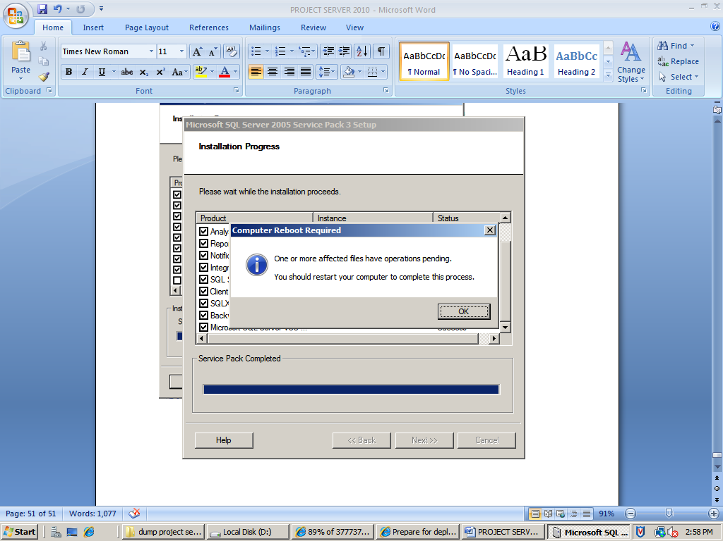

Click ok and next

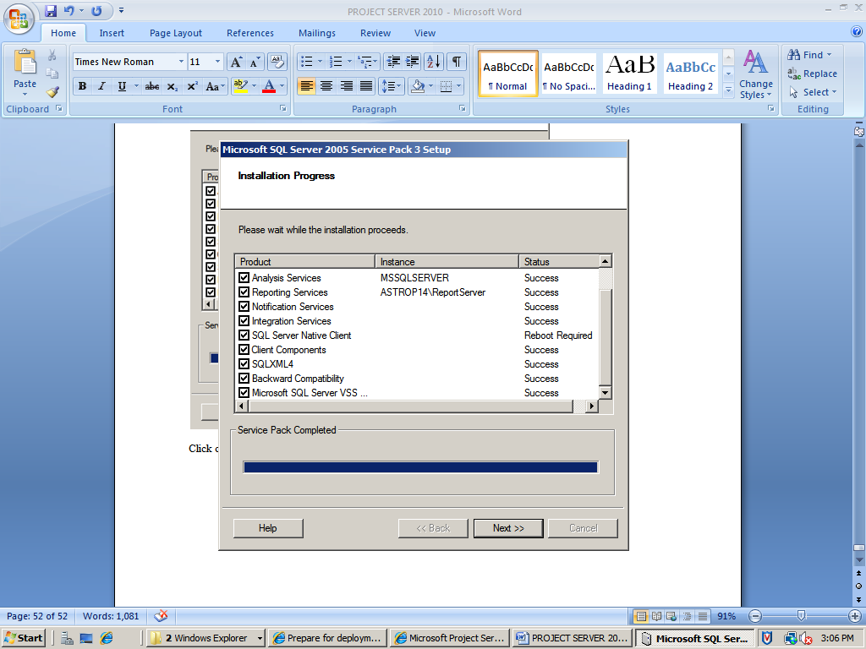

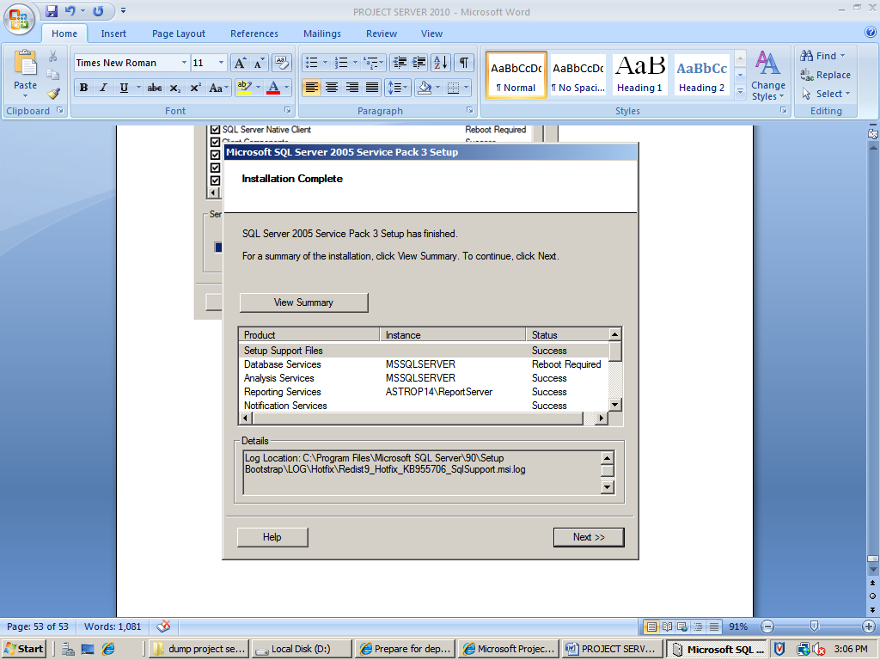

Click next

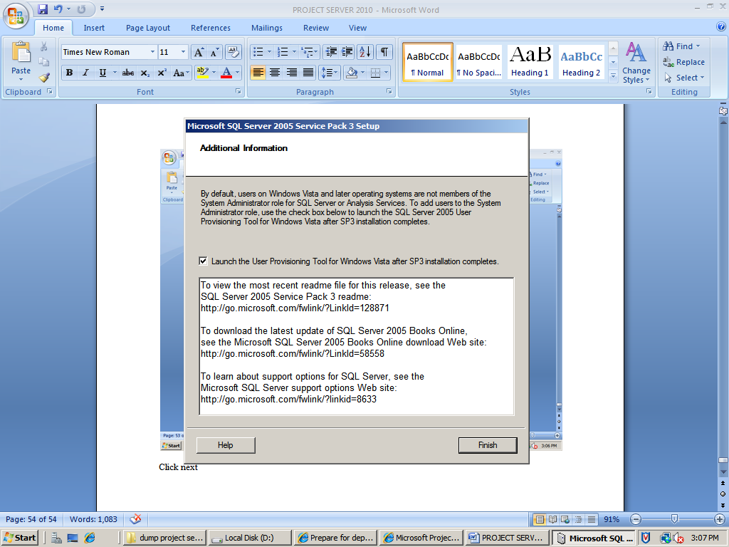

Click finish

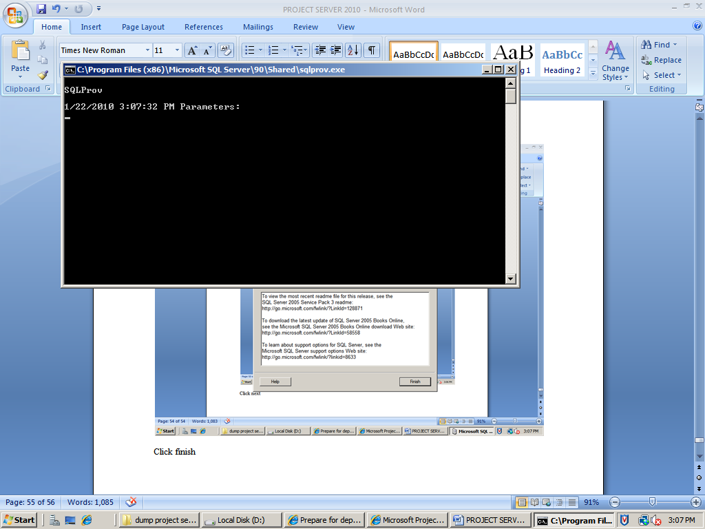

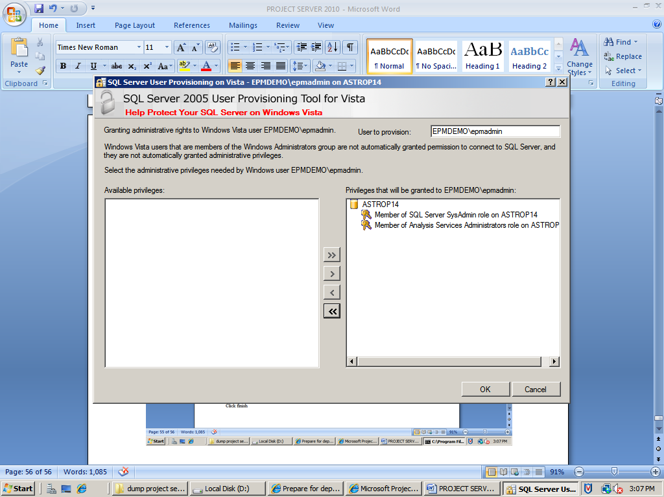

Add the privileges and click ok

INSTALL CUMMULATIVE UPDATE 3 FOR SQL SERVER 2005 SERVICE PACK 3

RUN the Setup (SQLServer2005-KB967909-x64-ENU)

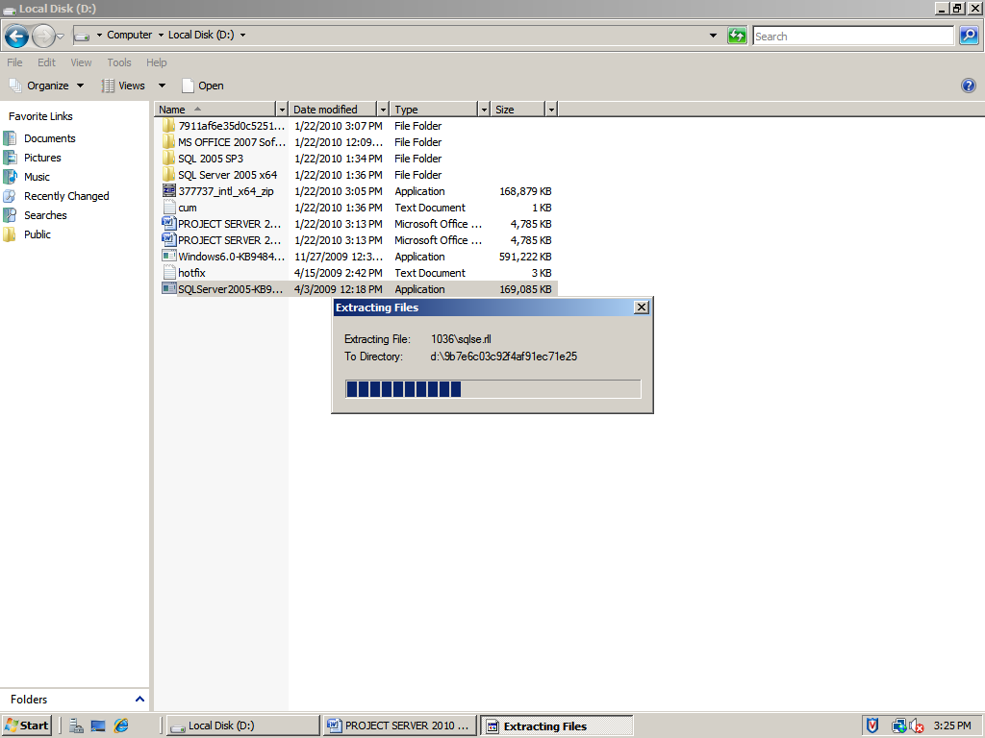

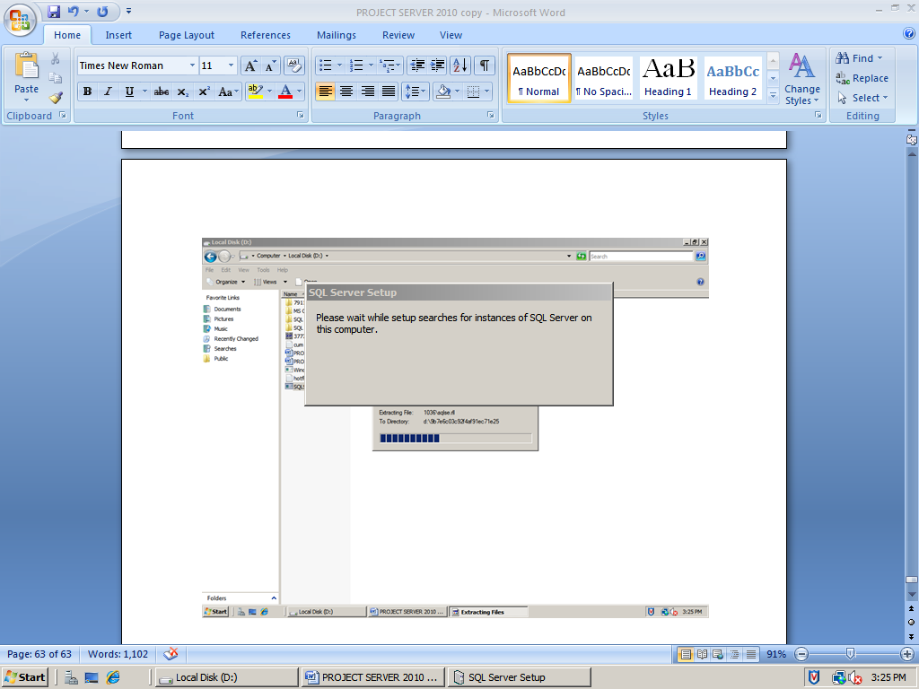

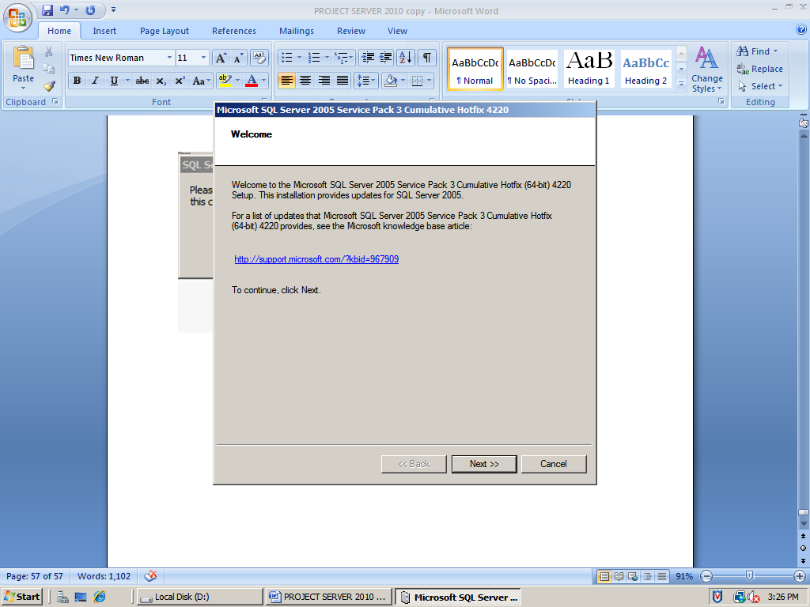

Click next

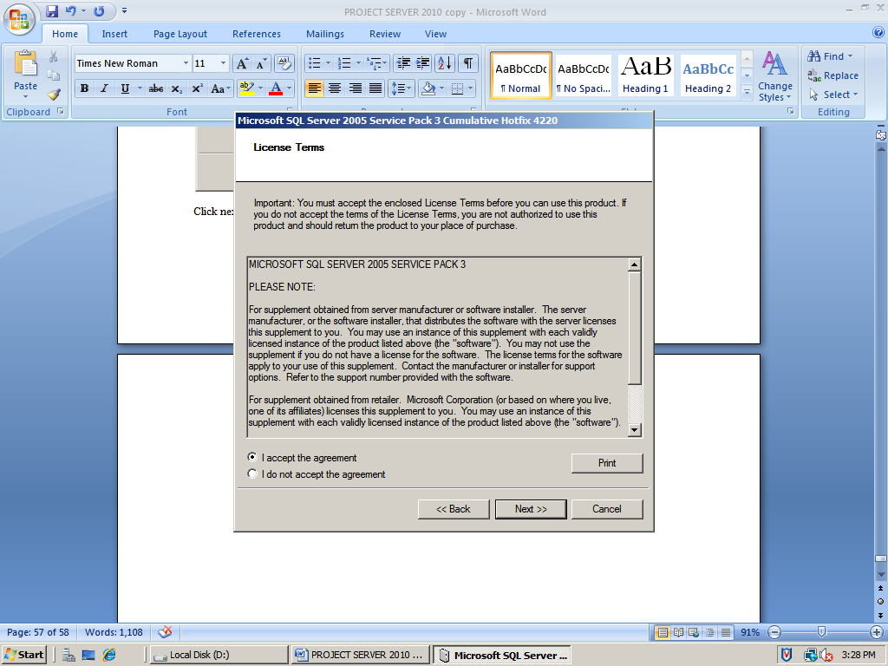

Accept and click next

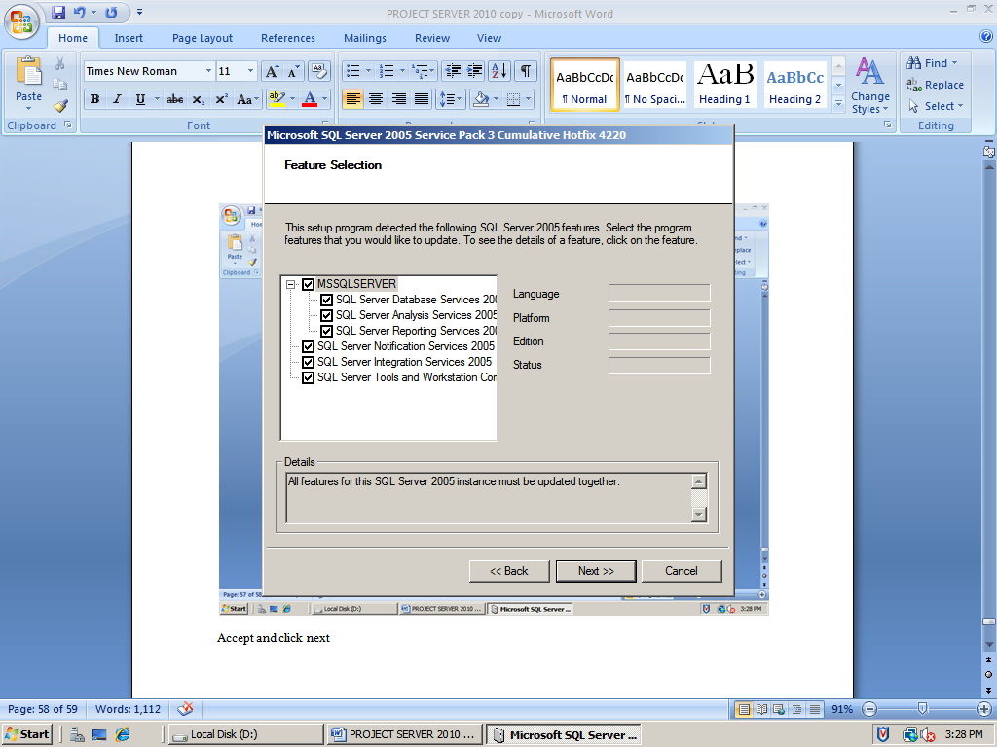

Click next

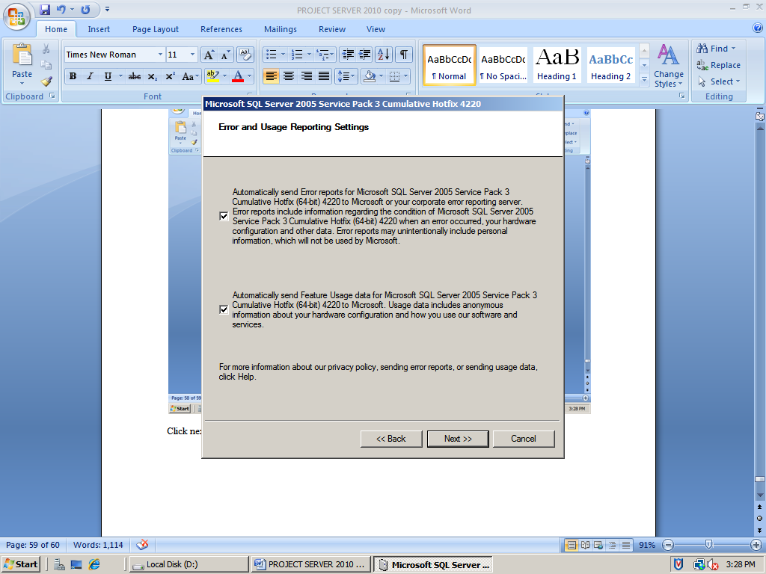

Click next

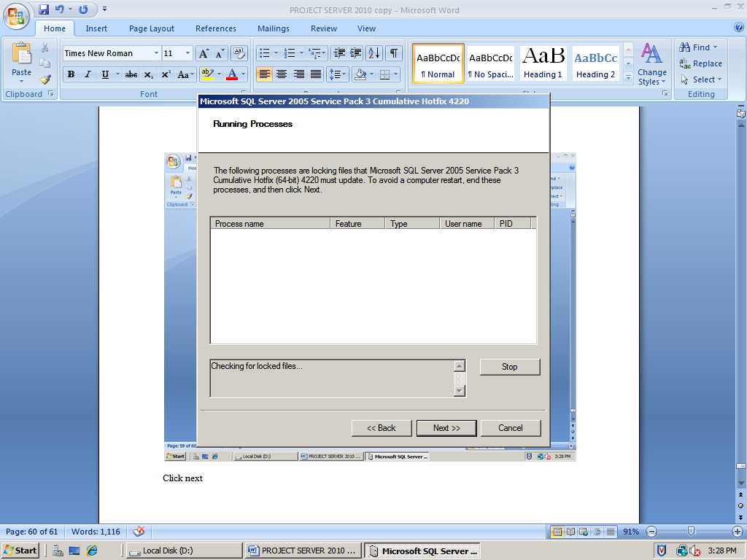

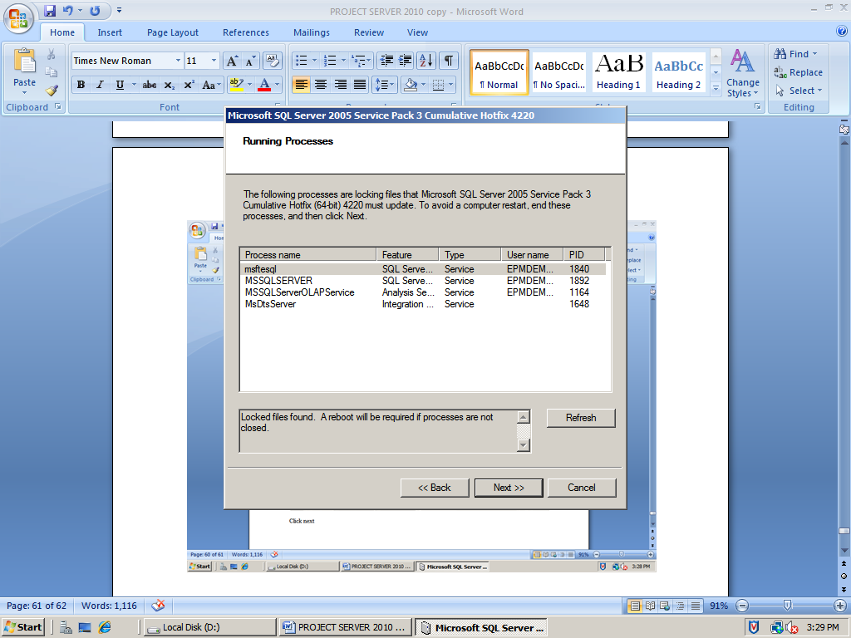

Click next

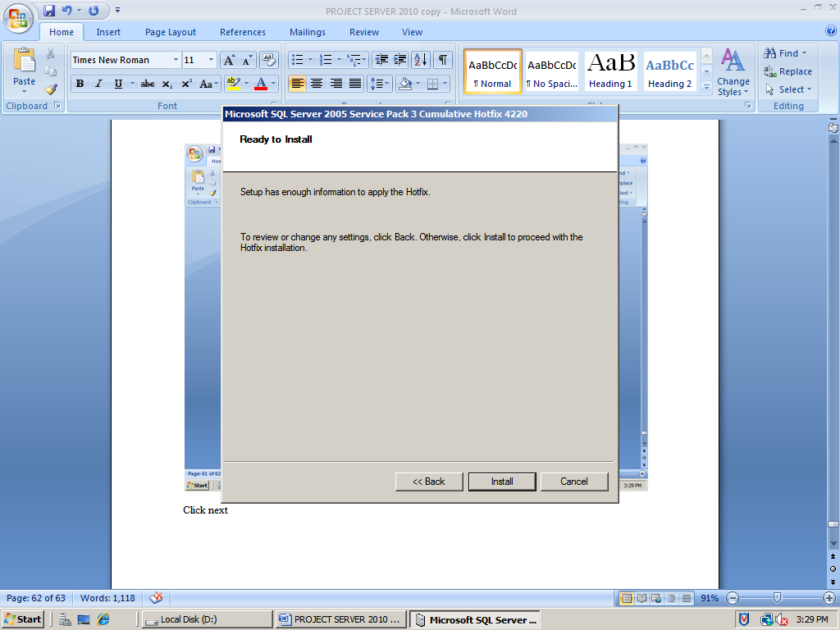

Click install

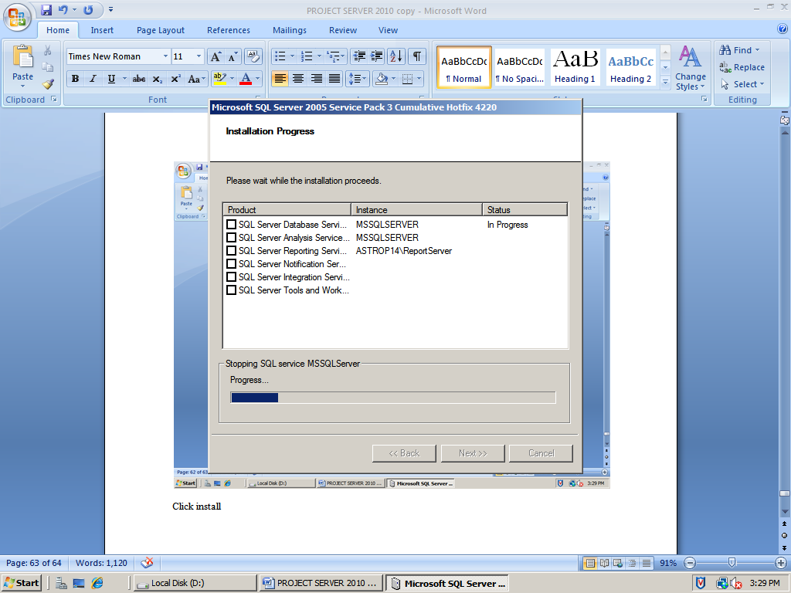

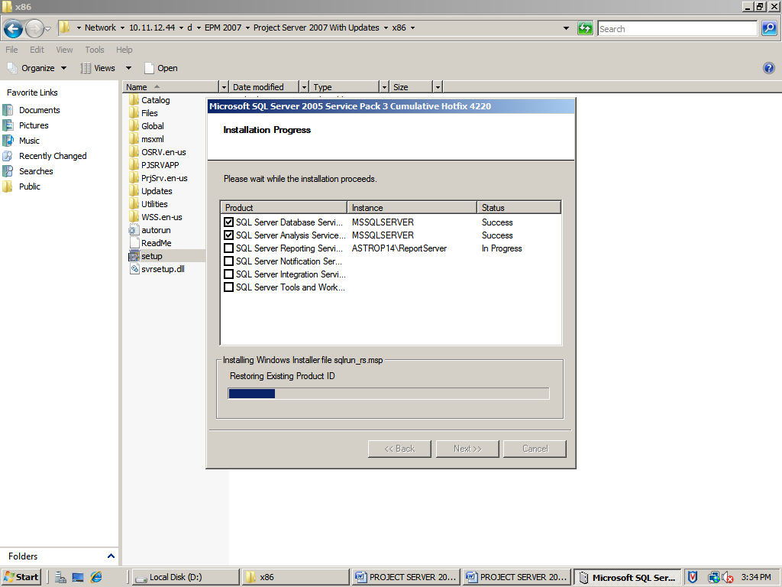

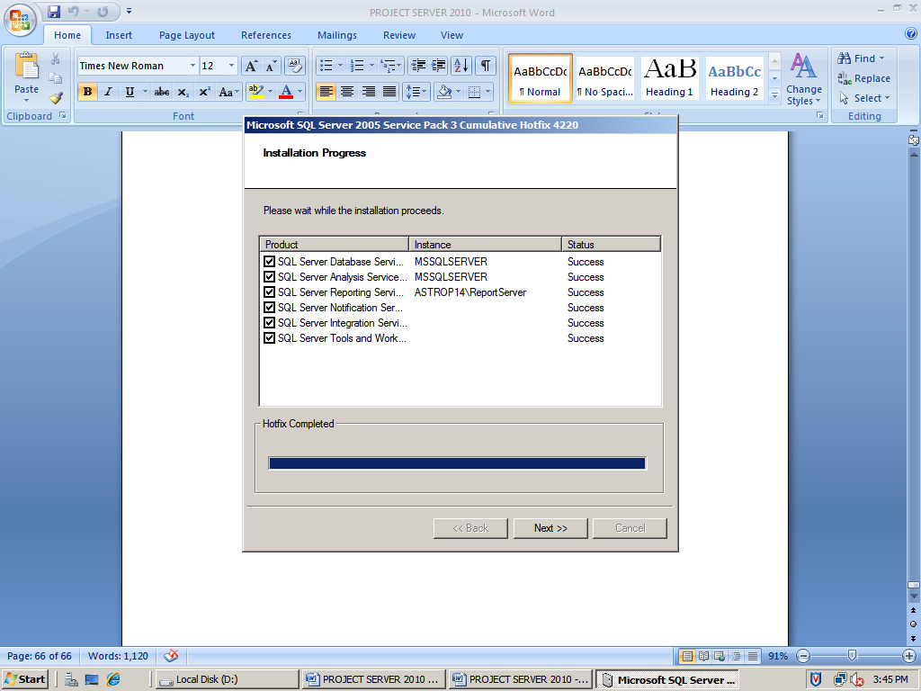

Click next

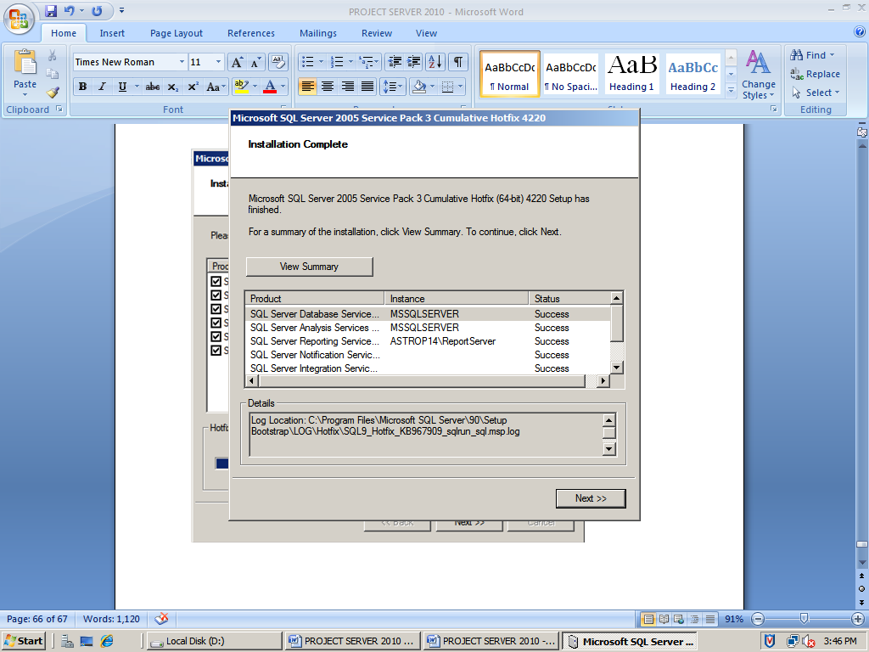

Click next

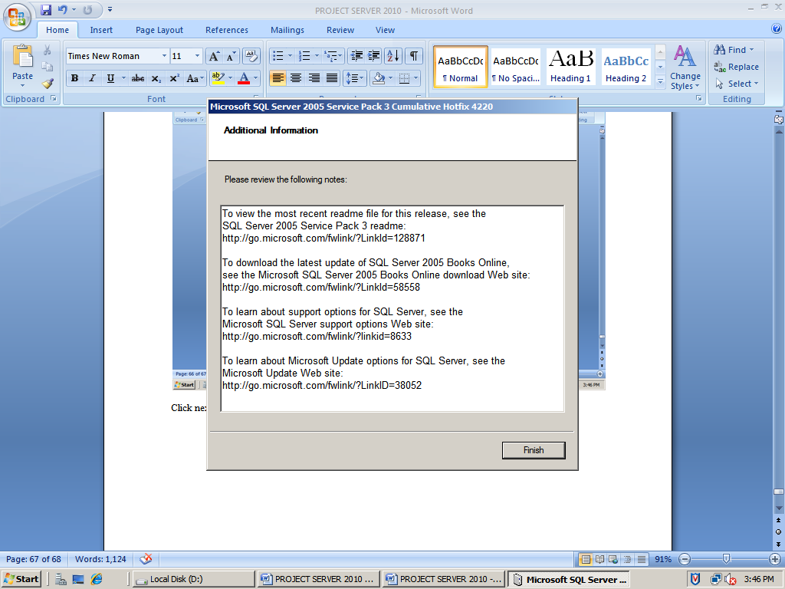

Click finish

# **Configure SQL Server network settings**

For Microsoft Project Server 2010 to work correctly, the associated instance of SQL Server must be configured to enable remote connections using TCP/IP. This is the default configuration for SQL Server, but we recommend confirming that the configuration is correct before you install Project Server 2010.

Use one of the next two procedures, depending on your version of SQL Server.

### To configure SQL Server 2005 network settings

1. Click **Start**, click **All Programs**, click **Microsoft SQL Server 2005**, click **Configuration Tools**, and then click **SQL Server Surface Area Configuration**.

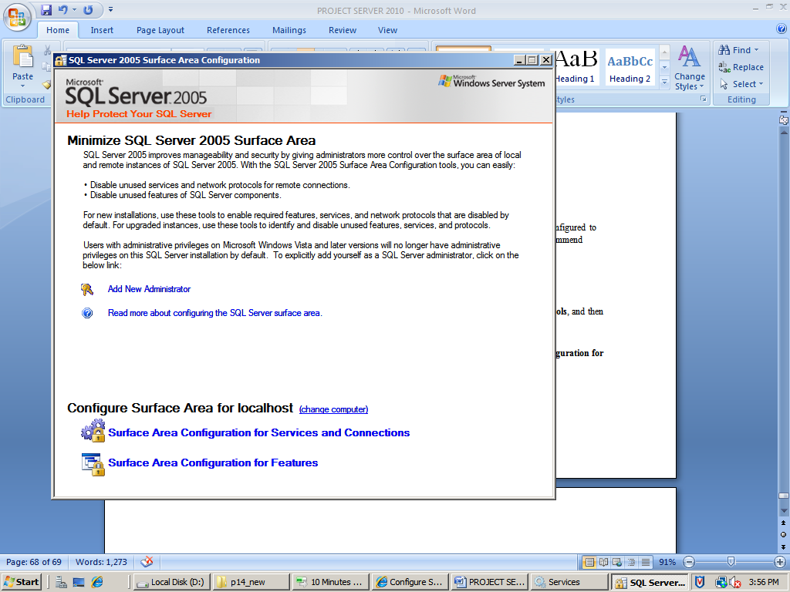

1. In the **SQL Server 2005 Surface Area Configuration** dialog box, click **Surface Area Configuration for Services and Connections**.

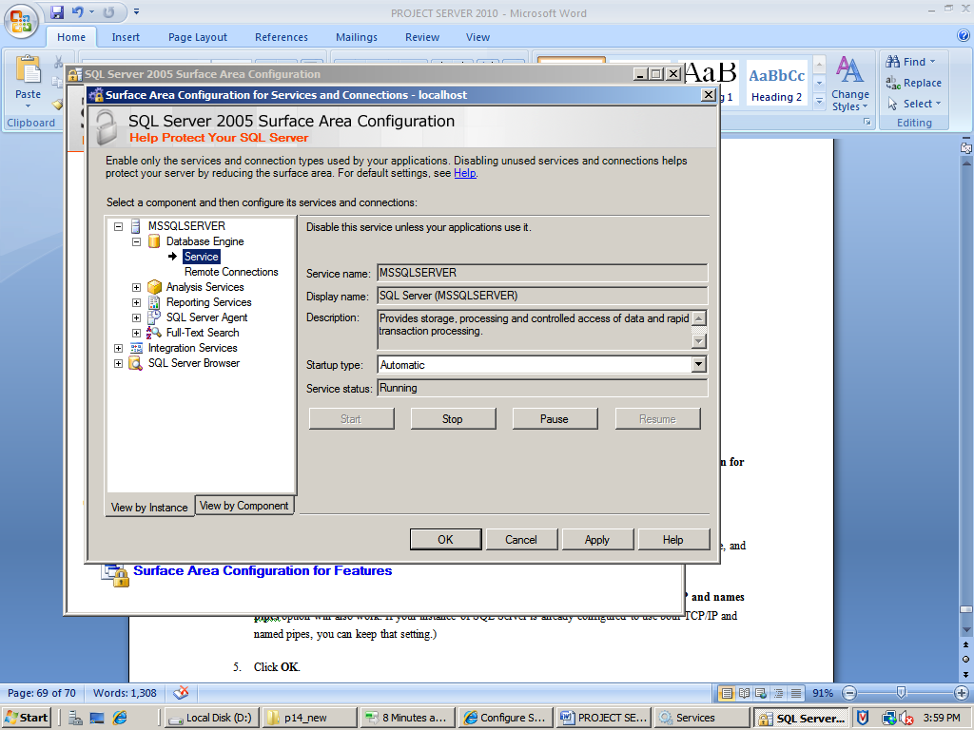

1. In the tree view, expand the node for your instance of SQL Server, expand the **Database Engine** node, and then click **Remote Connections**.
2. Select **Local and Remote Connections**, select **Using TCP/IP only**. (The **Using both TCP/IP and names pipes** option will also work. If your instance of SQL Server is already configured to use both TCP/IP and named pipes, you can keep that setting.)

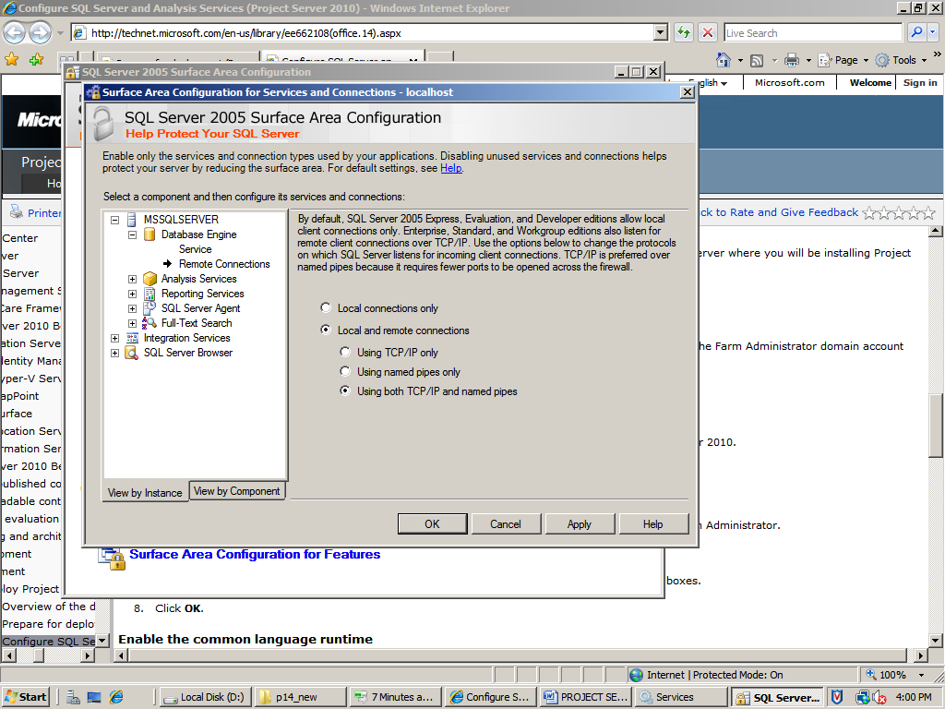

1. Click **APPLY** and **OK**.

Enable all the surface area configuration features, for database engine, analysis services and reporting services

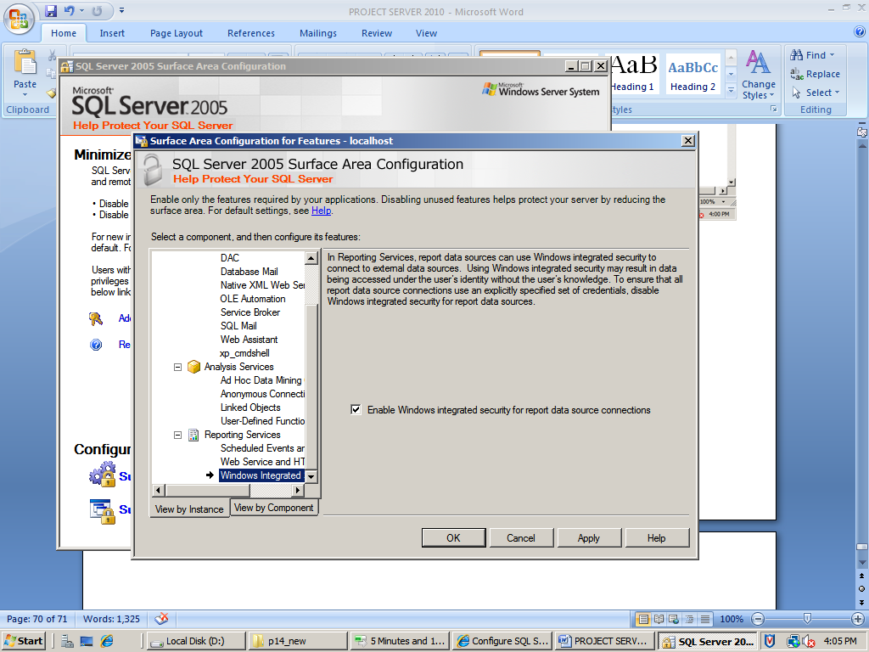

Click Apply and ok.

# **Add a login for the Farm Administrator account**

In order for Project Server 2010 setup and configuration to function, you must create a SQL Server login for the Farm Administrator domain account and give it the required server roles.

### To create a SQL Server login

1. Open SQL Server Management Studio.
2. Connect to the database engine of the instance of SQL Server that you will be using with Project Server 2010.

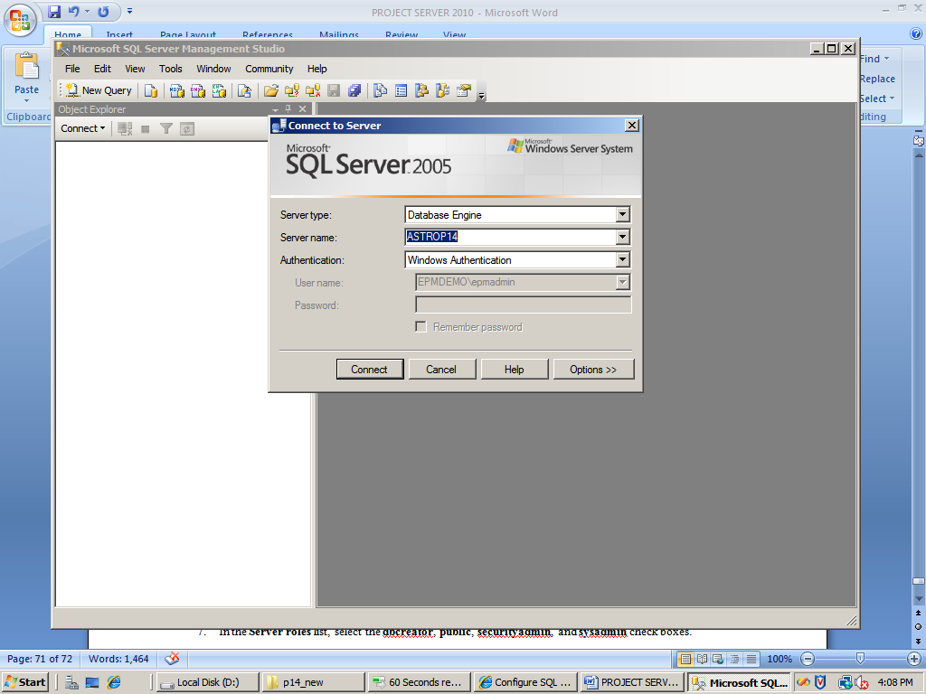

1. Expand the **Security** node.
2. Right-click **Logins**, if the user exist then check the server roles and permissions else click **New Login**.

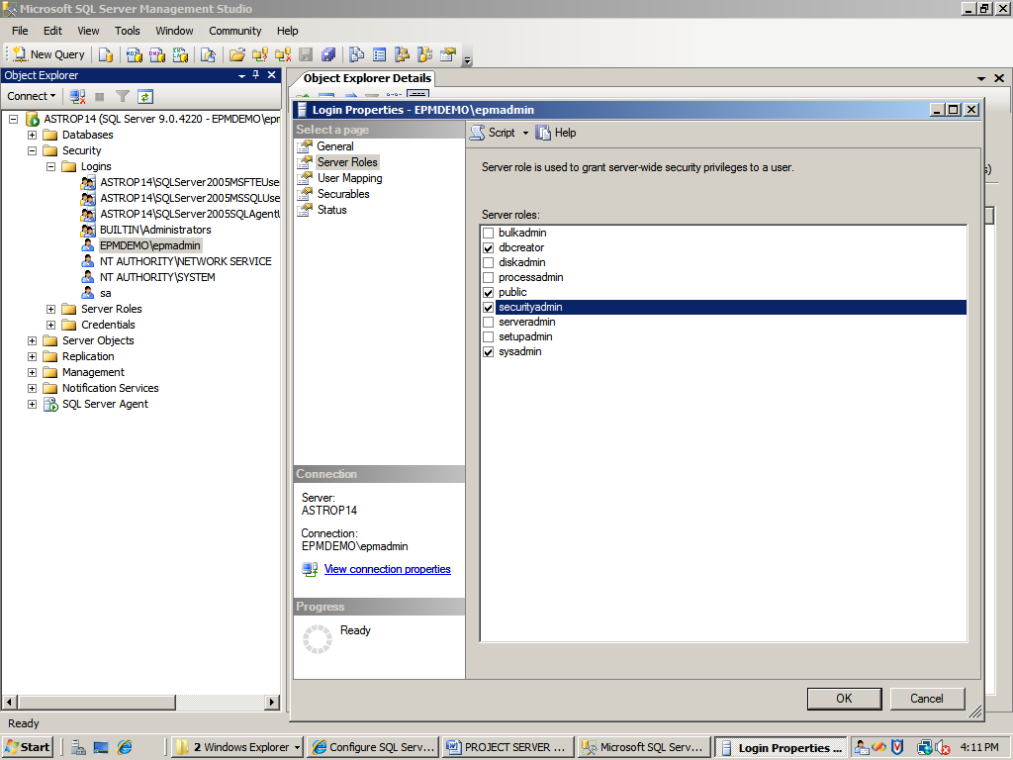

1. On the **New** page, in the **Login name** text box, type the domain account that you created for the Farm Administrator.
2. In the **Select a page** list, click **Server Roles**.
3. In the **Server roles** list, select the **dbcreator**, **public**, **securityadmin**, and **sysadmin** check boxes.
4. Click **OK**.

**Create a SharePoint Server 2010 farm**

Before you can install SharePoint Server 2010, you must install its software prerequisites. SharePoint Server 2010 provides a prerequisite installation tool that installs the necessary software prerequisites and configures the required server roles. This tool requires that the computer where you install SharePoint Server 2010 be connected to the Internet.

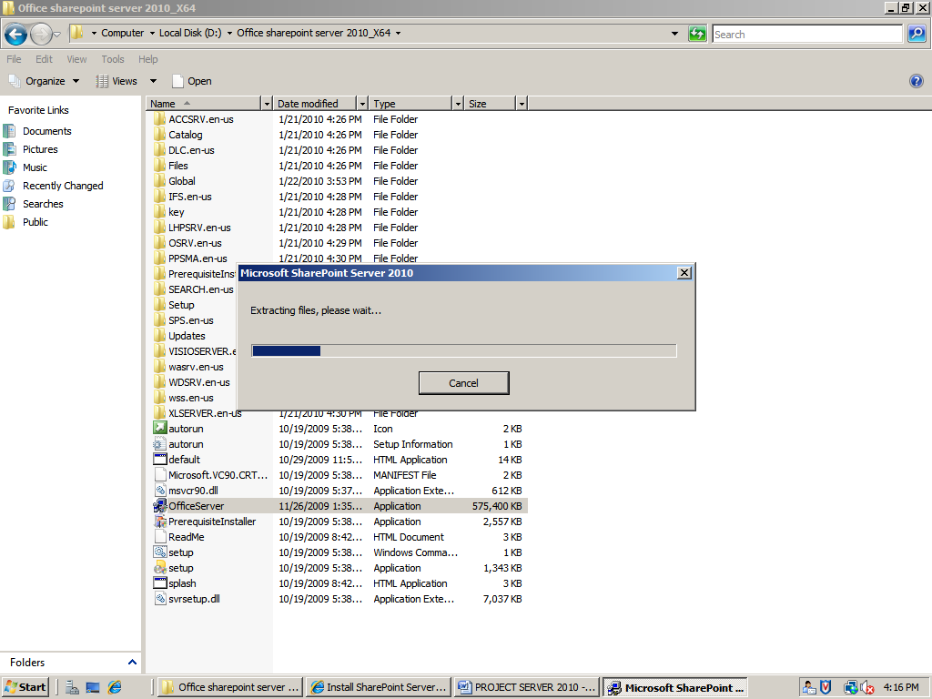



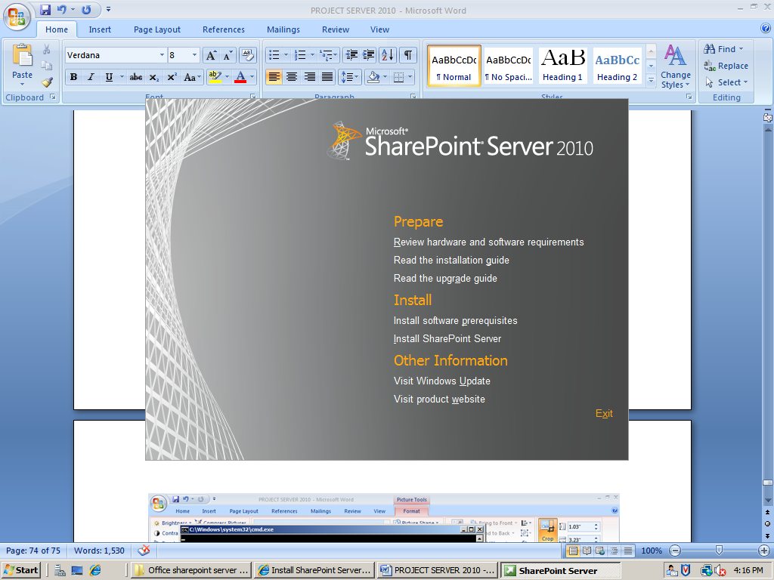

Click on install software prerequisites, the following software will get installed

1. Windows server 2008 Service Pack 2
2. Application Server Role. Web Server (IIS) Role
3. Microsoft SQL Server 2008 Native Client
4. Microsoft .NET Framework 3.5 SP1
5. Windows PowerShell (TM) V2 (CTP3)
6. Microsoft “Geneva” Framework Runtime
7. Microsoft Sync Framework Runtime v1.0 (x64)
8. Microsoft Chart controls for Microsoft .NET Framework 3.5
9. Microsoft Filter Pack 2.0
10. Microsoft SQL Server 2008 Analysis Services ADOMD.NET

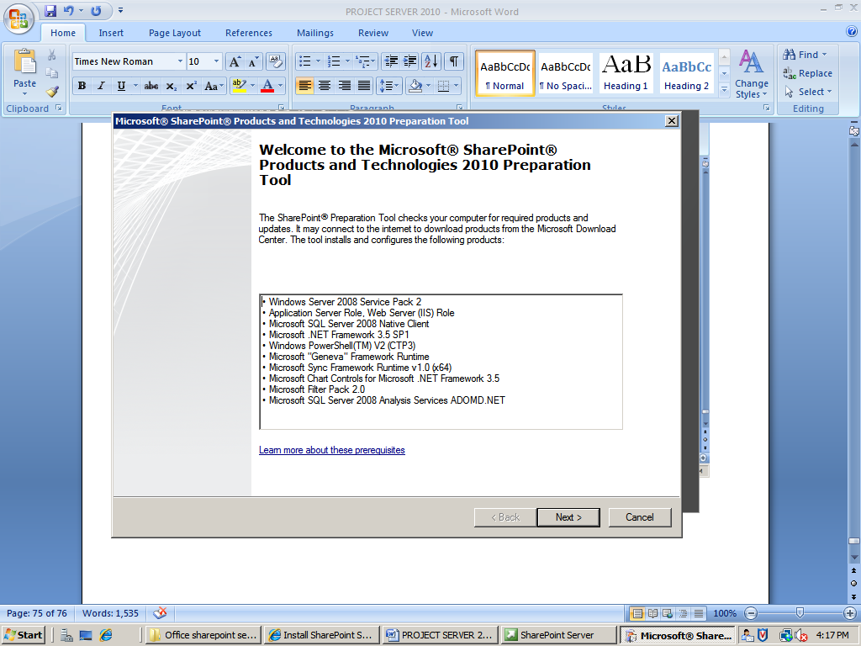

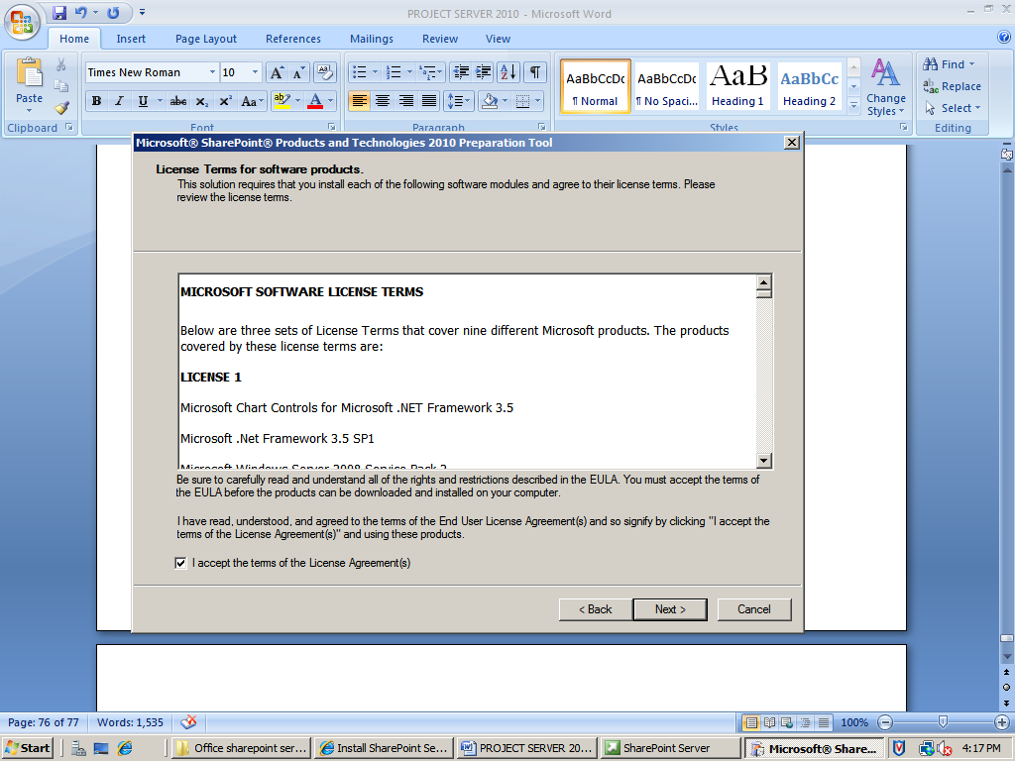

Click I accept and next

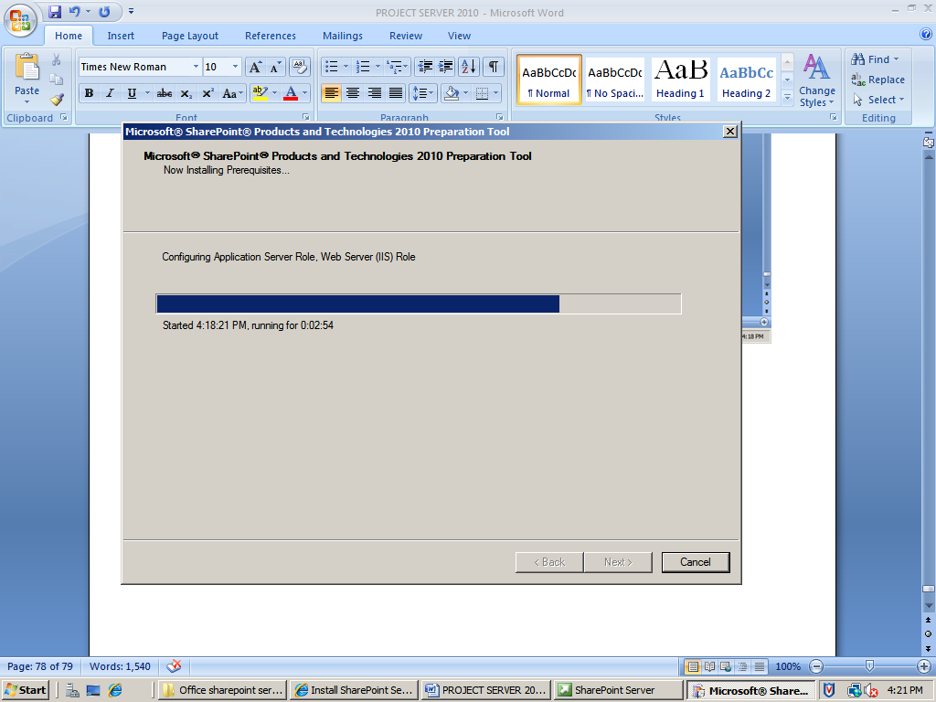

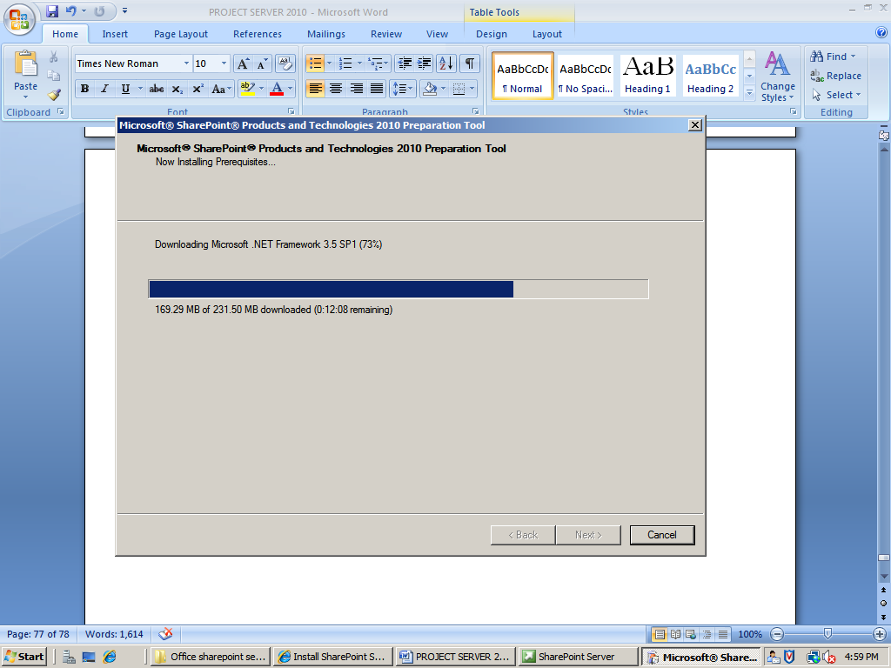

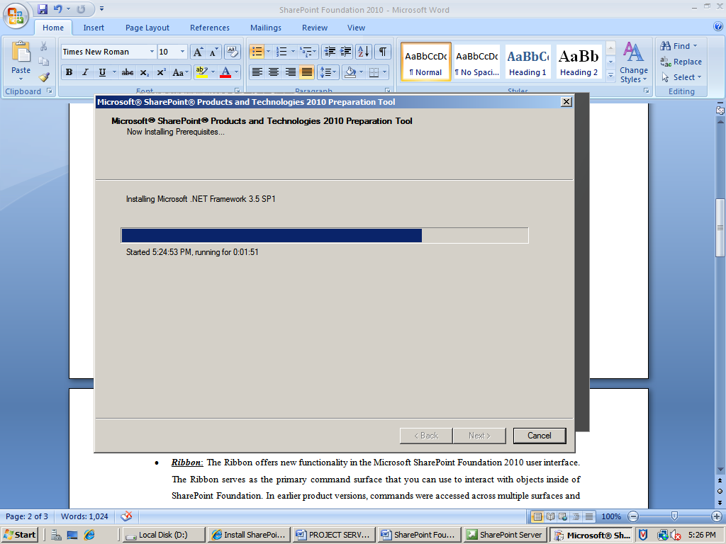

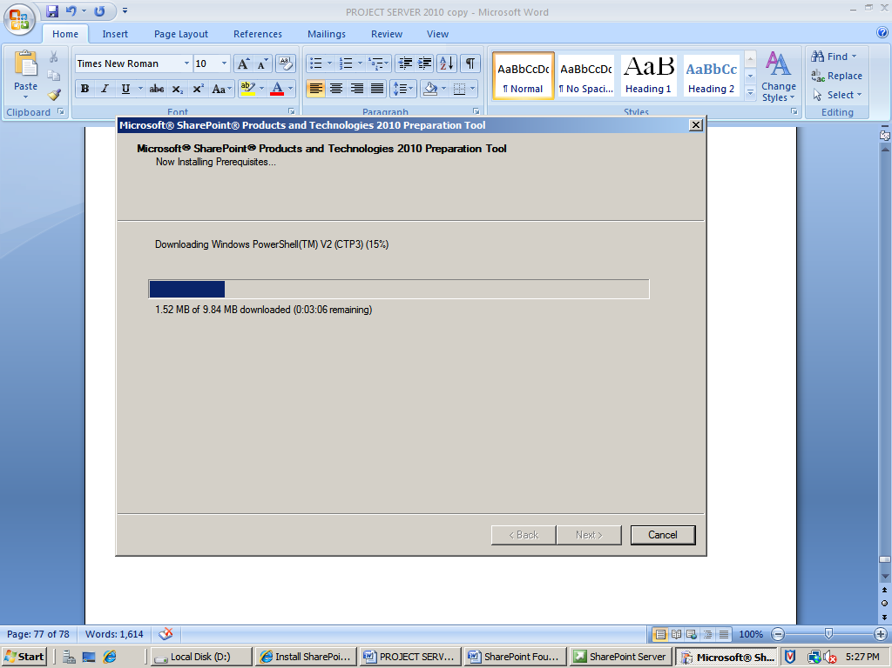

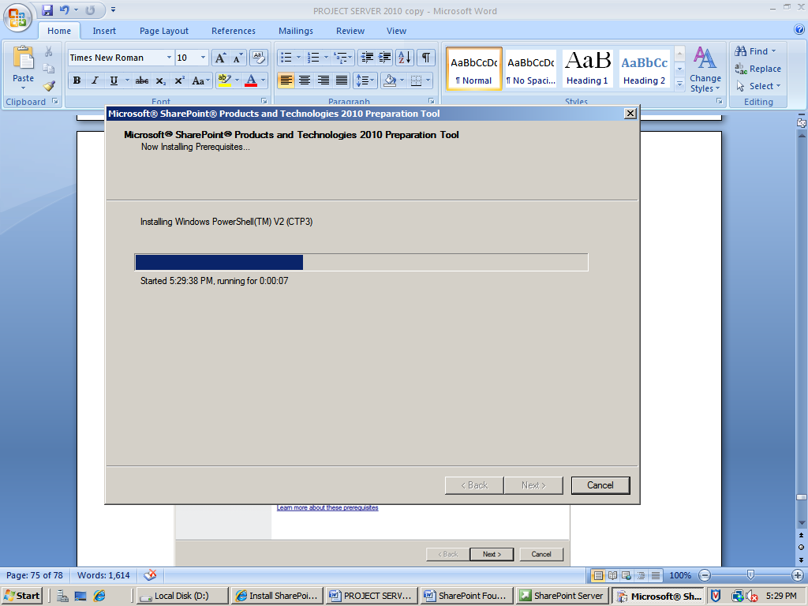

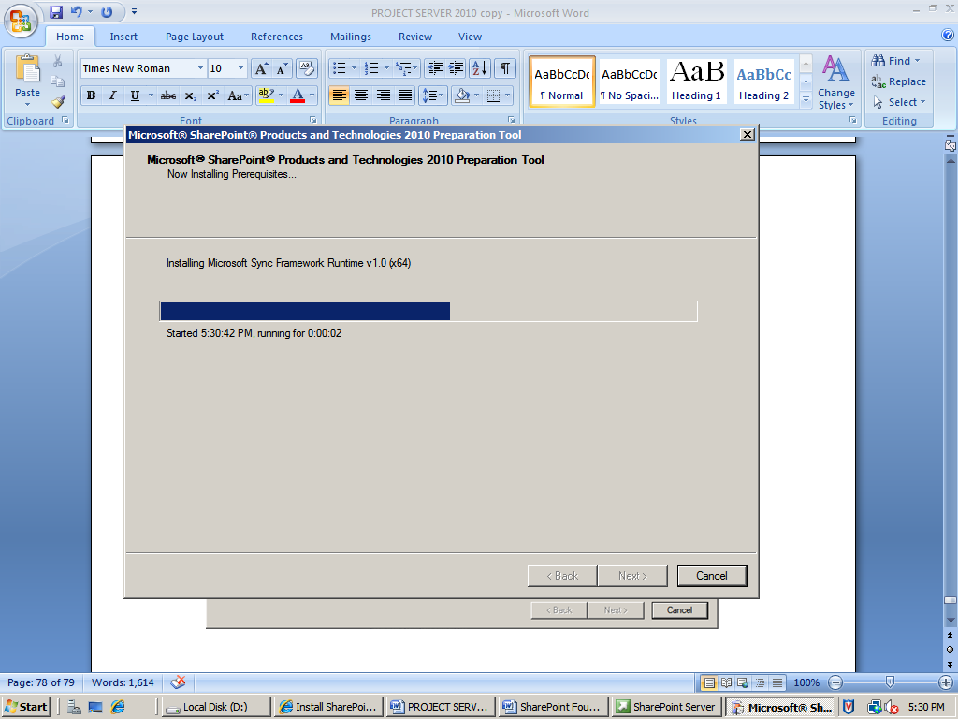

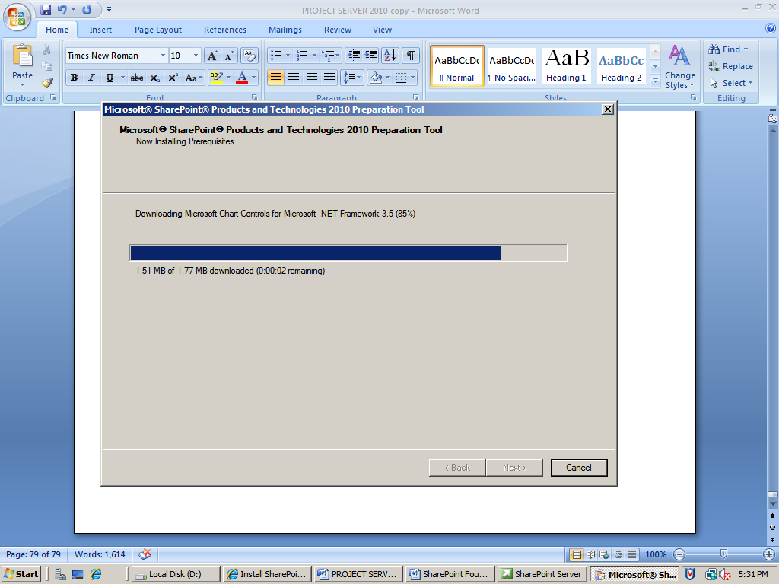

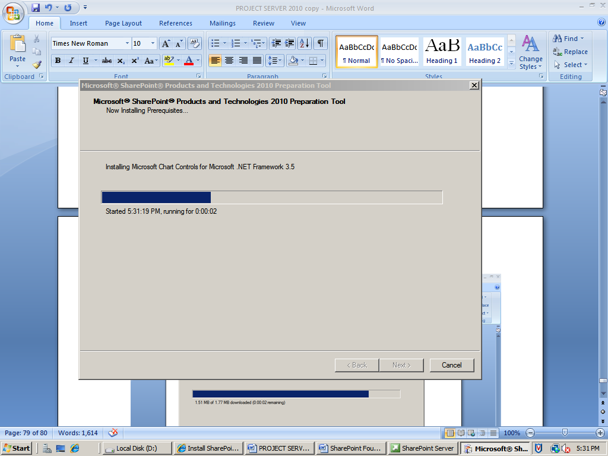

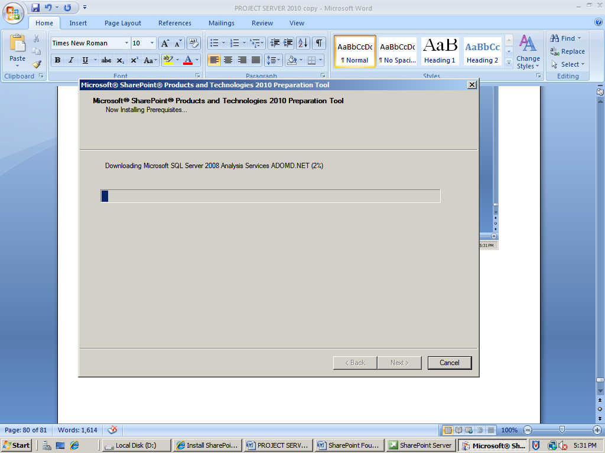

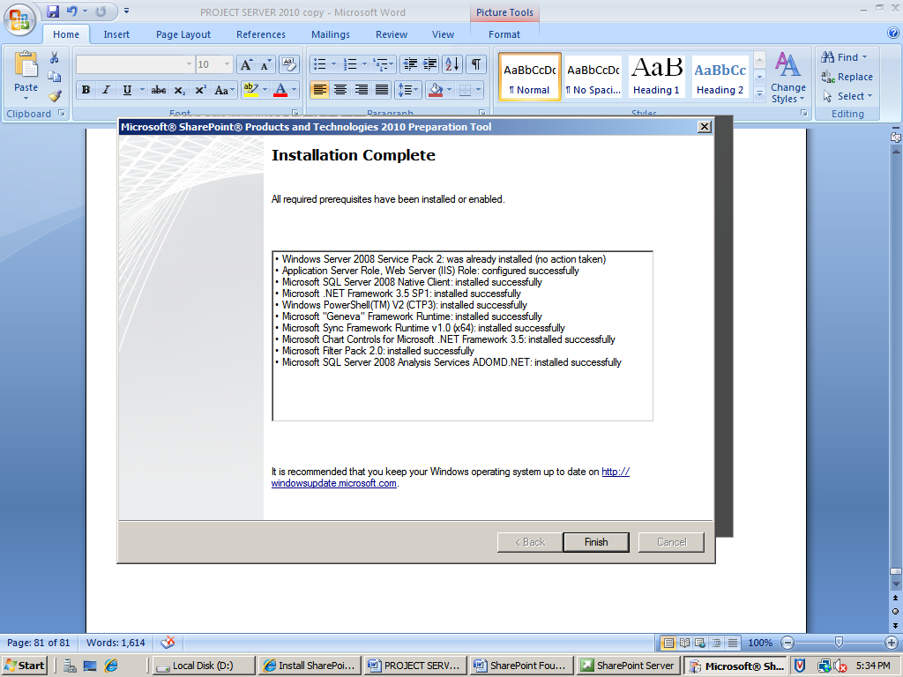

INSTALL SHARE POINT SERVER 2010

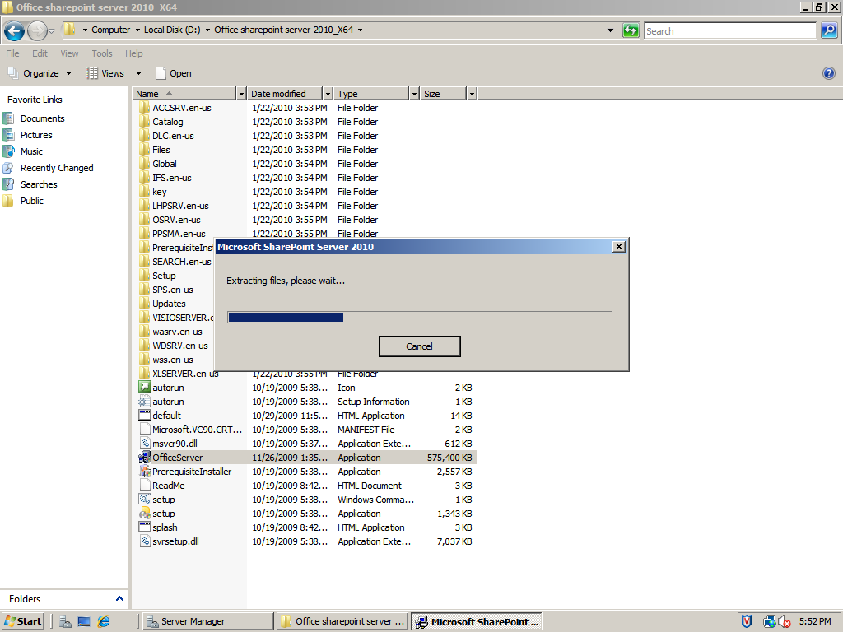

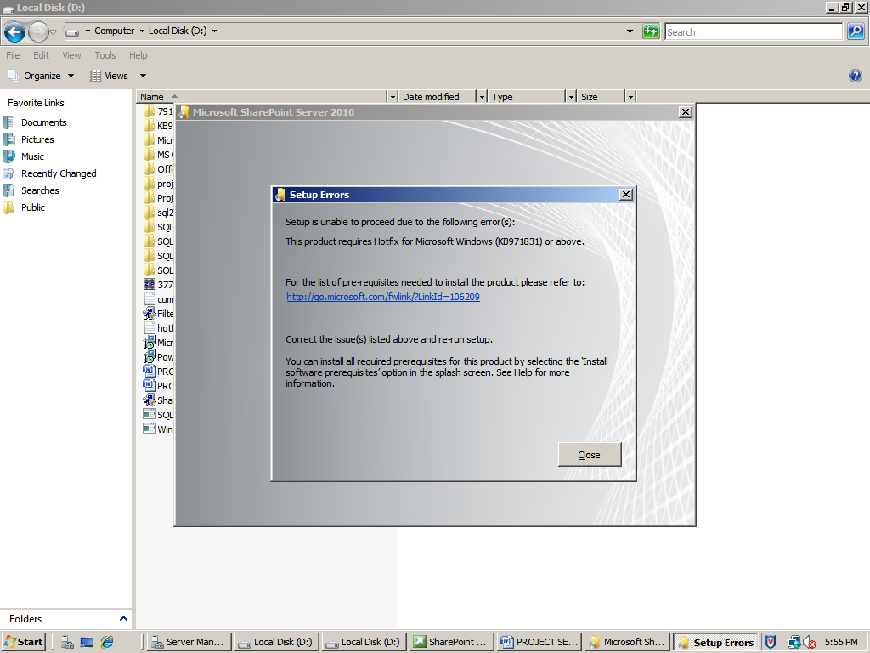

ERROR: The product require the Hotfix KB97183

Install the hot fix for Microsoft windows

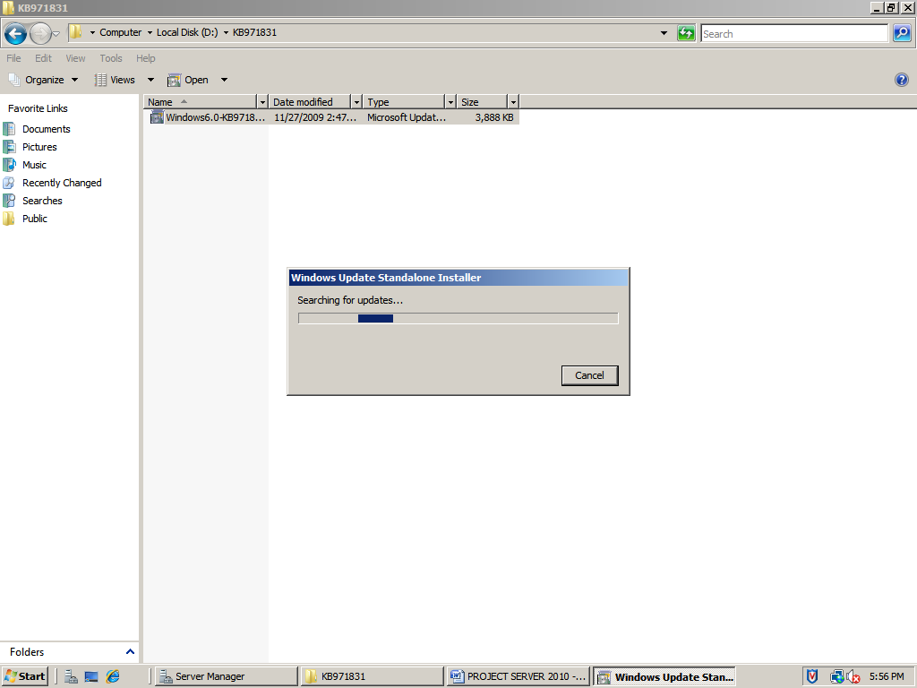

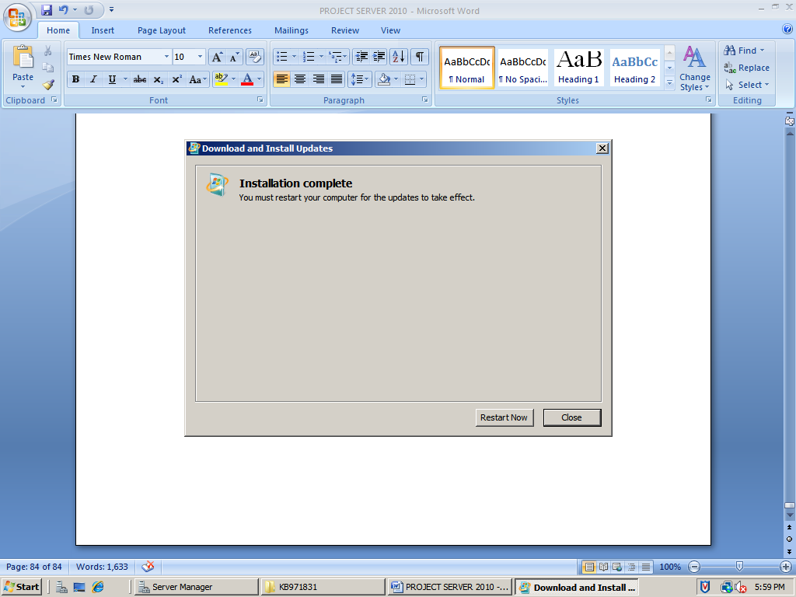

Click Restart Now

Now again Rum the office server 2010 setup n install the sharepoint server

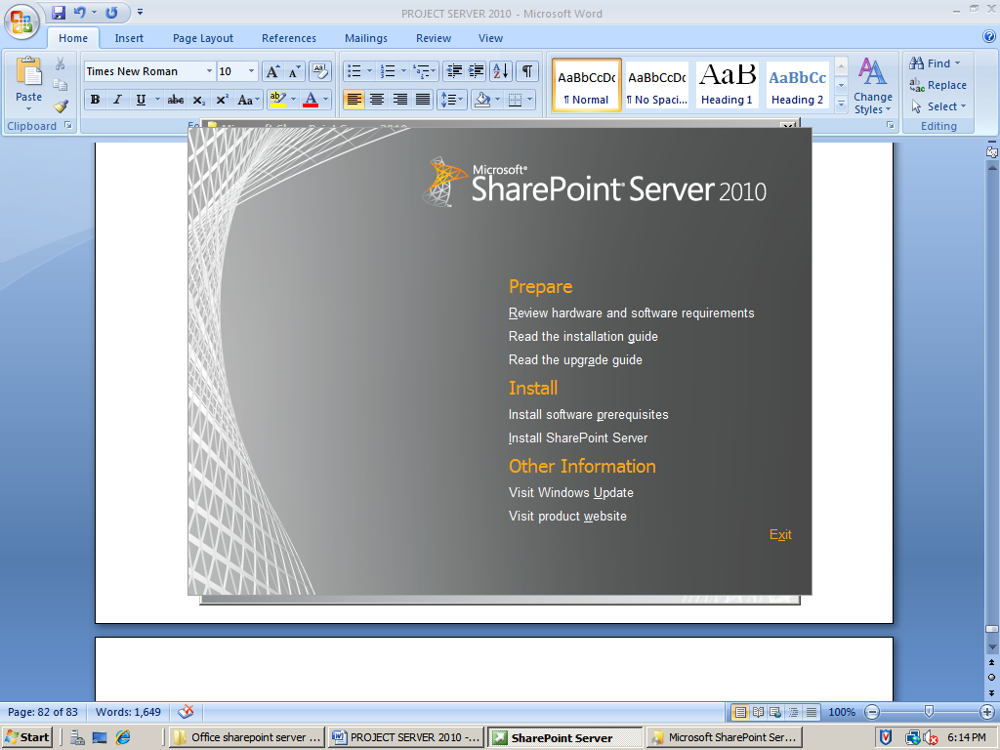

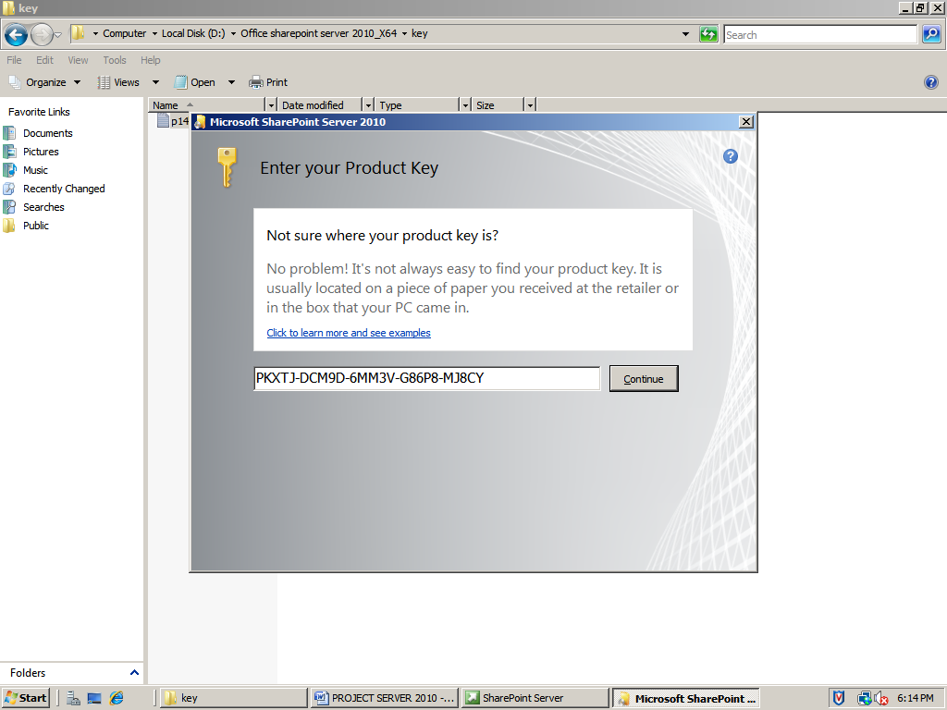

Click continue

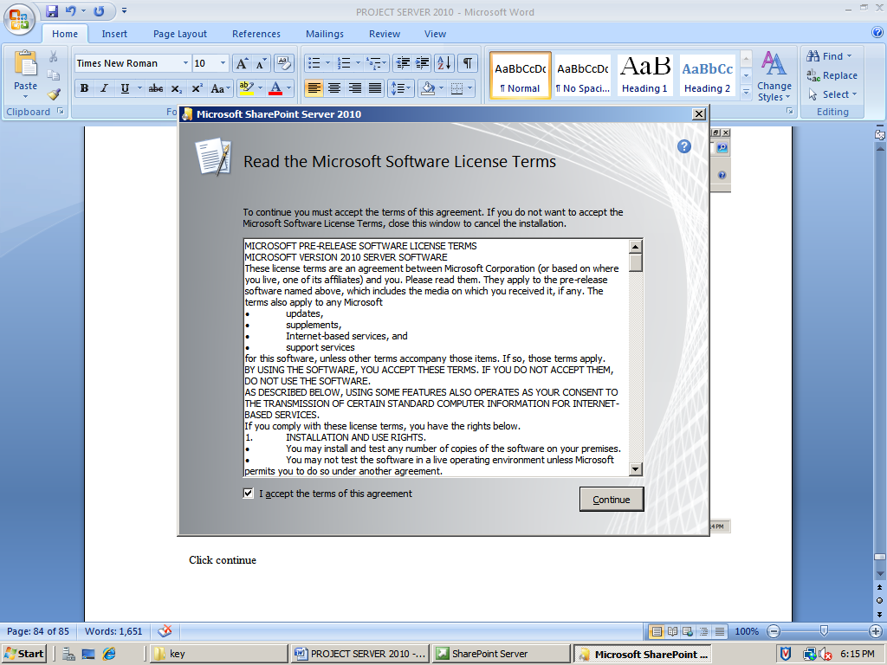

Accept the terms and click continue

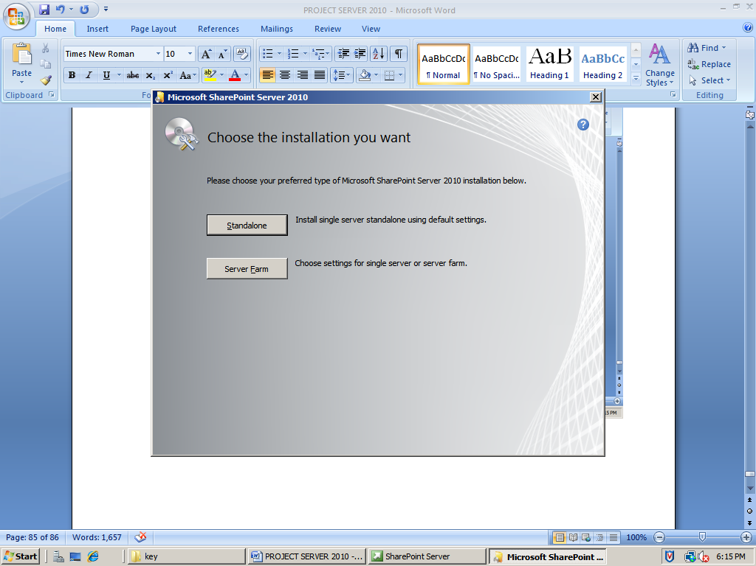

Click standalone type

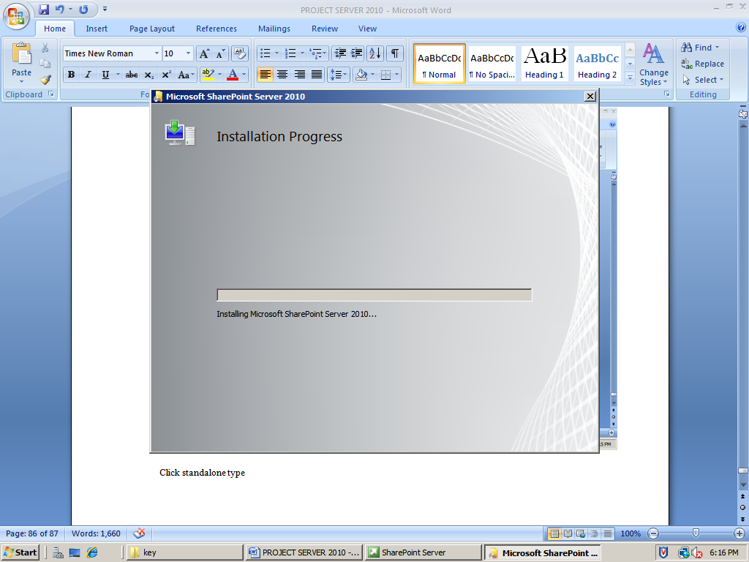

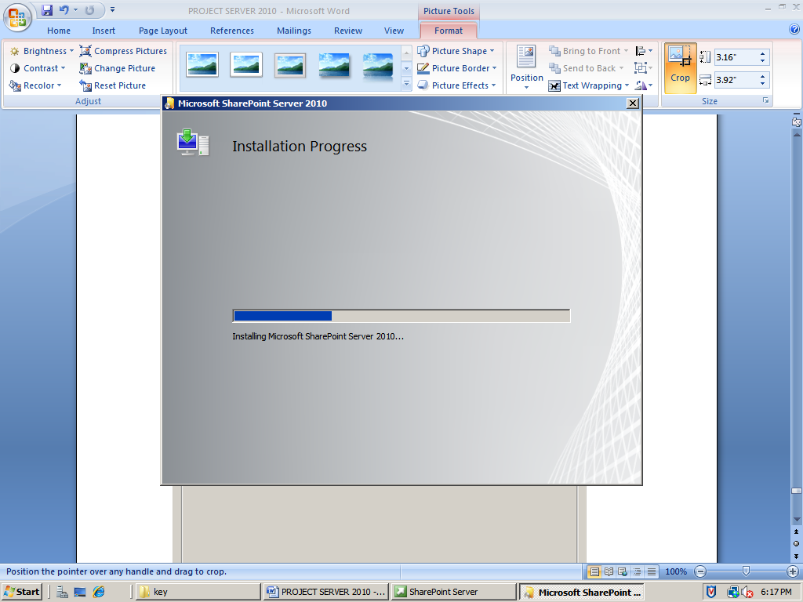

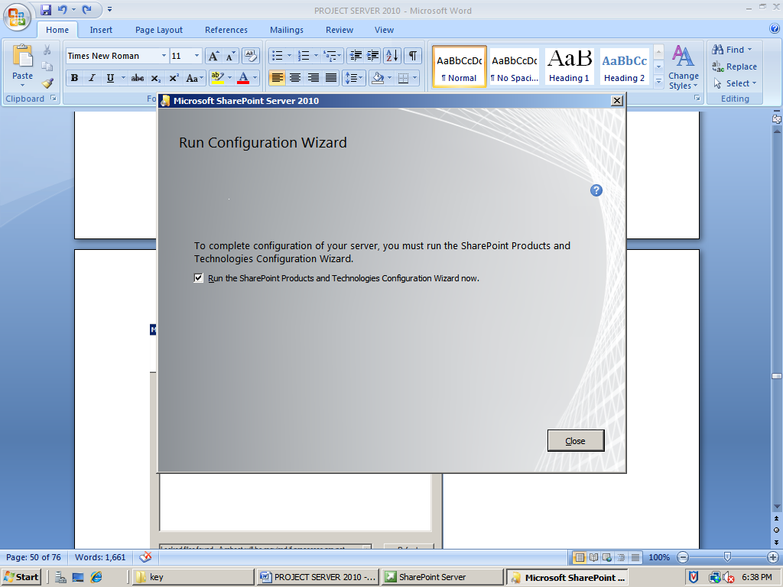

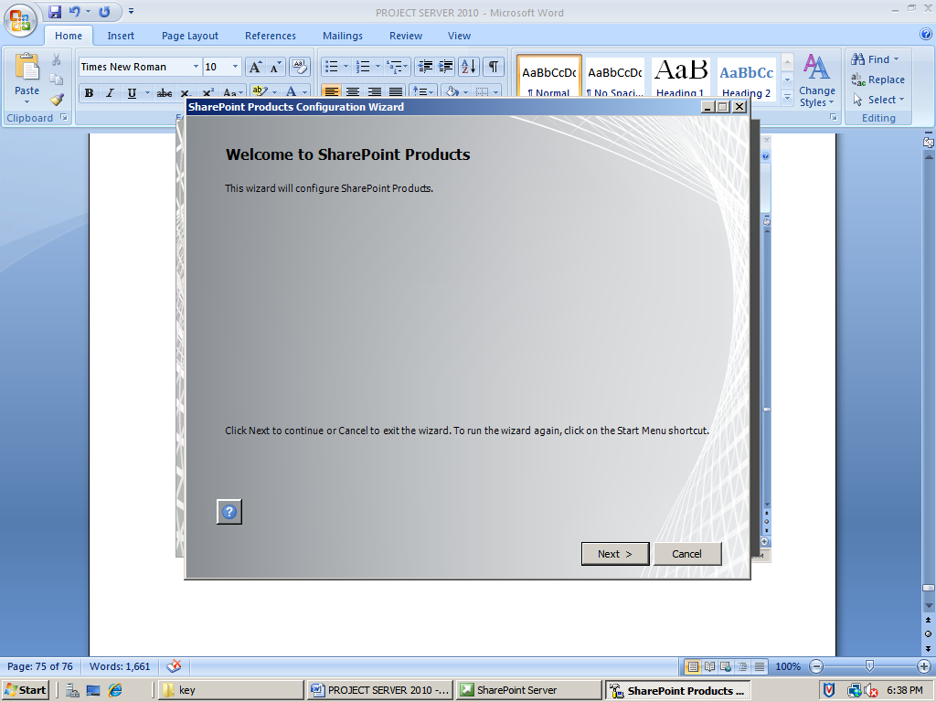

Click next

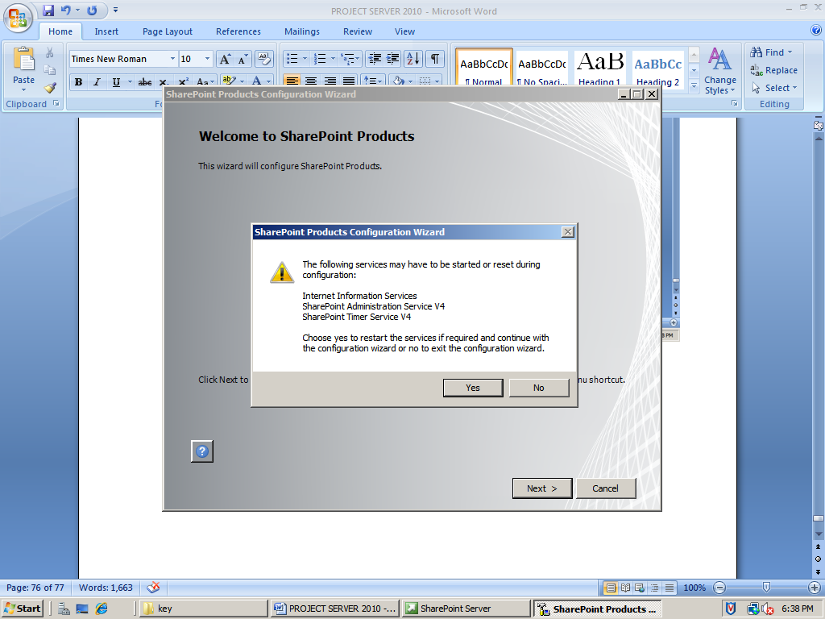

Click yes

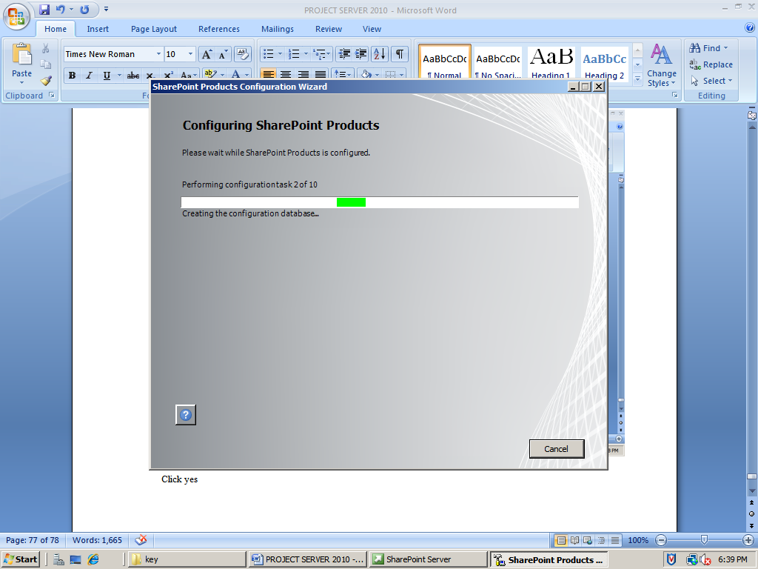

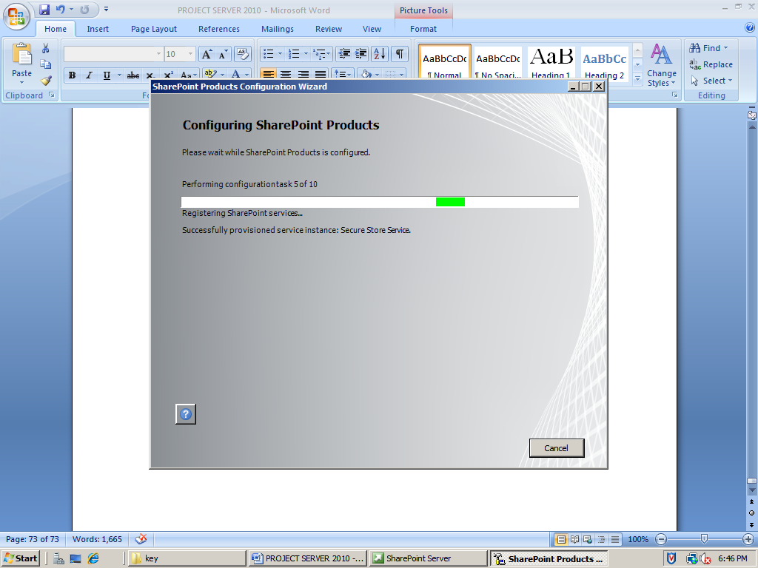

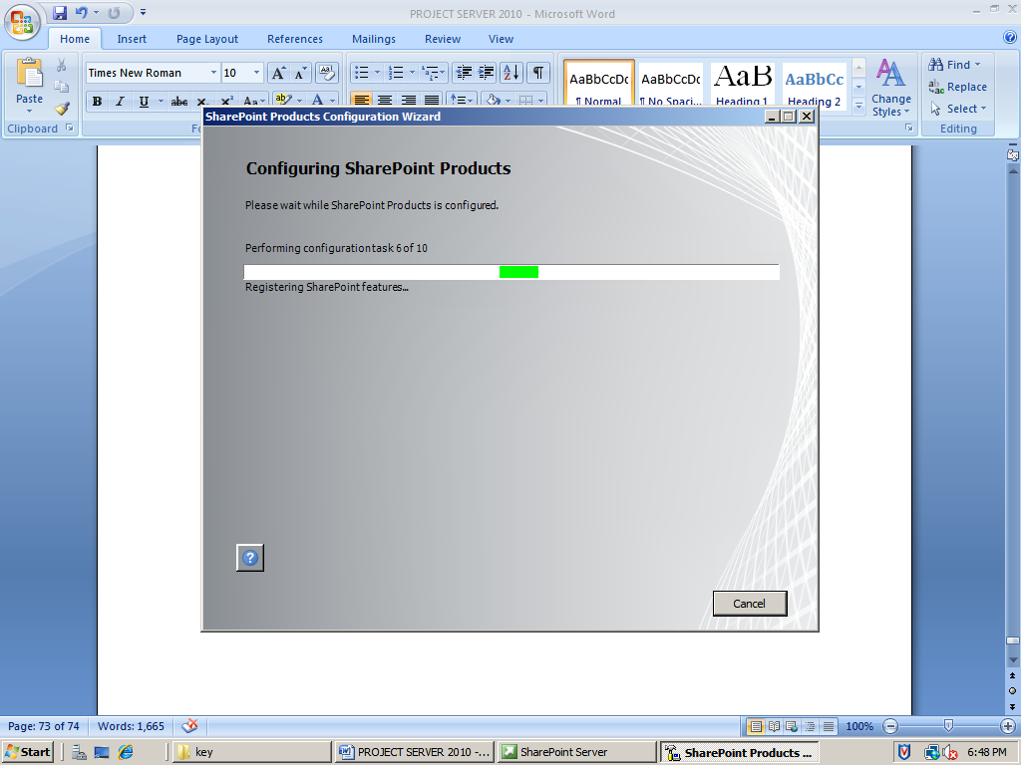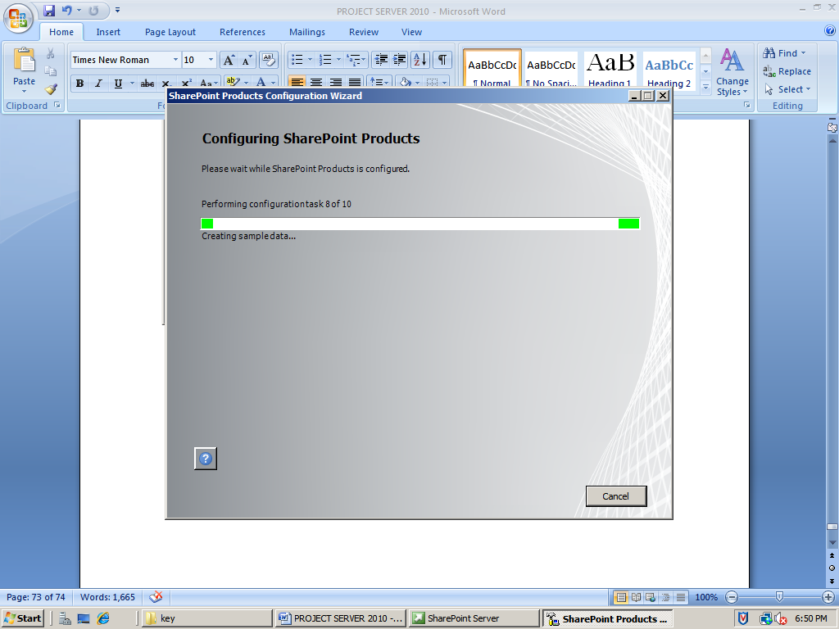 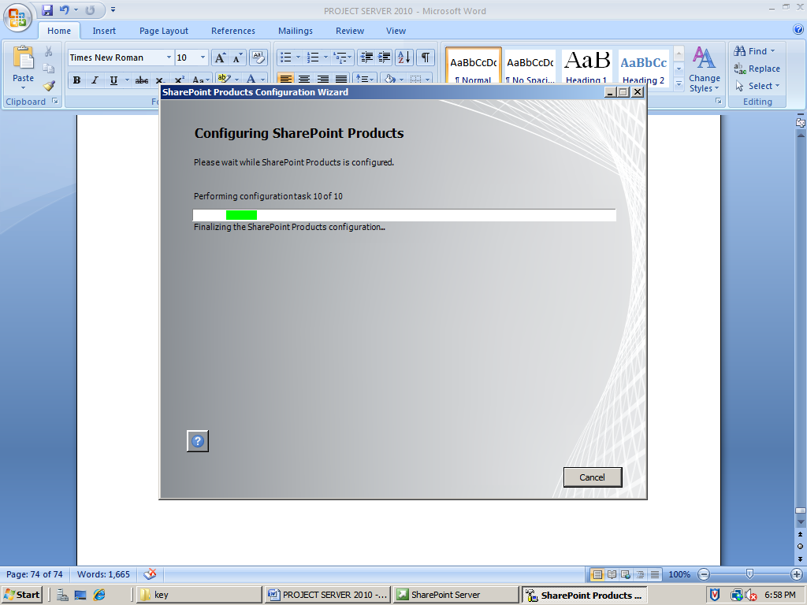 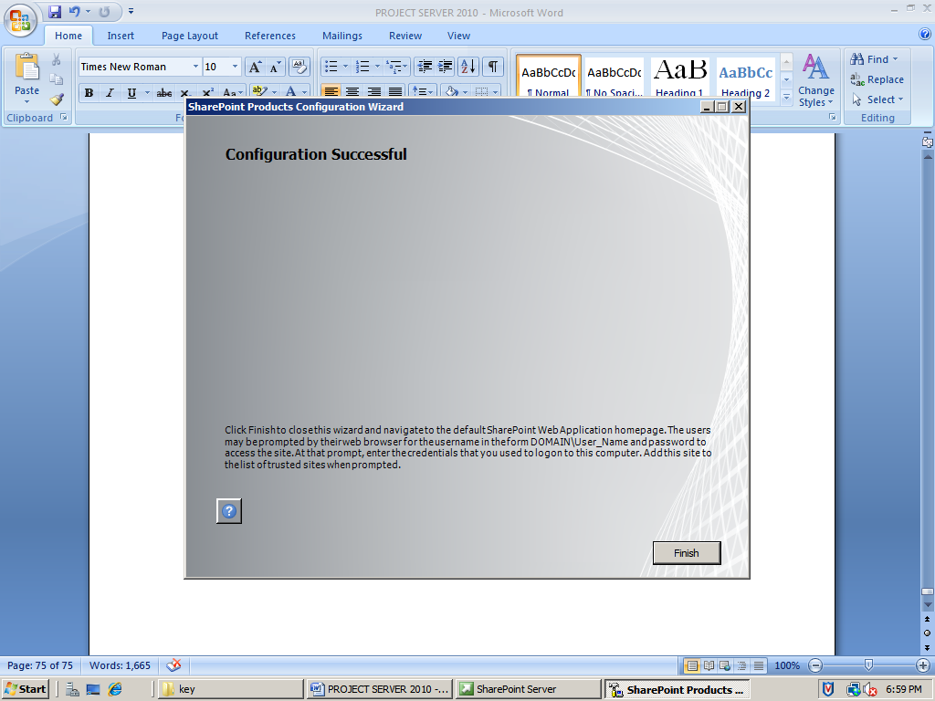

Click finish

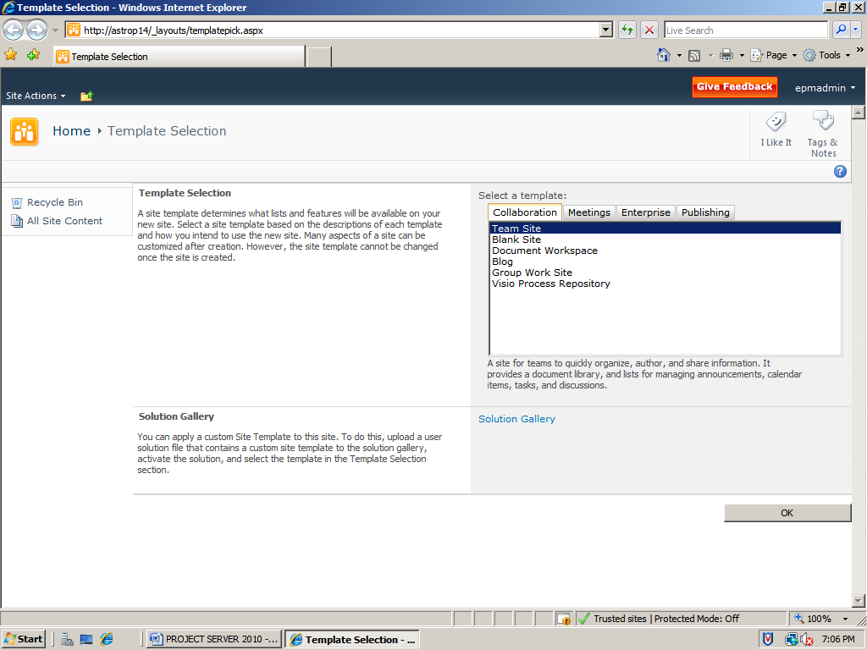

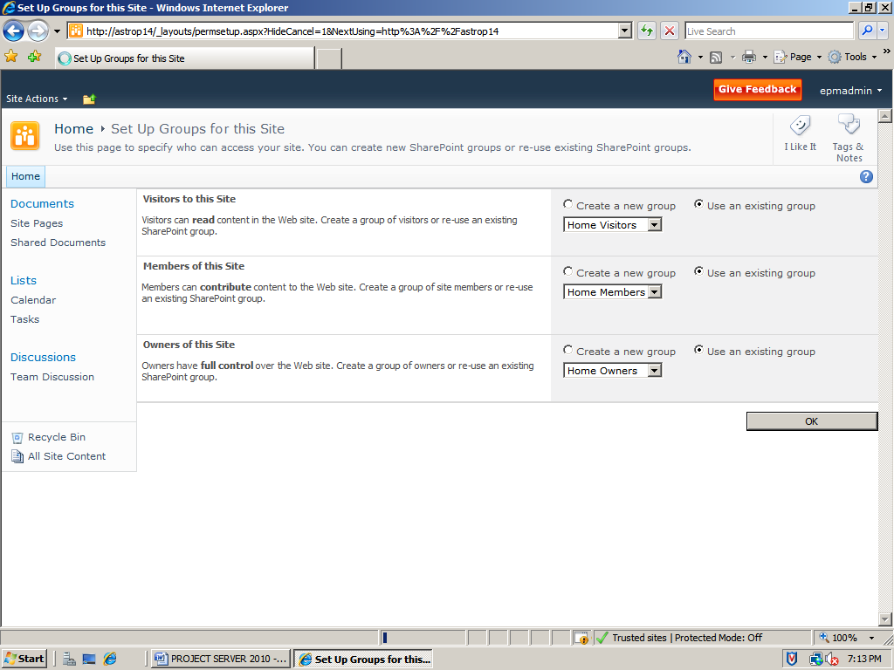

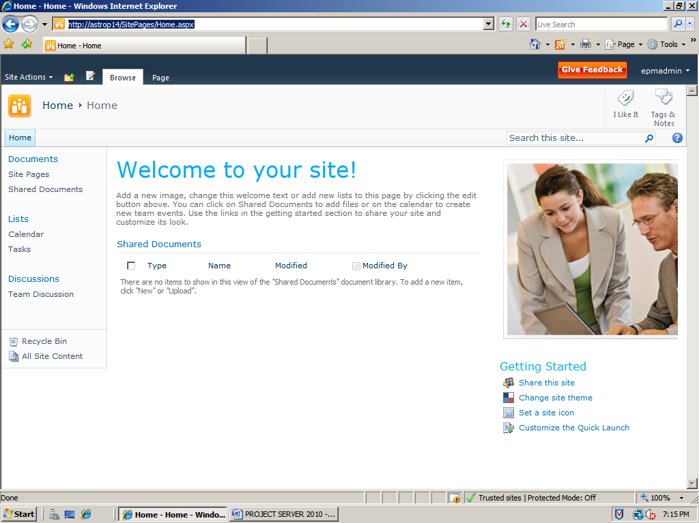

**Install and configure Project Server 2010**

Run the project server 2010 setup and run the software prerequisites

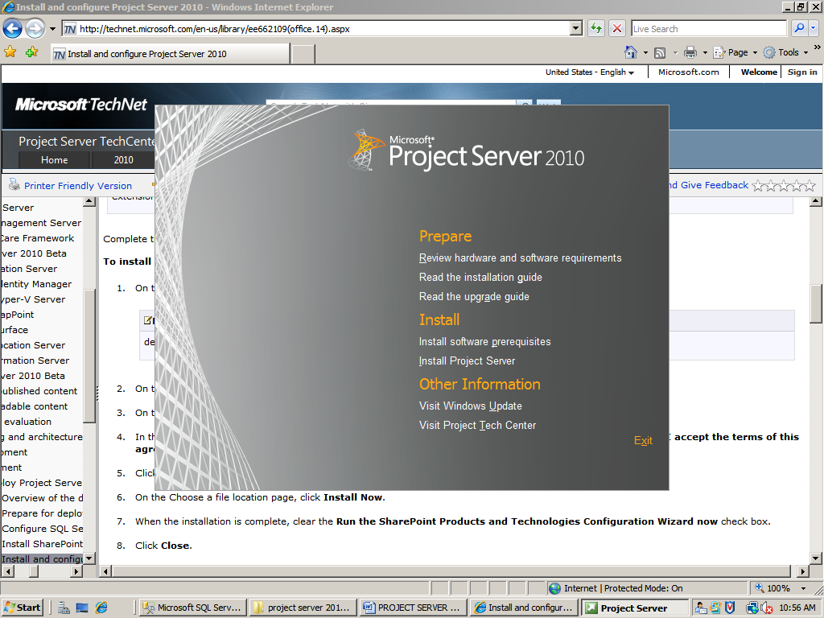

This will check your computer for required products and updates

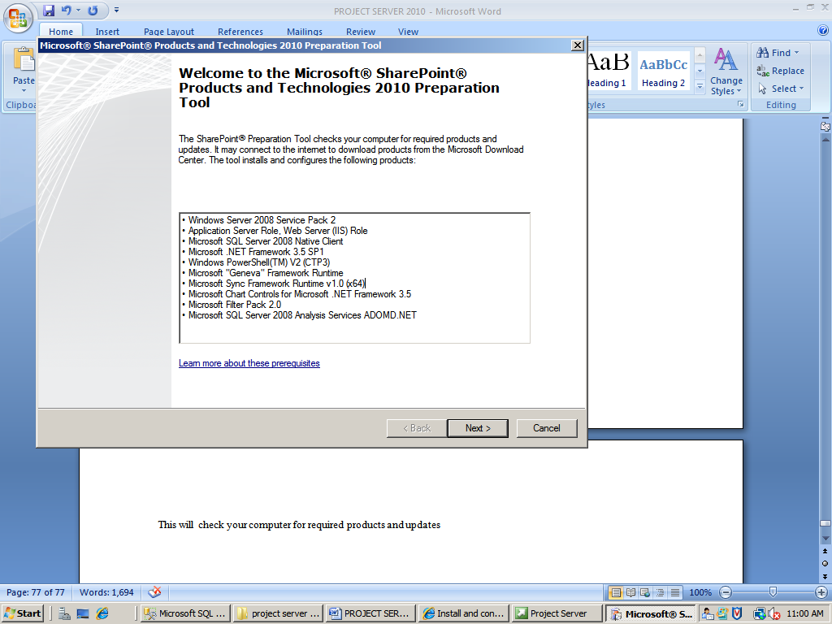

Click next

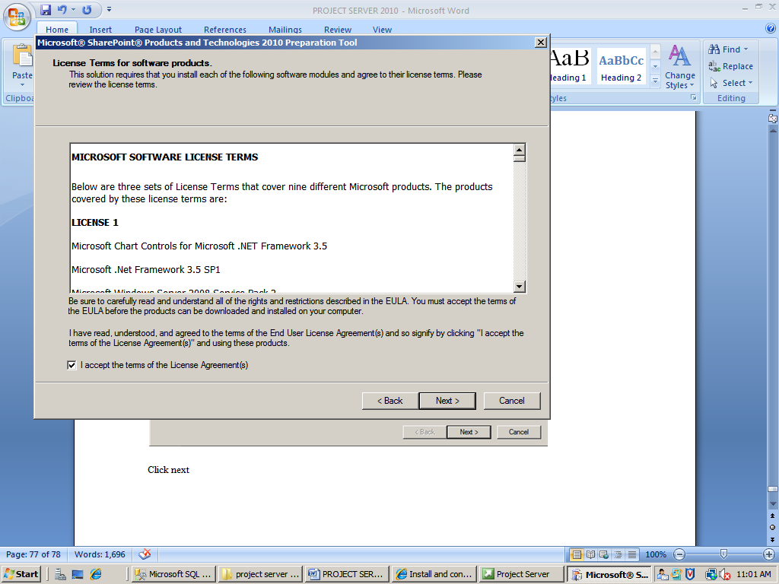

Accept and click next

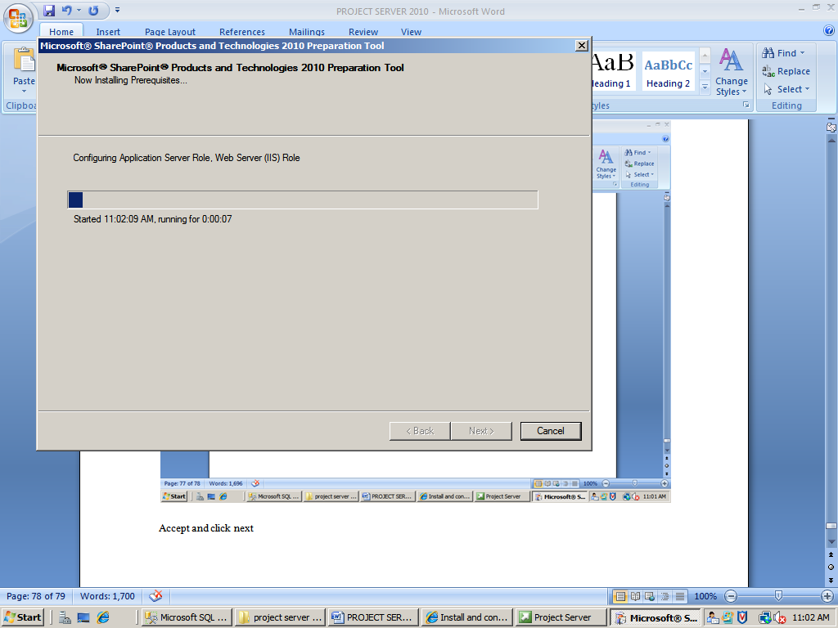

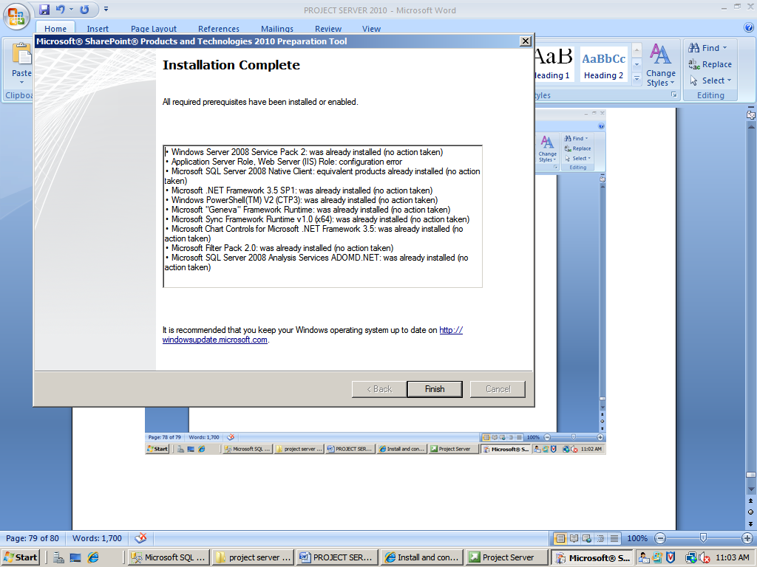

Click finish

Now, on the start page, click Install Project server

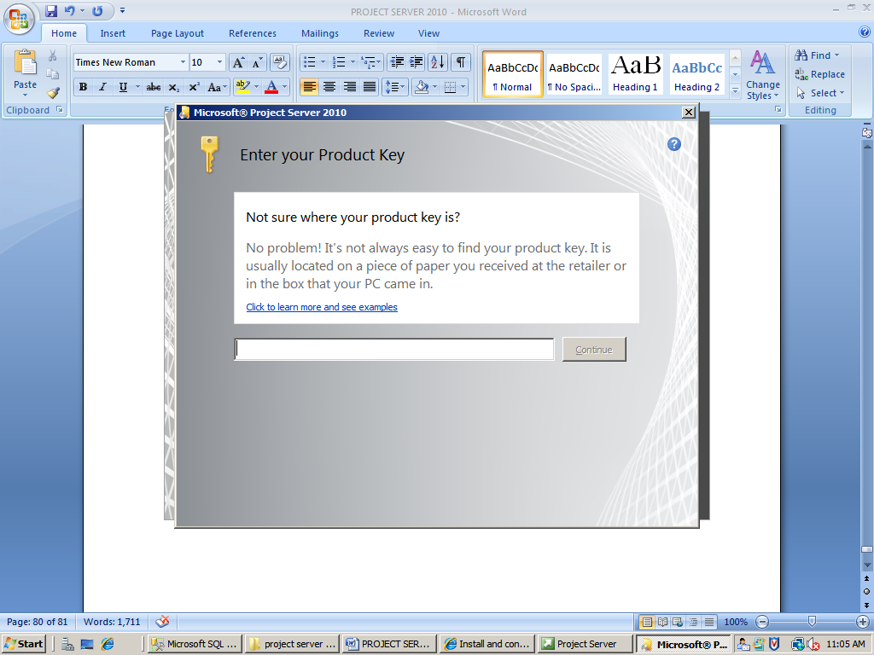

Enter the product key and continue

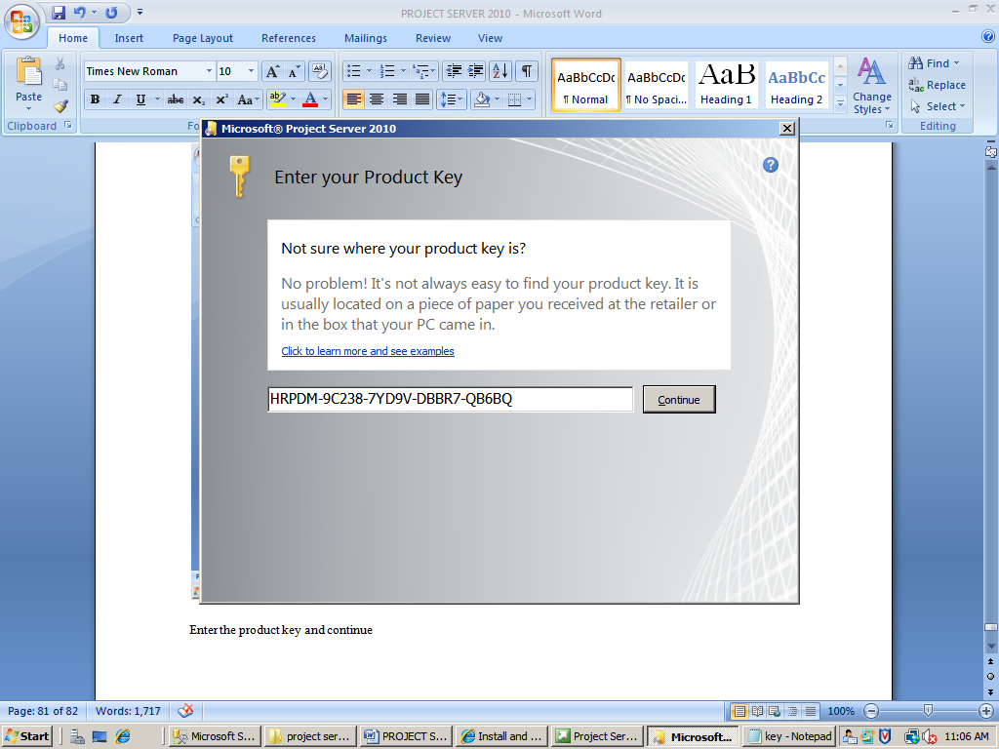

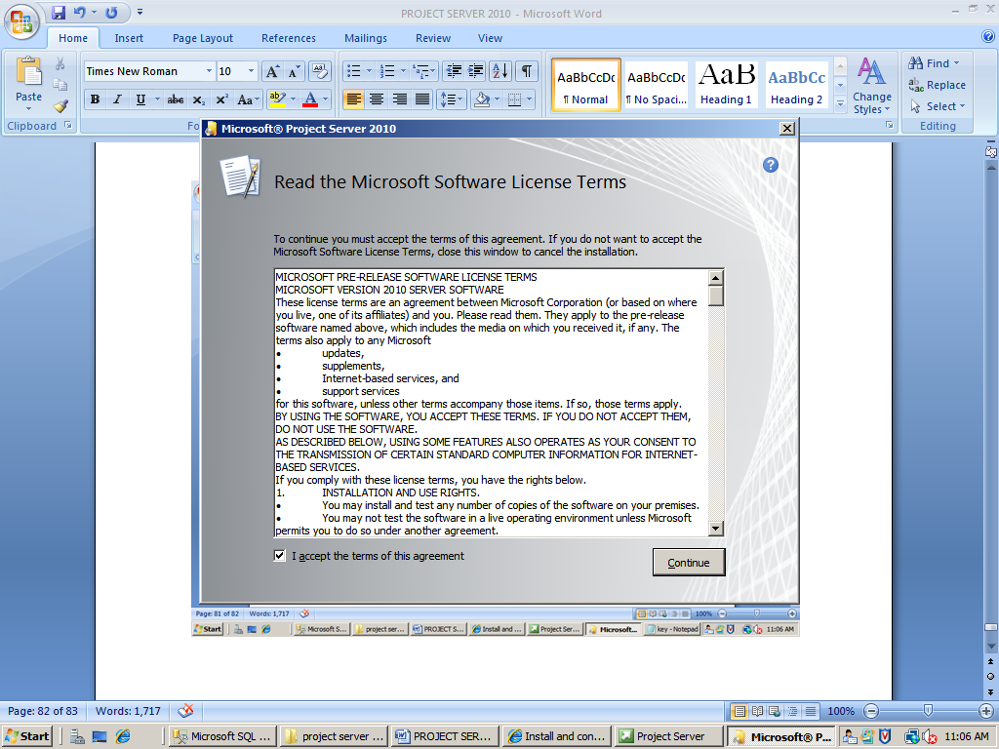

Accept the terms and continue

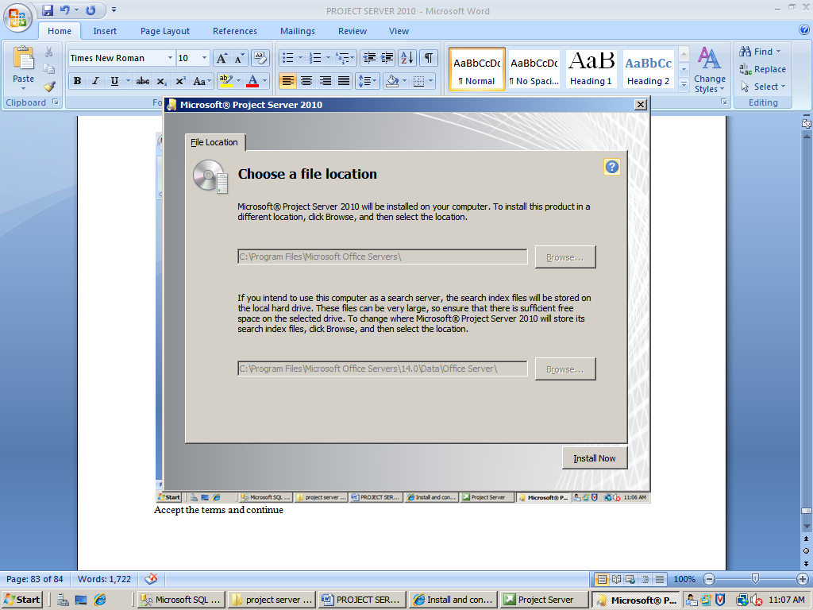

Click install now

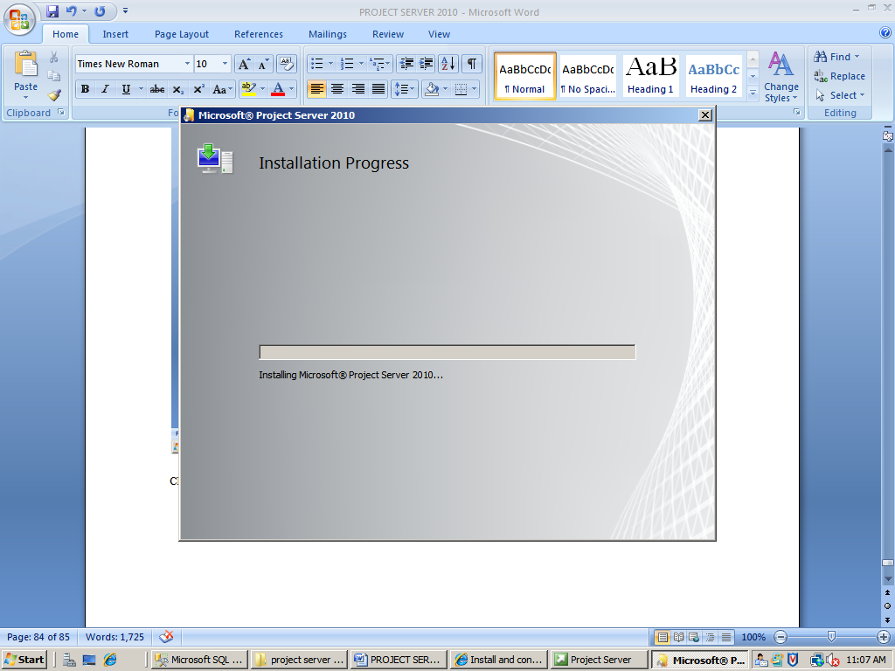

After the installation gets completed, remember to clear the **Run the SharePoint Products and Technologies Configuration Wizard now** check box.

Clear the check box and click close

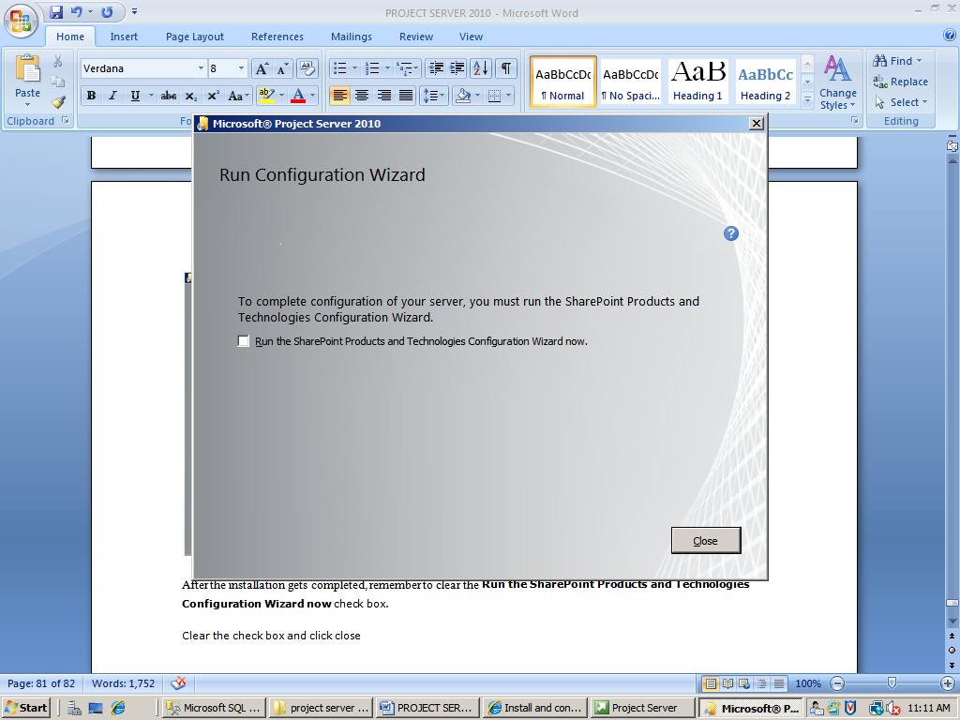

Once the Project Server 2010 software has been installed on each application server in the farm, you must run the SharePoint Products and Technologies Configuration Wizard to integrate Project Server with SharePoint Server 2010.

### To run the SharePoint Products and Technologies Configuration Wizard

1. Click **Start**, **All Programs**, **Microsoft SharePoint 2010 Products**, **SharePoint 2010 Products Configuration Wizard**.

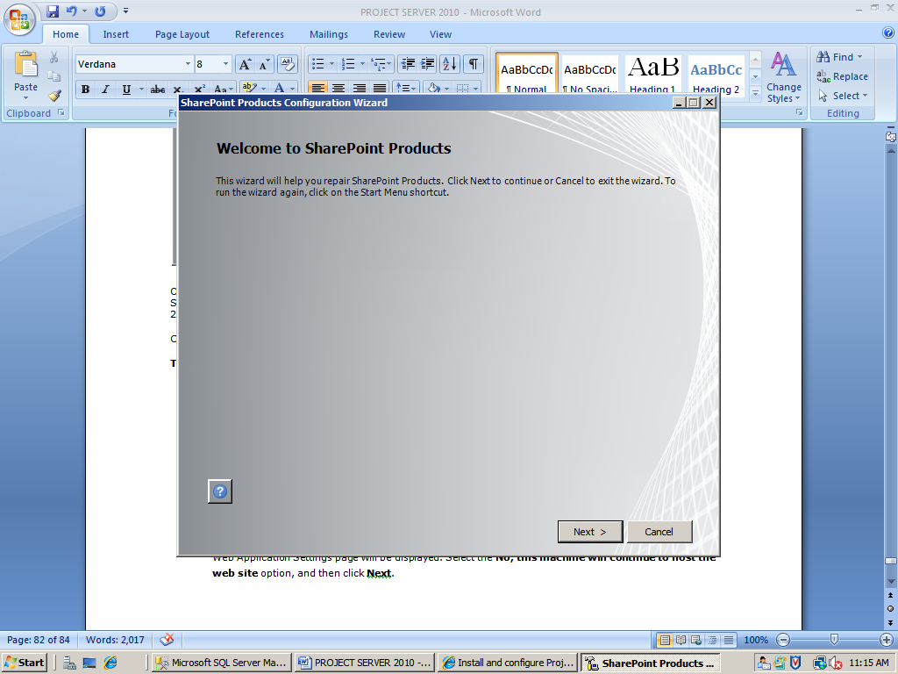

1. At the Welcome to SharePoint Products and Technologies page, click **Next**.
2. A confirmation dialog message appears, showing a list of services that may need to be restarted. Click **Yes**.

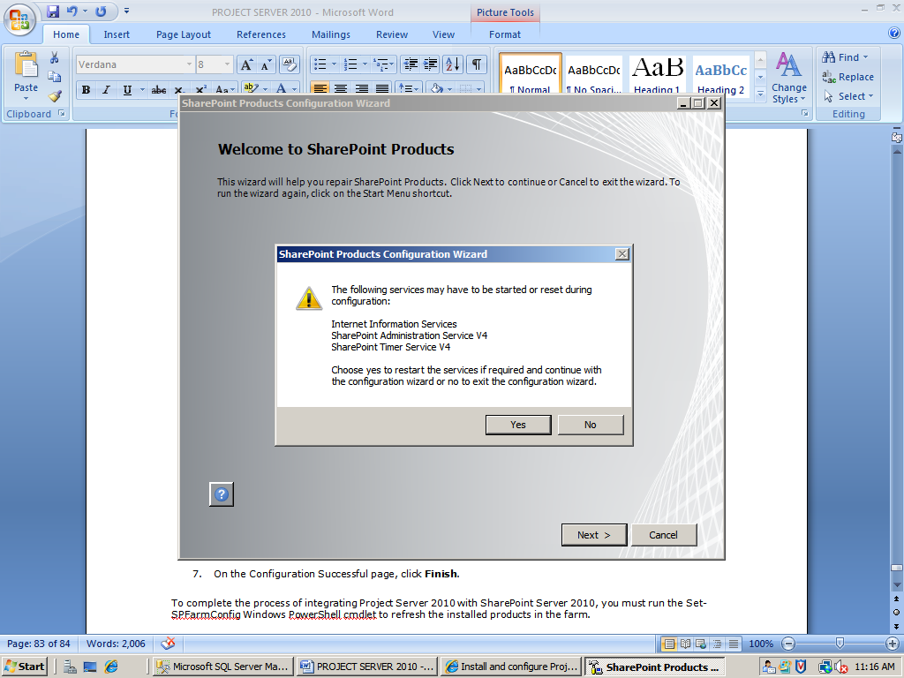

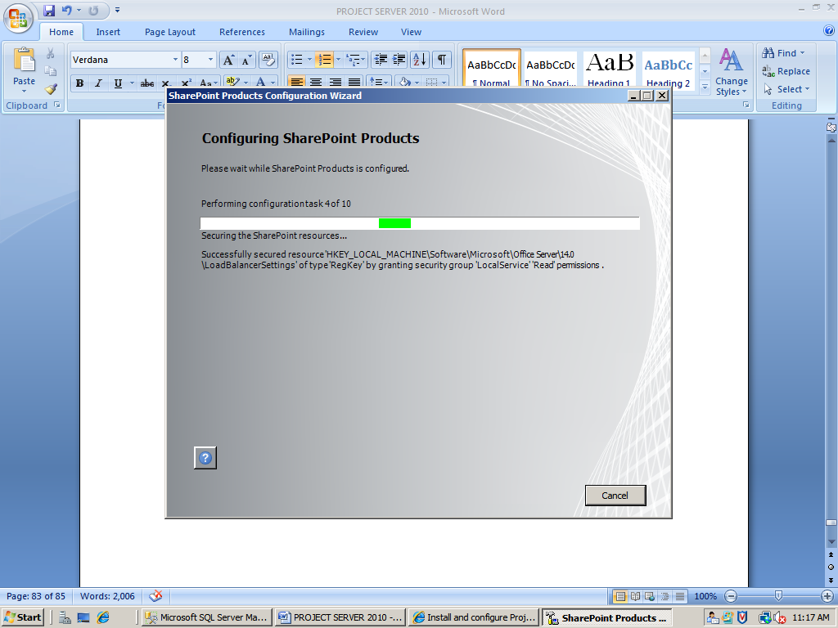

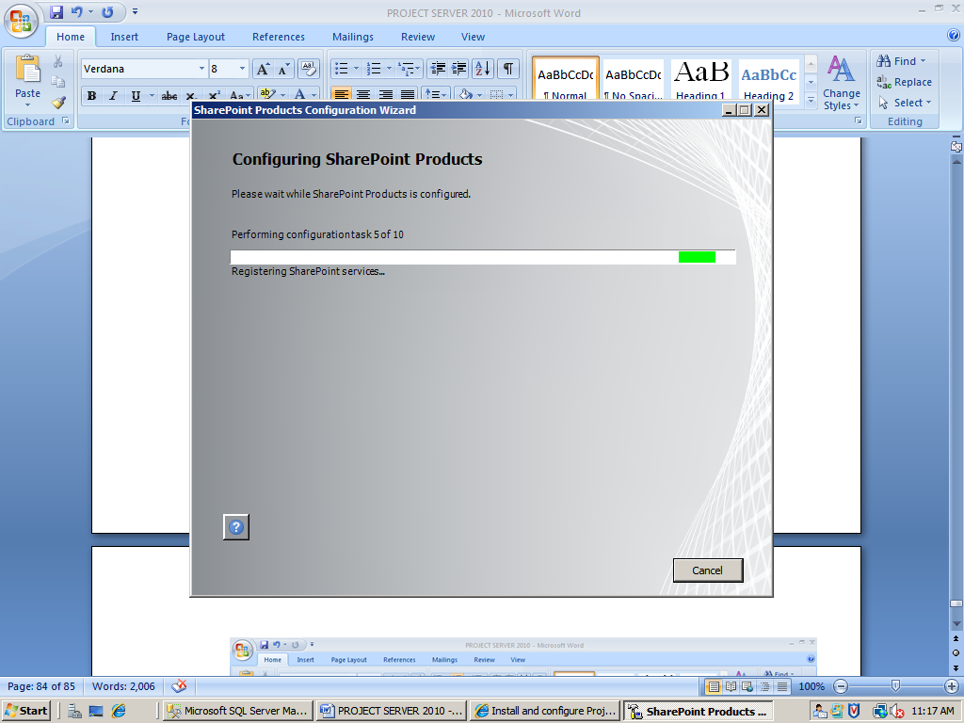

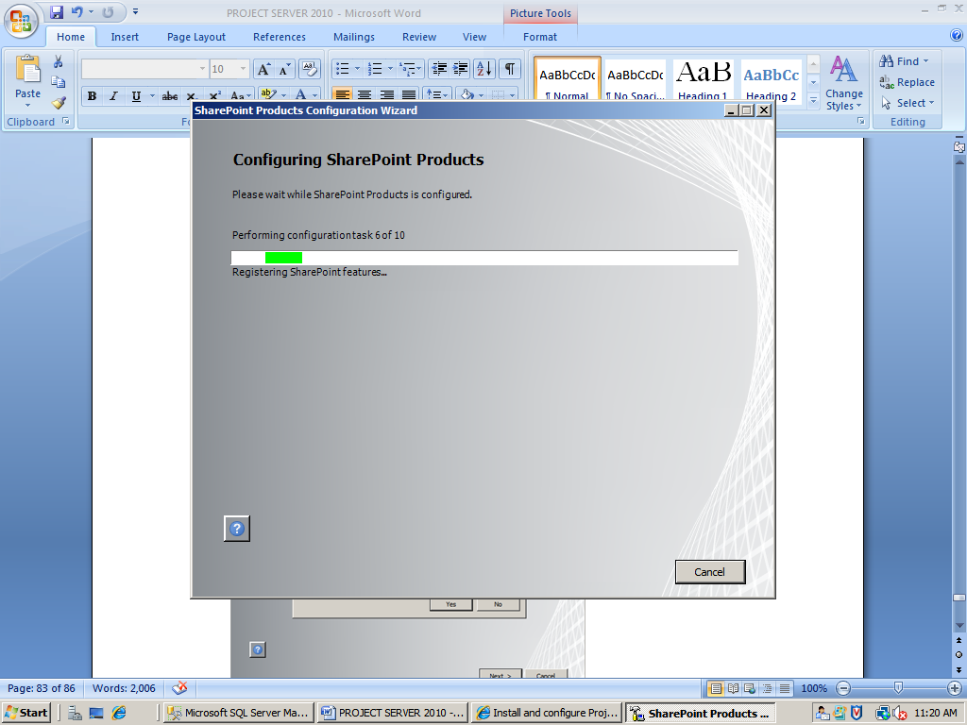

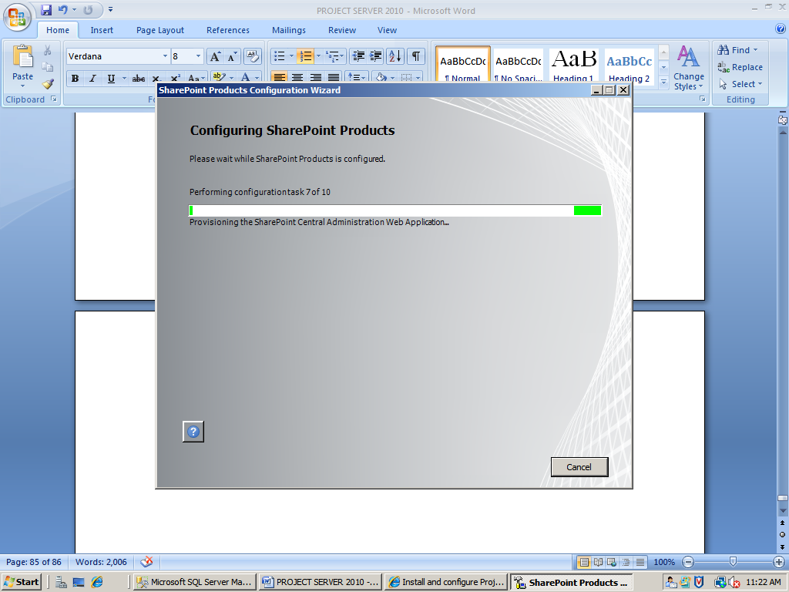

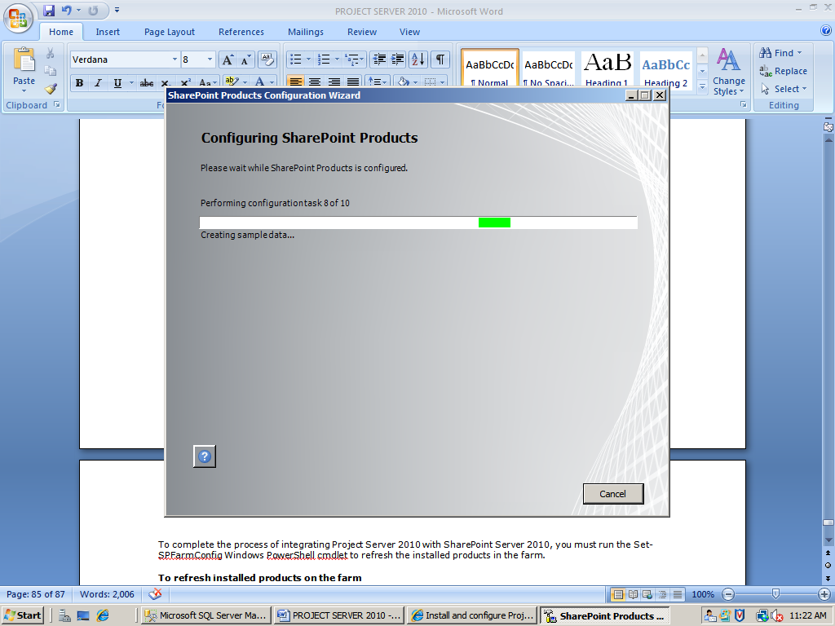

**Note:** Error occurs prompting request channel timed out

**Resolve:** Increase the timeout value passed to the call to Request or increase the SendTimeout value on the Binding

**Check the credentials for the physical path related to the site, and the authentication as well.**

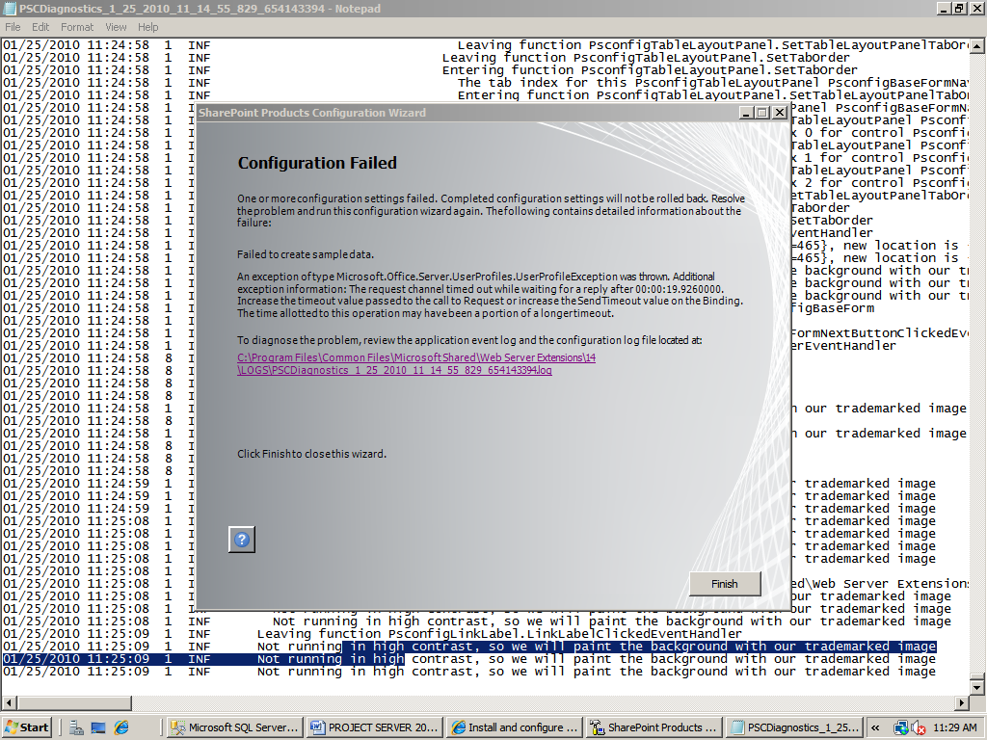

After the changes, run the **Microsoft SharePoint 2010 Products**, **SharePoint 2010 Products Configuration Wizard** again.

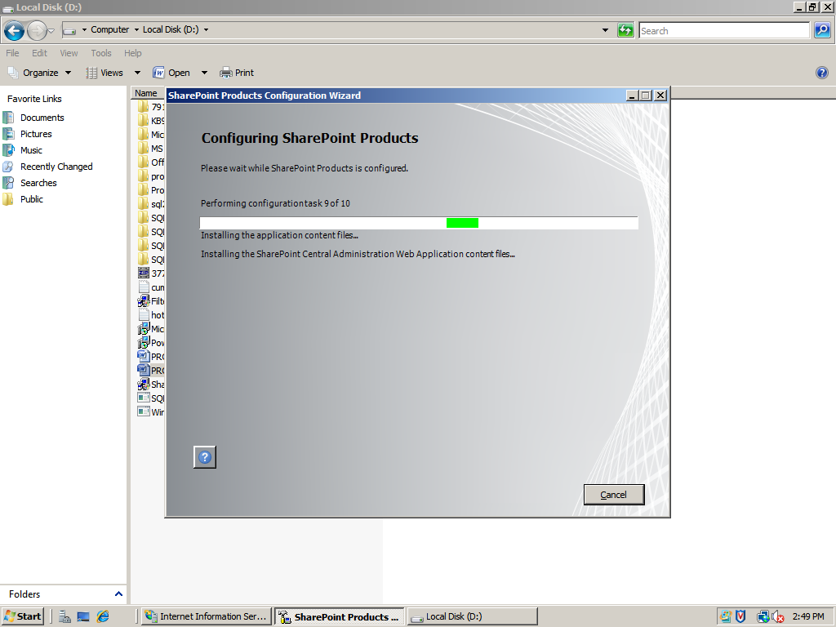

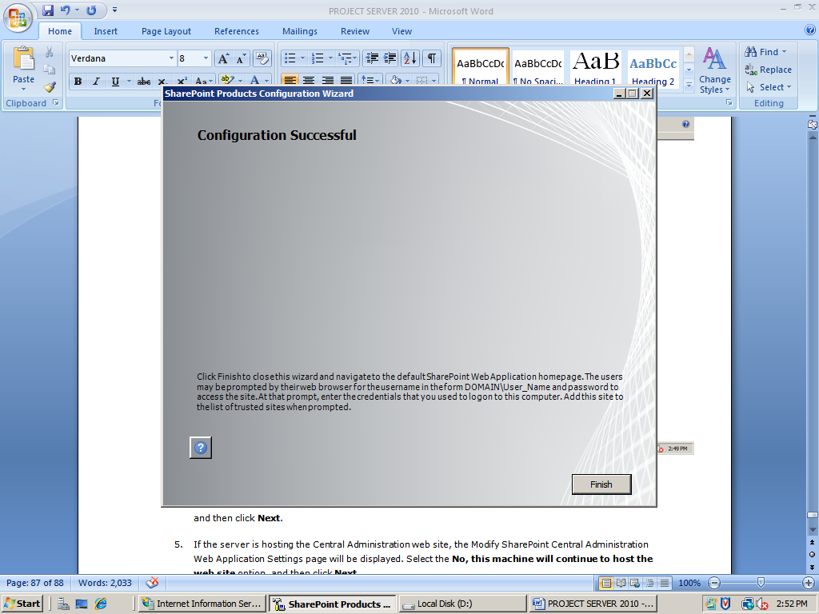

On the Configuration Successful page, click **Finish**



Central Administrator Site

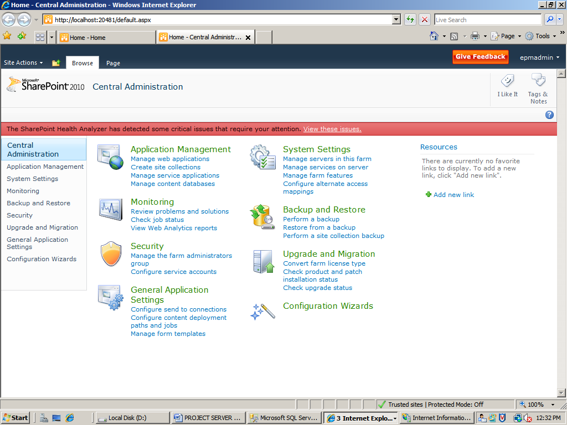

To complete the process of integrating Project Server 2010 with SharePoint Server 2010, you must run the Set-SPFarmConfig Windows PowerShell cmdlet to refresh the installed products in the farm.

### To refresh installed products on the farm

1. Click **Start**, click **All Programs**, click **Microsoft SharePoint 2010 Products**, and then right-click **SharePoint 2010 Management Shell** and click **Run as administrator**.

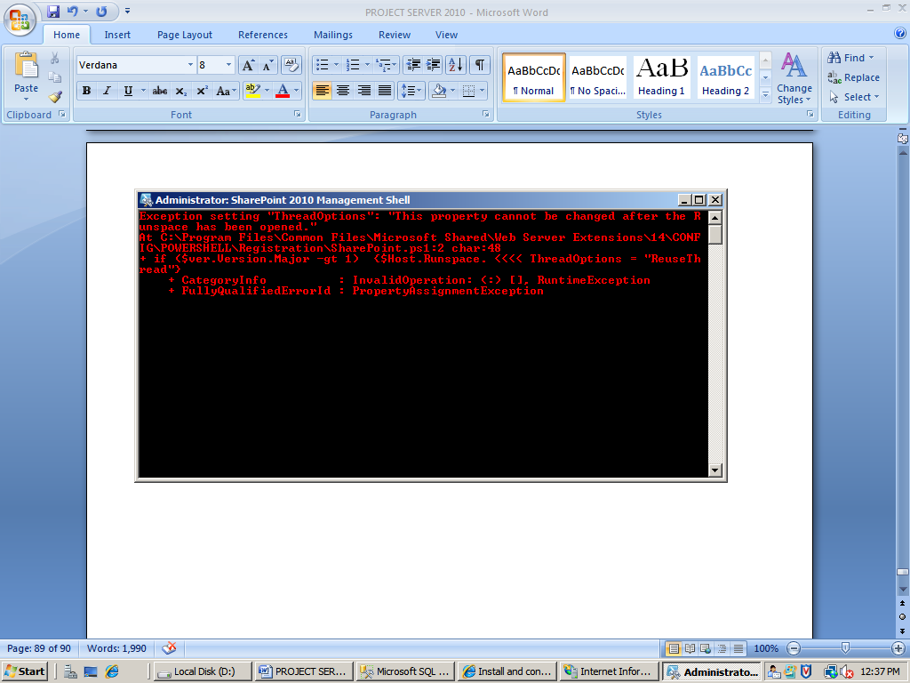

1. At the Windows PowerShell command prompt (that is, PS C:\>), type:

Set-SPFarmConfig –InstalledProductsRefresh

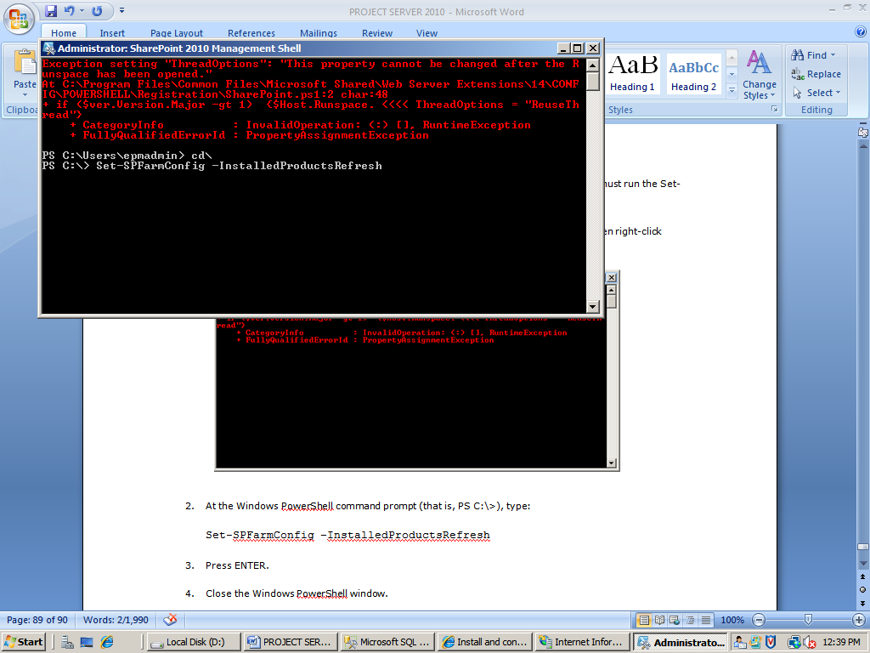

1. Press ENTER.
2. Close the Windows PowerShell window.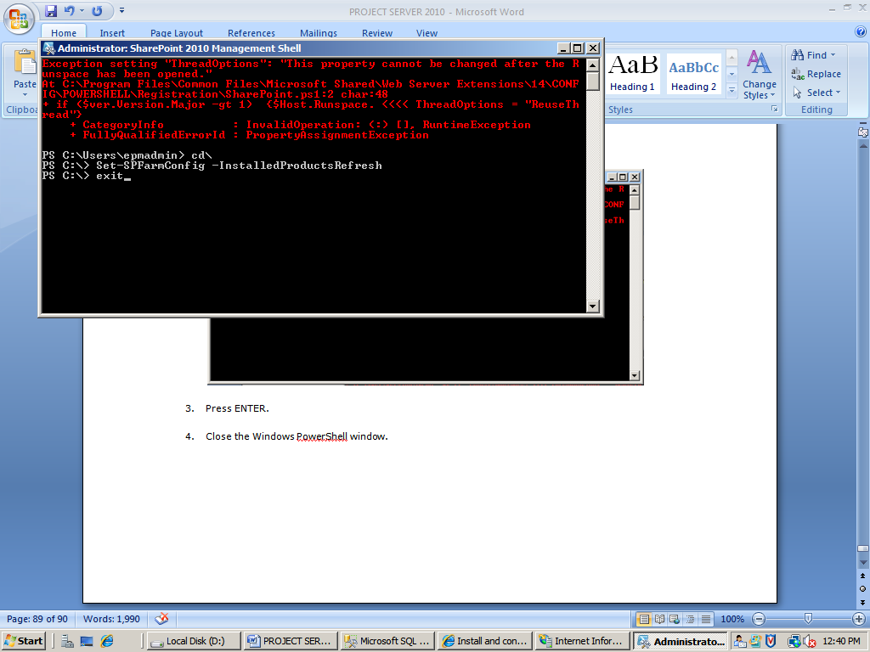

Before you create a Project Server service application, start the Project Application Service and the PerformancePoint service on the servers in the farm where you want to run these services.

### To start the Project Application Service

1. On the SharePoint Central Administration home page, in the **System Settings** section, click **Manage services on server**.

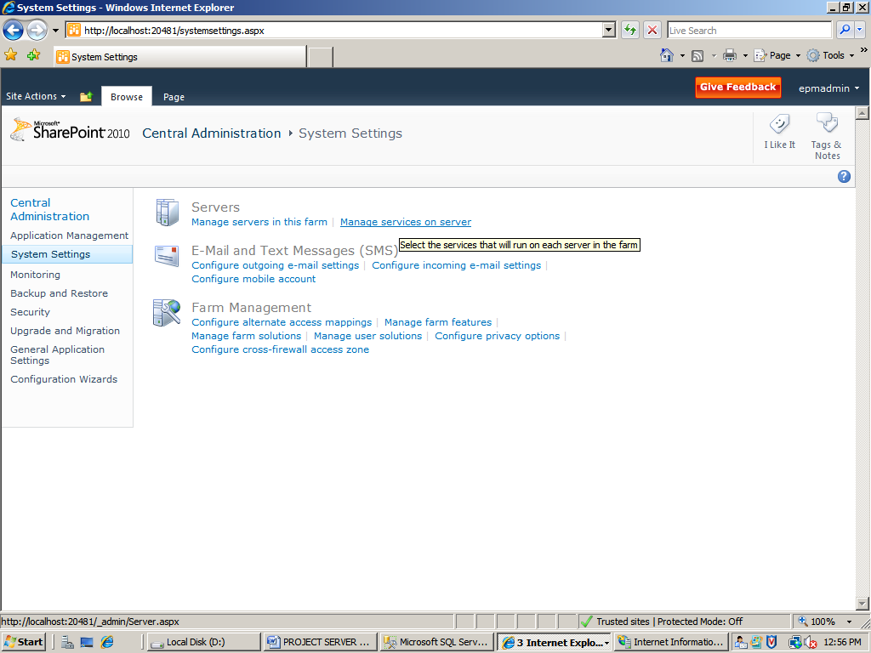

1. On the Services on Server page, select the server where you want to run the Project Application Service from the **Server** drop-down list.
2. On the **Service** list, click **Start** next to **Project Application Service**.

### To start the PerformancePoint Service

1. On the Central Administration home page, in the **System Settings** section, click **Manage services on server**.
2. On the Services on Server page, select the server where you want to run the PerformancePoint Service from the **Server** drop-down list.
3. On the **Service** list, click **Start** next to **PerformancePoint Service**.

Once you have started the Project Server and PerformancePoint services on the desired computers in the farm, you must create a service application for each service.

### To create a Project Server service application

1. On the Central Administration home page, in the **Application Management** section, click **Manage service applications**.

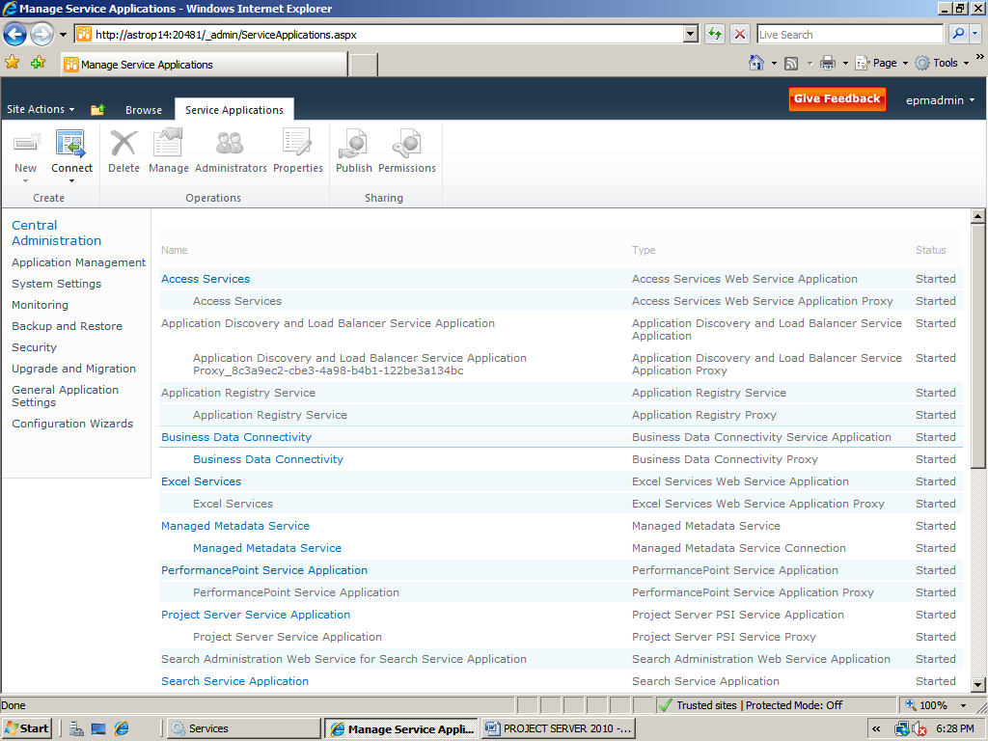

1. On the Manage Service Applications page, on the ribbon, click **New**, and then click **Project Server Service Application**.

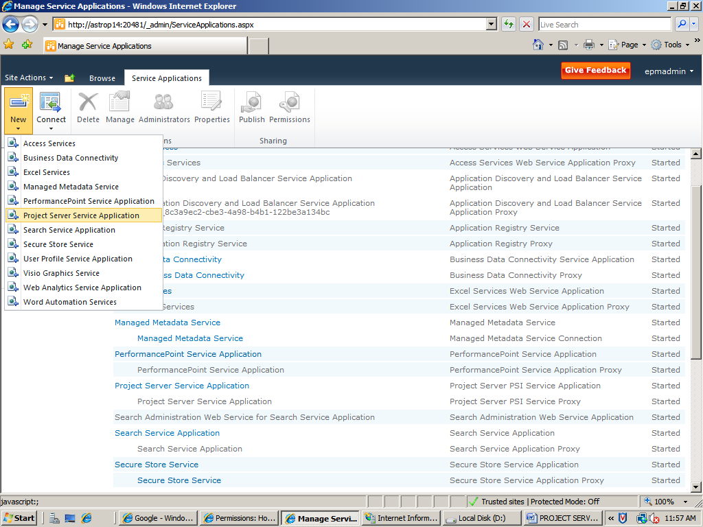

1. On the Create Project Web App service application page:
   1. Type a name for the service application in the **Project Web App service application name** box.
   2. In the **Application Pool** section, choose an existing application pool or type the name of the application pool you want to create in the **Application pool name** box.
   3. Select the **Configurable** option, and choose the managed account you want to use to run the application pool.

Note: If there is no managed account, then register the new managed account accessing the link to register new manage account

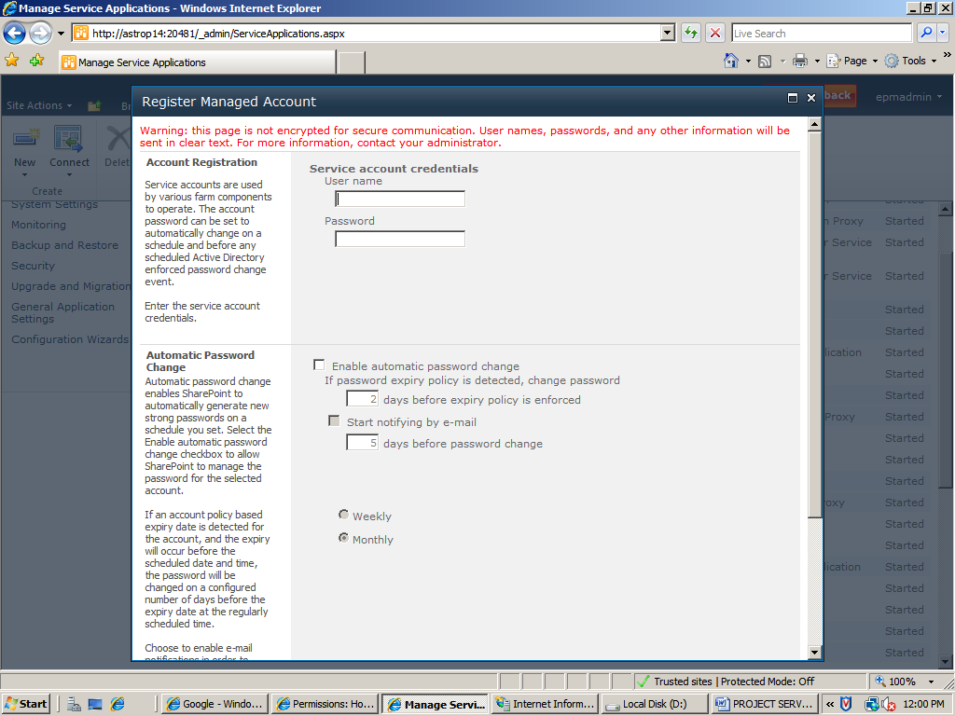

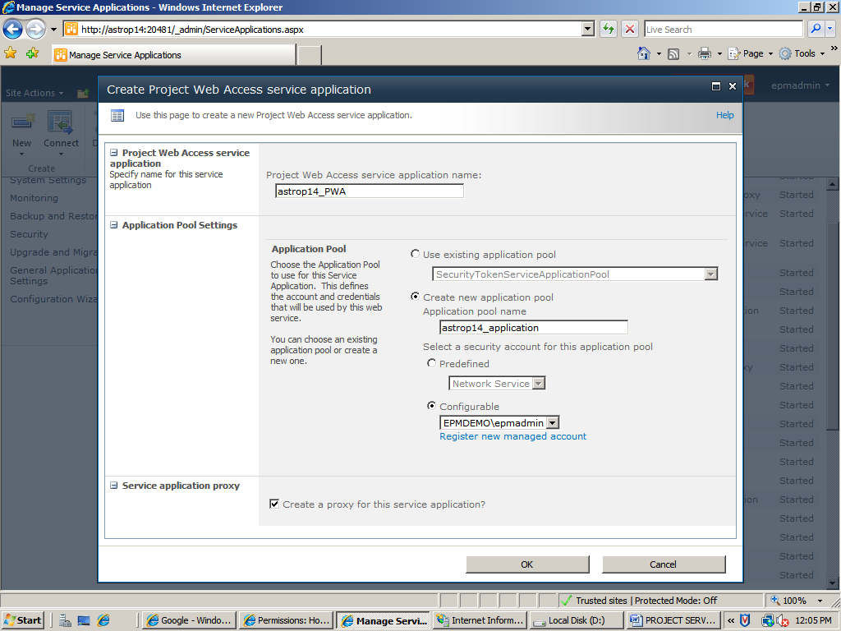

* 1. Click **OK**.

NOTE: The Project Server Service Application exit by default. To create PWA one can also use this default application too.

### To create a PerformancePoint service application

1. On the Central Administration home page, in the **Application Management** section, click **Manage service applications**.
2. On the Manage Service Applications page, on the ribbon, click **New**, and then click **PerformancePoint Service Application**.

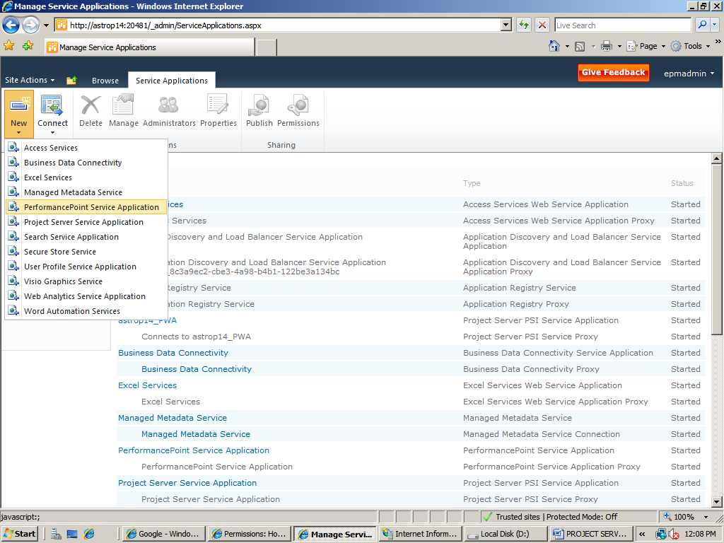

1. On the New PerformancePoint Service Application page:
   1. Type a name for the service application in the **Name** box.
   2. Select the **Add this service application’s proxy to the farm’s default proxy list** check box.
   3. In the **Application Pool** area, choose an existing application pool or type the name of the application pool that you want to create in the **Application pool name** box.
   4. Select the **Configurable** button, and choose the managed account that you want to use to run the application pool.

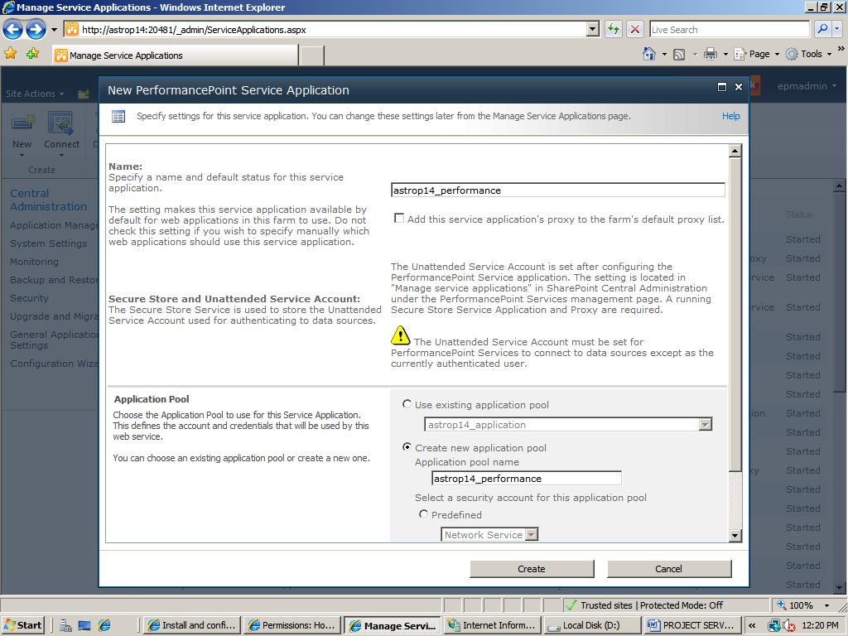

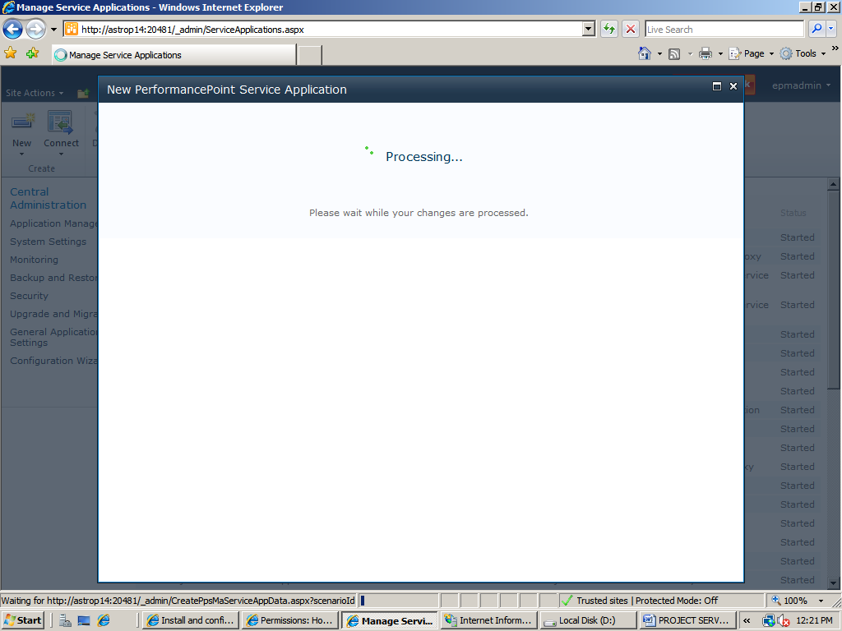

* 1. Click **Create**.

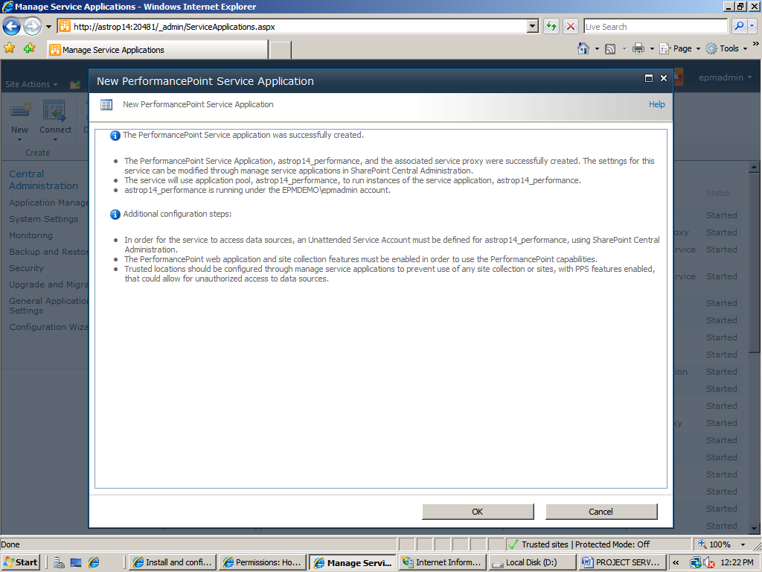

* 1. When the service application has been successfully created, click **OK**.

The next step is to create a top-level Web site if one does not yet exist, and give users read permission to that site. If there is not yet a top level Web site, create one using the following procedure.

### To create a top-level Web site

1. In Central Administration, in the **Application Management** section, click **Create site collections**.

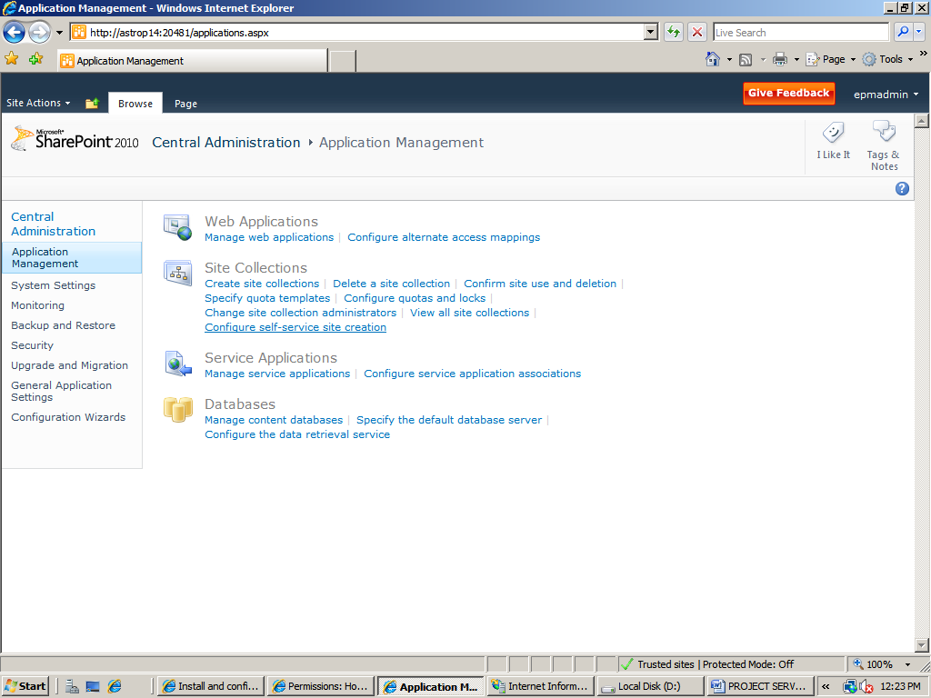

1. Choose a Web application from the **Web Application** drop-down menu.

NOTE: If no Web application is available, you will need to create one.

1. Type a title for the site collection in the **Title** box.
2. In the **Template Selection** section, choose a template for the site.

NOTE: Project Server 2010 does not require a specific template. You can choose one appropriate for your organization

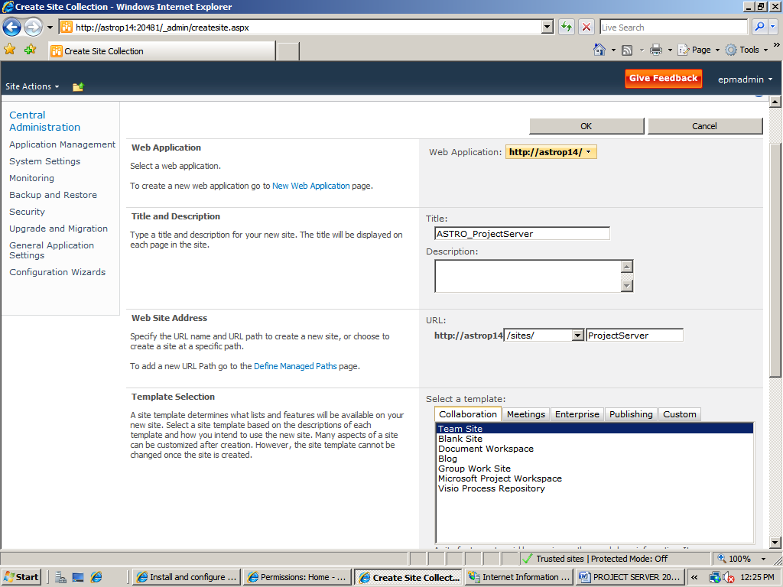

1. In the **Primary Site Collection Administrator** section, type the name of the account you want to use for the site administrator.
2. Click **OK**.

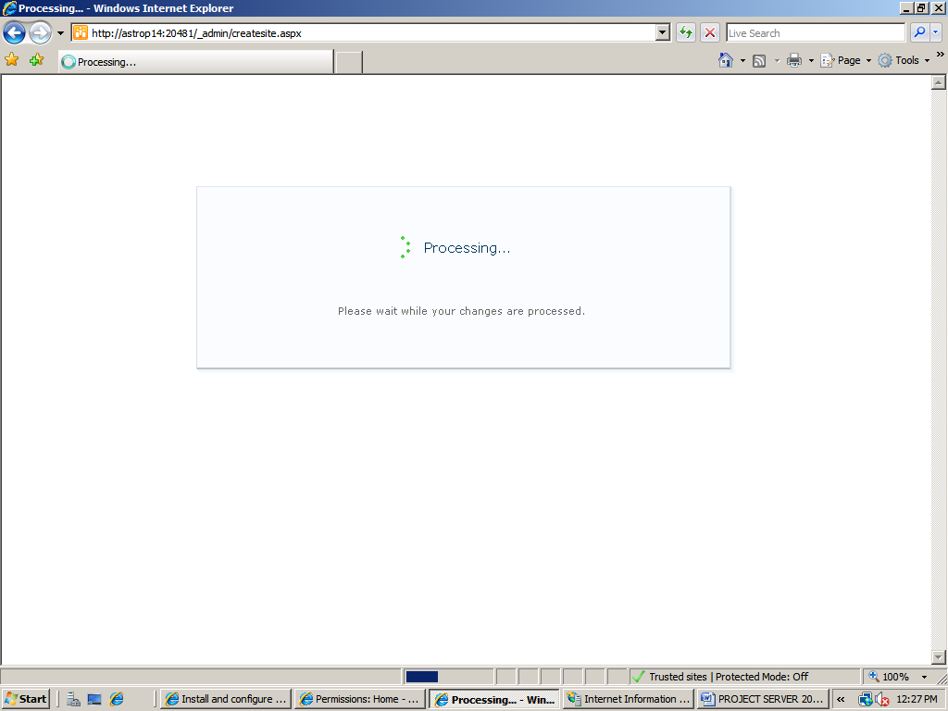

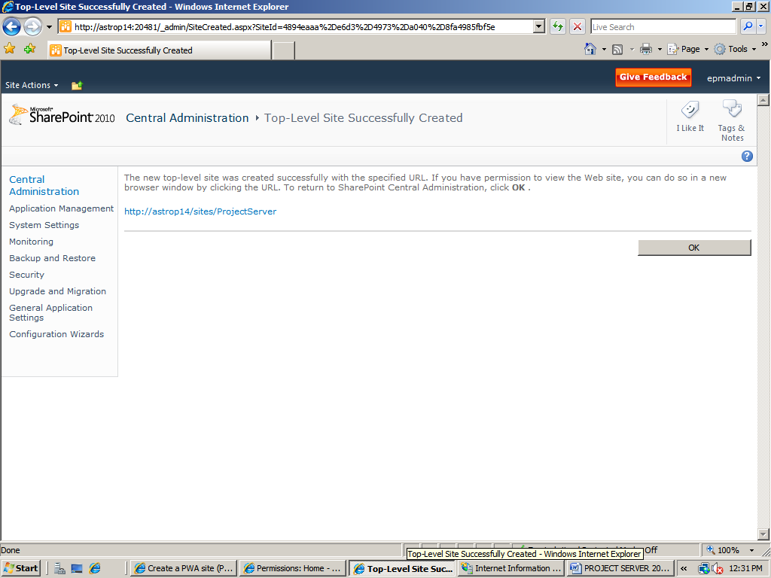

### To set Read permissions on the top-level Web site

1. Navigate to the root site (that is, http://<servername>).
2. Click **Site Actions**.
3. Click **Site Permissions**.

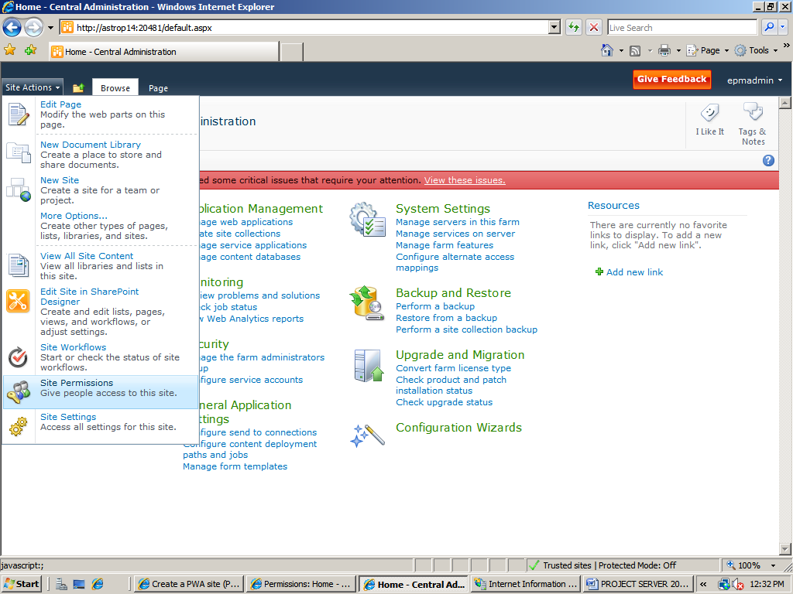

1. Click **Grant Permissions**.
2. In the **Users/Groups** box, type **NT AUTHORITY\Authenticated Users**.

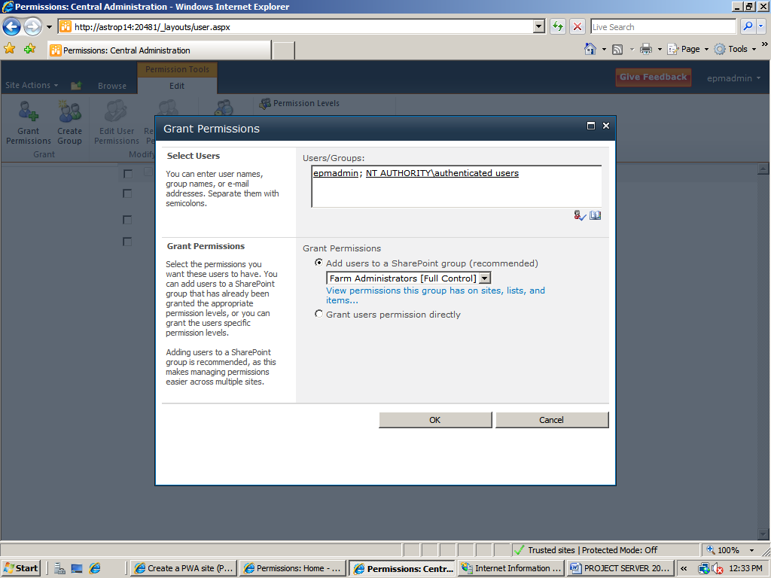

1. Under **Give Permission**, select **<SiteName> Visitors [Read]**.
2. Click **OK**

**Create a PWA site**

The Project Web App site requires a Web application to host it. You can use an existing Web application or create a new one for PWA.

**Important:** Due to a Project Server Beta issue, you must run the psconfig command before creating the first PWA site. Use the following procedure to run the psconfig command. You do not need to rerun this command for additional PWA sites on the same farm.

### To run psconfig

1. Open a Command Prompt window as an Administrator.
2. Navigate to \program files\common files\Microsoft shared\Web server extensions\14\bin.

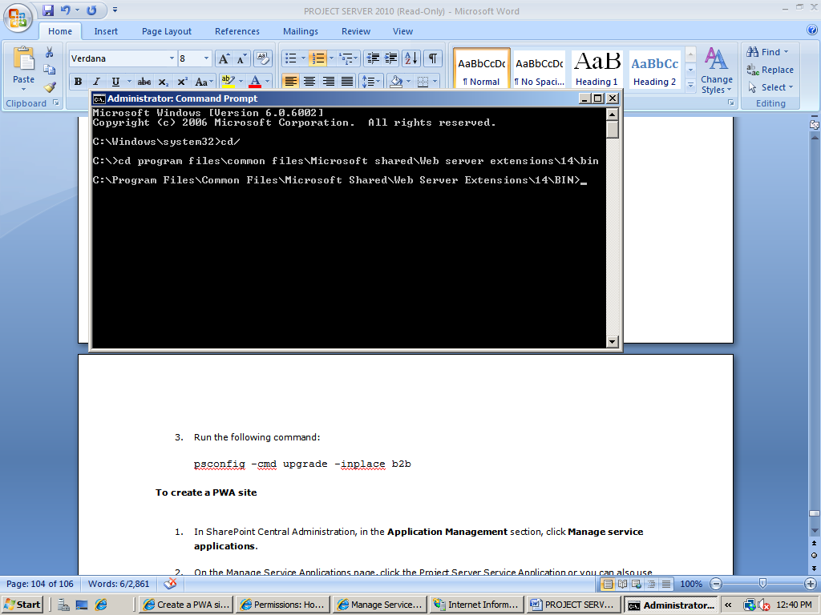

1. Run the following command:

psconfig -cmd upgrade -inplace b2b

### To create a PWA site

1. In SharePoint Central Administration, in the **Application Management** section, click **Manage service applications**.
2. On the Manage Service Applications page, click the Project Server Service Application or you can also use the new project server service application

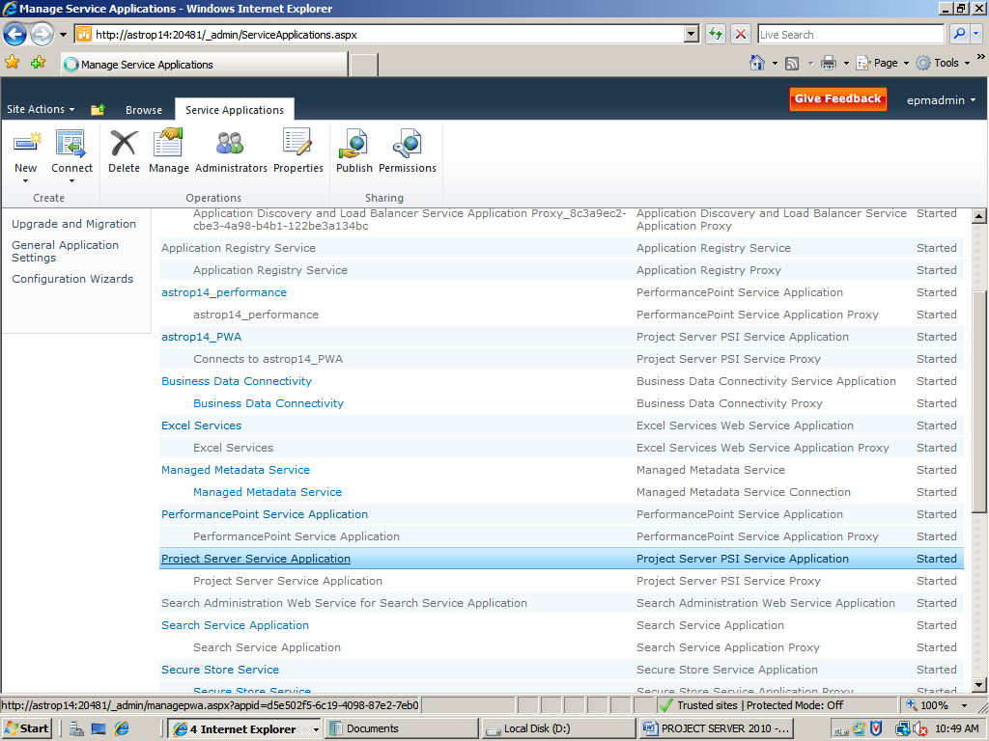

1. On the Manage Project Web Access Sites page, click **Create Project Web Access Site**.

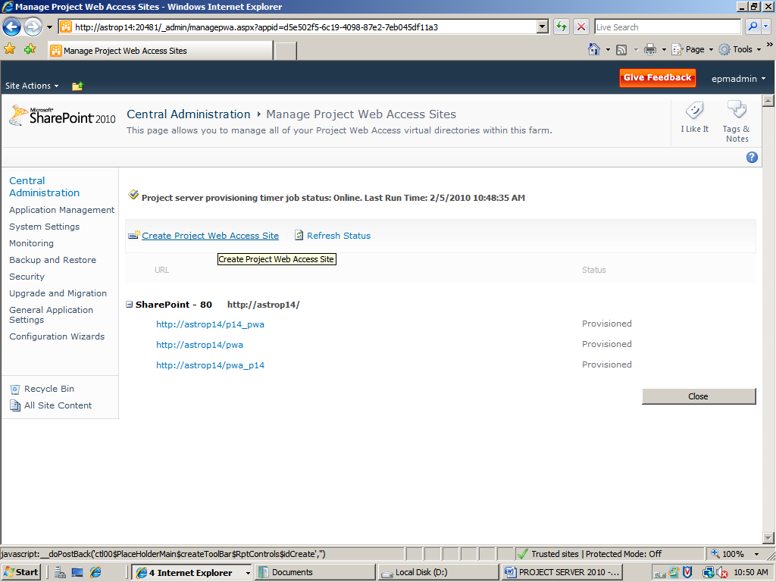

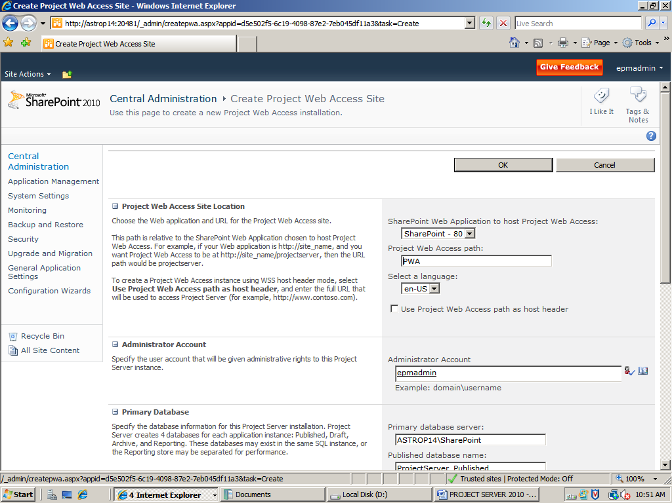

1. Click **OK**.

Project Server will start the PWA site creation process. This may take some time. When the site creation process is completed, the status shown on the PWA site list is **provisioned**.

Click on the PWA link to access your PWA Site

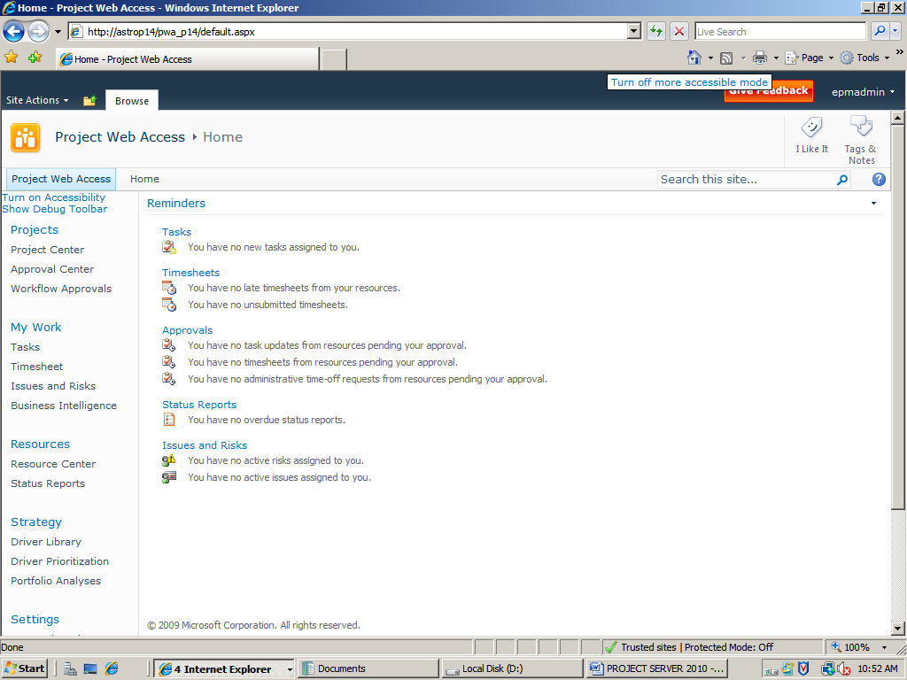

Your PWA Site looks like this.

The Project server 2010 gets deployed completely and successfully after this.

Congratulations!!